ARTIFICIAL INTELLIGENCE
UNIT - I
Problem Solving by Search-I: Introduction to AI, Intelligent Agents Problem Solving by Search –II: Problem-Solving Agents, Searching for Solutions,Uninformed Search Strategies: Breadth-first search, Uniform cost search, Depth-first search,Iterative deepening Depth-first search, Bidirectional search, Informed (Heuristic) SearchStrategies: Greedy best-first search, A* search, Heuristic Functions, Beyond Classical Search: Hill-climbing search, Simulated annealing search, Local Search in Continuous Spaces, Searching with Non-Deterministic Actions, Searching with Partial Observations, Online Search Agents and Unknown Environment .

UNIT-II

Problem Solving by Search-II and Propositional Logic .Adversarial Search: Games, Optimal Decisions in Games, Alpha–Beta Pruning, Imperfect Real-Time Decisions.
Constraint Satisfaction Problems: Defining Constraint Satisfaction Problems, Constraint Propagation, Backtracking Search for CSPs, Local Search for CSPs, The Structure of Problems.
Propositional Logic: Knowledge-Based Agents, The Wumpus World, Logic, Propositional Logic, Propositional Theorem Proving: Inference and proofs, Proof by resolution, Horn clauses and definite clauses, Forward and backward chaining, Effective Propositional Model Checking, Agents Based on Propositional Logic.

UNIT-III
Logic and Knowledge Representation
First-Order Logic: Representation, Syntax and Semantics of First-Order Logic, Using FirstOrder Logic, Knowledge Engineering in First-Order Logic.
Inference in First-Order Logic: Propositional vs. First-Order Inference, Unification and Lifting, Forward Chaining, Backward Chaining, Resolution.
Knowledge Representation: Ontological Engineering, Categories and Objects, Events. Mental Events and Mental Objects, Reasoning Systems for Categories, Reasoning with Default Information.

UNIT-IV
Planning
Classical Planning: Definition of Classical Planning, Algorithms for Planning with StateSpace Search, Planning Graphs, other Classical Planning Approaches, Analysis of Planning approaches.
Planning and Acting in the Real World: Time, Schedules, and Resources, Hierarchical Planning, Planning and Acting in Nondeterministic Domains, Multi agent Planning.

UNIT-V

Uncertain knowledge and Learning
Uncertainty: Acting under Uncertainty, Basic Probability Notation, Inference Using Full Joint Distributions, Independence, Bayes’ Rule and Its Use, Probabilistic Reasoning: Representing Knowledge in an Uncertain Domain, The Semantics of Bayesian Networks, Efficient Representation of Conditional Distributions, Approximate Inference in Bayesian Networks, Relational and First-Order Probability, Other Approaches to Uncertain Reasoning; Dempster-Shafer theory.
Learning: Forms of Learning, Supervised Learning, Learning Decision Trees.Knowledge in Learning: Logical Formulation of Learning, Knowledge in Learning, Explanation-Based Learning, Learning Using Relevance Information, Inductive Logic Programming.

TEXT BOOKS

1. Artificial Intelligence A Modern Approach, Third Edition, Stuart Russell and Peter Norvig, Pearson Education.

REFERENCES:

- Artificial Intelligence, 3rd Edn., E. Rich and K. Knight (TMH)
- Artificial Intelligence, 3rd Edn., Patrick Henny Winston, Pearson Education.
- Artificial Intelligence, Shivani Goel, Pearson Education.
- Artificial Intelligence and Expert systems – Patterson, Pearson Education.

UNIT I:
Problem Solving by Search-I: Introduction to AI, Intelligent Agents Problem Solving by Search –II: Problem- Solving Agents, Searching for Solutions,
Uninformed Search Strategies: Breadth-first search, Uniform cost search, Depth-first search, Iterative deepening Depth-first search, Bidirectional search, Informed (Heuristic) Search Strategies: Greedy best-first search, A* search, Heuristic Functions, Beyond Classical Search: Hill-climbing search, Simulated annealing search,
Local Search in Continuous Spaces, Searching with Non-Deterministic Actions, Searching wih Partial Observations, Online Search Agents and Unknown Environment

Introduction:

- Artificial Intelligence is concerned with the design of intelligence in an artificial device. The term was coined by John McCarthy in 1956.
- Intelligence is the ability to acquire, understand and apply the knowledge to achieve goals in the world.
- AI is the study of the mental faculties through the use of computational models
- AI is the study of intellectual/mental processes as computational processes.
- AI program will demonstrate a high level of intelligence to a degree that equals or exceeds the intelligence required of a human in performing some task.
- AI is unique, sharing borders with Mathematics, Computer Science, Philosophy, Psychology, Biology, Cognitive Science and many others.
- Although there is no clear definition of AI or even Intelligence, it can be described as an attempt to build machines that like humans can think and act, able to learn and use knowledge to solve problems on their own.

History of AI:

Important research that laid the groundwork for AI:

- In 1931, Goedel layed the foundation of Theoretical Computer Science1920-30s:
He published the first universal formal language and showed that math itself is either flawed or allows for unprovable but true statements.
- In 1936, Turing reformulated Goedel’s result and church’s extension thereof.

- In 1956, John McCarthy coined the term "Artificial Intelligence" as the topic of the Dartmouth Conference, the first conference devoted to the subject.
- In 1957, The General Problem Solver (GPS) demonstrated by Newell, Shaw & Simon
- In 1958, John McCarthy (MIT) invented the Lisp language.
- In 1959, Arthur Samuel (IBM) wrote the first game-playing program, for checkers, to achieve sufficient skill to challenge a world champion.
- In 1963, Ivan Sutherland's MIT dissertation on Sketchpad introduced the idea of interactive graphics into computing.
- In 1966, Ross Quillian (PhD dissertation, Carnegie Inst. of Technology; now CMU) demonstrated semantic nets
- In 1967, Dendral program (Edward Feigenbaum, Joshua Lederberg, Bruce Buchanan, Georgia Sutherland at Stanford) demonstrated to interpret mass spectra on organic chemical compounds. First successful knowledge-based program for scientific reasoning.
- In 1967, Doug Engelbart invented the mouse at SRI
- In 1968, Marvin Minsky & Seymour Papert publish Perceptrons, demonstrating limits of simple neural nets.
- In 1972, Prolog developed by Alain Colmerauer.
- In Mid 80’s, Neural Networks become widely used with the Backpropagation algorithm (first described by Werbos in 1974).
- 1990, Major advances in all areas of AI, with significant demonstrations in machine learning, intelligent tutoring, case-based reasoning, multi-agent planning, scheduling, uncertain reasoning, data mining, natural language understanding and translation, vision, virtual reality, games, and other topics.
- In 1997, Deep Blue beats the World Chess Champion Kasparov
- In 2002,iRobot, founded by researchers at the MIT Artificial Intelligence Lab, introduced Roomba, a vacuum cleaning robot. By 2006, two million had been sold.

Foundations of Artificial Intelligence:

Philosophy
e.g., foundational issues (can a machine think?), issues of knowledge and believe, mutual knowledge

Psychology and Cognitive Science
e.g., problem solving skills

Neuro-Science
e.g., brain architecture

Computer Science And Engineering
e.g., complexity theory, algorithms, logic and inference, programming languages, and system building.

Mathematics and Physics
e.g., statistical modeling, continuous mathematics,

Statistical Physics, and Complex Systems. Sub Areas of AI:

- Game Playing
Deep Blue Chess program beat world champion Gary Kasparov

Speech Recognition
PEGASUS spoken language interface to American Airlines' EAASY SABRE reseration system, which allows users to obtain flight information and make reservations over the telephone. The 1990s has seen significant advances in speech recognition so that limited systems are now successful.

Computer Vision
Face recognition programs in use by banks, government, etc. The ALVINN system from CMU autonomously drove a van from Washington, D.C. to San Diego (all but 52 of 2,849 miles), averaging 63 mph day and night, and in all weather conditions. Handwriting recognition, electronics and manufacturing inspection, photo interpretation, baggage inspection, reverse engineering to automatically construct a 3D geometric model.

Expert Systems
Application-specific systems that rely on obtaining the knowledge of human experts in an area and programming that knowledge into a system.
  - Diagnostic Systems : MYCIN system for diagnosing bacterial infections of the blood and suggesting treatments. Intellipath pathology diagnosis system (AMA approved). Pathfinder medical diagnosis system, which suggests tests and makes diagnoses. Whirlpool customer assistance center.

System Configuration
DEC's XCON system for custom hardware configuration. Radiotherapy treatment planning.

Financial Decision Making
Credit card companies, mortgage companies, banks, and the U.S. government employ AI systems to detect fraud and expedite financial transactions. For example, AMEX credit check.

Classification Systems
Put information into one of a fixed set of categories using several sources of information. E.g., financial decision making systems. NASA developed a system for classifying very faint areas in astronomical images into either stars or galaxies with very high accuracy by learning from human experts' classifications.

Mathematical Theorem Proving
Use inference methods to prove new theorems.

Natural Language Understanding
AltaVista's translation of web pages. Translation of Catepillar Truck manuals into 20 languages.

Scheduling and Planning
Automatic scheduling for manufacturing. DARPA's DART system used in Desert Storm and Desert Shield operations to plan logistics of people and supplies. American Airlines rerouting contingency planner. European space agency planning and scheduling of spacecraft assembly, integration and verification.

Artificial Neural Networks:
- Machine Learning Application of AI:
AI algorithms have attracted close attention of researchers and have also been applied successfully to solve problems in engineering. Nevertheless, for large and complex problems, AI algorithms consume considerable computation time due to stochastic feature of the search approaches

- Business; financial strategies

- Engineering: check design, offer suggestions to create new product, expert systems for all engineering problems
- Manufacturing: assembly, inspection and maintenance
- Medicine: monitoring, diagnosing
- Education: in teaching
- Fraud detection
- Object identification
- Information retrieval
- Space shuttle scheduling

Building AI Systems:

Perception
Intelligent biological systems are physically embodied in the world and experience the world through their sensors (senses). For an autonomous vehicle, input might be images from a camera and range information from a rangefinder. For a medical diagnosis system, perception is the set of symptoms and test results that have been obtained and input to the system manually.

Reasoning
Inference, decision-making, classification from what is sensed and what the internal "model" is of the world. Might be a neural network, logical deduction system, Hidden Markov Model induction, heuristic searching a problem space, Bayes Network inference, genetic algorithms, etc.
Includes areas of knowledge representation, problem solving, decision theory, planning, game theory, machine learning, uncertainty reasoning, etc.

Action
Biological systems interact within their environment by actuation, speech, etc. All behavior is centered around actions in the world. Examples include controlling the steering of a Mars rover or autonomous vehicle, or suggesting tests and making diagnoses for a medical diagnosis system. Includes areas of robot actuation, natural language generation, and speech synthesis.

The definitions of AI:

a) "The exciting new effort to make computers think . . . machines with minds, in the full and literal sense" (Haugeland, 1985)  "The automation of] activities that we associate with human thinking, activities such as decision-making, problem solving,  learning..."(Bellman, 1978) | b) "The study of mental faculties through the use of computational models" (Charniak and McDermott, 1985)  "The study of the computations that make it possible to perceive, reason, and act" (Winston, 1992)
c) "The art of creating machines that perform functions that require intelligence when performed by people" (Kurzweil, 1990)  "The study of how to make computers do things at which, at the moment, people are better" (Rich and Knight, 1 99 1 ) | d) "A field of study that seeks to explain and emulate intelligent behavior in terms of computational processes" (Schalkoff, 1 990)  "The branch of computer science that is concerned with the automation of intelligent behavior" (Luger and Stubblefield, 1993)
The definitions on the top, (a) and (b) are concerned with reasoning, whereas those on the bottom, (c) and (d) address behavior.The definitions on the left, (a) and (c) measure success in terms of human performance, and those on the right, (b) and (d) measure the ideal concept of intelligence called rationality

Intelligent Systems:

In order to design intelligent systems, it is important to categorize them into four categories (Luger and Stubberfield 1993), (Russell and Norvig, 2003)
- Systems that think like humans
- Systems that think rationally
- Systems that behave like humans
- Systems that behave rationally

 | Human- Like | Rationally
Think: | Cognitive Science Approach  “Machines that think like humans” | Laws of thought Approach  “ Machines that think Rationally”
Act: | Turing Test Approach  “Machines that behave like humans” | Rational Agent Approach  “Machines that behave Rationally”

Scientific Goal: To determine which ideas about knowledge representation, learning, rule systems search, and so on, explain various sorts of real intelligence.
Engineering Goal:To solve real world problems using AI techniques such as Knowledge representation, learning, rule systems, search, and so on.
Traditionally, computer scientists and engineers have been more interested in the engineering goal, while psychologists, philosophers and cognitive scientists have been more interested in the scientific goal.

Cognitive Science: Think Human-Like

  - Requires a model for human cognition. Precise enough models allow simulation by computers.

  - Focus is not just on behavior and I/O, but looks like reasoning process.

  - Goal is not just to produce human-like behavior but to produce a sequence of steps of the reasoning process, similar to the steps followed by a human in solving the same task.

Laws of thought: Think Rationally

- The study of mental faculties through the use of computational models; that it is, the study of computations that make it possible to perceive reason and act.

- Focus is on inference mechanisms that are probably correct and guarantee an optimal solution.

- Goal is to formalize the reasoning process as a system of logical rules and procedures of inference.

- Develop systems of representation to allow inferences to be like “Socrates is a man. All men are mortal. Therefore Socrates is mortal”

Turing Test: Act Human-Like

- The art of creating machines that perform functions requiring intelligence when performed by people; that it is the study of, how to make computers do things which, at the moment, people do better.

- Focus is on action, and not intelligent behavior centered around the representation of the world

- Example: Turing Test

  - 3 rooms contain: a person, a computer and an interrogator.

  - The interrogator can communicate with the other 2 by teletype (to avoid the machine imitate the appearance of voice of the person)

  - The interrogator tries to determine which the person is and which the machine is.

  - The machine tries to fool the interrogator to believe that it is the human, and the person also tries to convince the interrogator that it is the human.

  - If the machine succeeds in fooling the interrogator, then conclude that the machine is intelligent.

Rational agent: Act Rationally

- Tries to explain and emulate intelligent behavior in terms of computational process; that it is concerned with the automation of the intelligence.

- Focus is on systems that act sufficiently if not optimally in all situations.

- Goal is to develop systems that are rational and sufficient

The difference between strong AI and weak AI:

Strong AI makes the bold claim that computers can be made to think on a level (at least) equal to humans.

Weak AI simply states that some "thinking-like" features can be added to computers to make them more useful tools... and this has already started to happen (witness expert systems, drive-by-wire cars and speech recognition software).

AI Problems:

AI problems (speech recognition, NLP, vision, automatic programming, knowledge representation, etc.) can be paired with techniques (NN, search, Bayesian nets, production systems, etc.).AI problems can be classified in two types:

- Common-place tasks(Mundane Tasks)
- Expert tasks

Common-Place Tasks:
- Recognizing people, objects.
- Communicating (through natural language).
- Navigating around obstacles on the streets.

These tasks are done matter of factly and routinely by people and some other animals.

Expert tasks:
  - Medical diagnosis.
  - Mathematical problem solving
  - Playing games like chess
These tasks cannot be done by all people, and can only be performed by skilled specialists.
Clearly tasks of the first type are easy for humans to perform, and almost all are able to master them. The second range of tasks requires skill development and/or intelligence and only some specialists can perform them well. However, when we look at what computer systems have been able to achieve to date, we see that their achievements include performing sophisticated tasks like medical diagnosis, performing symbolic integration, proving theorems and playing chess.

1. Intelligent Agent’s:
Agents andenvironments:

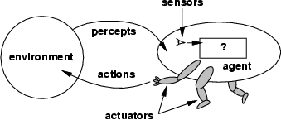

Fig 2.1: Agents and Environments

Agent:
An Agent is anything that can be viewed as perceiving its environment through sensors and acting upon that environment through actuators.
      - A human agent has eyes, ears, and other organs for sensors and hands, legs, mouth, and other body parts foractuators.
      - A robotic agent might have cameras and infrared range finders for sensors and various motors foractuators.
      - A software agent receives keystrokes, file contents, and network packets as sensory

inputs and acts on the environment by displaying on the screen, writing files, and sending network packets.

Percept:
We use the term percept to refer to the agent's perceptual inputs at any given instant.

PerceptSequence:
An agent's percept sequence is the complete history of everything the agent has ever perceived.

Agent function:
Mathematically speaking, we say that an agent's behavior is described by the agent function that maps any given percept sequence to an action.

Agentprogram
Internally, the agent function for an artificial agent will be implemented by an agent program. It is important to keep these two ideas distinct. The agent function is an abstract mathematical description; the agent program is a concrete implementation, running on the agent architecture.
To illustrate these ideas, we will use a very simple example-the vacuum-cleaner world shown in Fig
2.1.5. This particular world has just two locations: squares A and B. The vacuum agent perceives which square it is in and whether there is dirt in the square. It can choose to move left, move right, suck up the dirt, or do nothing. One very simple agent function is the following: if the current square is dirty, then suck, otherwise move to the other square. A partial tabulation of this agent function is shown in Fig 2.1.6.

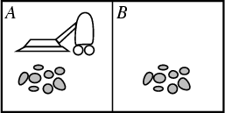

Fig 2.1.5: A vacuum-cleaner world with just two locations.

Agentfunction

Percept Sequence | Action
[A, Clean] | Right
[A, Dirty] | Suck
[B, Clean] | Left
[B, Dirty] | Suck
[A, Clean], [A, Clean] | Right
[A, Clean], [A, Dirty] | Suck
…
Fig 2.1.6: Partial tabulation of a simple agent function for the example: vacuum-cleaner
world shown in the Fig 2.1.5

Function REFLEX-VACCUM-AGENT ([location, status]) returns an action If status=Dirty then return Suck
else if location = A then return Right

else if location = B then return Left

Fig 2.1.6(i): The REFLEX-VACCUM-AGENT program is invoked for each new percept (location, status) and returns an action each time

Strategies of Solving Tic-Tac-Toe Game Playing Tic-Tac-Toe Game Playing:
Tic-Tac-Toe is a simple and yet an interesting board game. Researchers have used various approaches to study the Tic-Tac-Toe game. For example, Fok and Ong and Grim et al. have used artificial neural network based strategies to play it. Citrenbaum and Yakowitz discuss games like Go-Moku, Hex and Bridg-It which share some similarities with Tic-Tac-Toe.

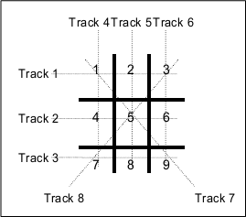

Fig 1.

A Formal Definition of the Game:

The board used to play the Tic-Tac-Toe game consists of 9 cells laid out in the form of a 3x3 matrix (Fig. 1). The game is played by 2 players and either of them can start. Each of the two players is assigned a unique symbol (generally 0 and X). Each player alternately gets a turn to make a move. Making a move is compulsory and cannot be deferred. In each move a player places the symbol assigned to him/her in a hitherto blank cell.

Let a track be defined as any row, column or diagonal on the board. Since the board is a square matrix with 9 cells, all rows, columns and diagonals have exactly 3 cells. It can be easily observed that there are 3 rows, 3 columns and 2 diagonals, and hence a total of 8 tracks on the board (Fig. 1). The goal of the game is to fill all the three cells of any track on the board with the symbol assigned to one before the opponent does the same with the symbol assigned to him/her. At any point of the game, if there exists a track whose all three cells have been marked by the same symbol, then the player to whom that symbol have been assigned wins and the game terminates. If there exist no track whose cells have been marked by the same symbol when there is no more blank cell on the board then the game is drawn.

Let the priority of a cell be defined as the number of tracks passing through it. The priorities of the nine cells on the board according to this definition are tabulated in Table 1. Alternatively, let the priority of a track be defined as the sum of the priorities of its three cells. The priorities of the eight tracks on the board according to this definition are tabulated in Table 2. The prioritization of the cells and the tracks lays the foundation of the heuristics to be used in this study. These heuristics are somewhat similar to those proposed by Rich and Knight.

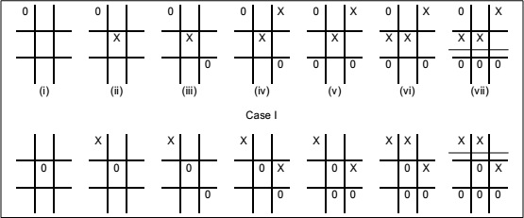

Strategy 1:

Algorithm:

- View the vector as a ternary number. Convert it to a decimal number.

- Use the computed number as an index into Move-Table and access the vector stored there.

- Set the new board to that vector.

Procedure:

- Elements of vector:

0: Empty

1: X

2: O

→ the vector is a ternary number

- Store inside the program a move-table (lookuptable):

  - Elements in the table: 19683 (3⁹)
  - Element = A vector which describes the most suitable move from the
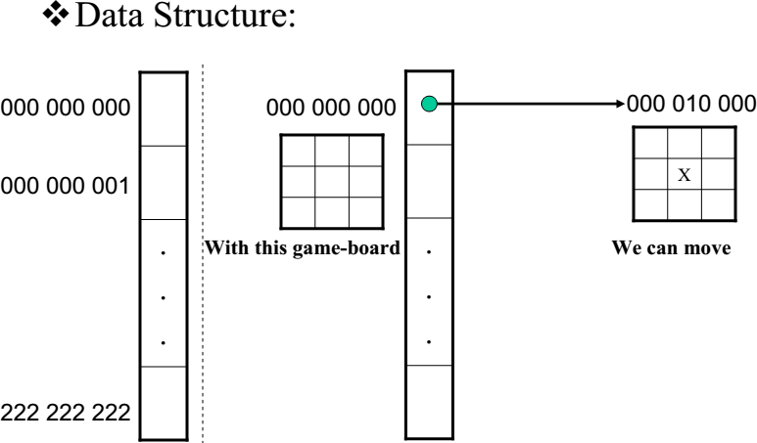

Comments:

- A lot of space to store the Move-Table.

- A lot of work to specify all the entries in the Move-Table.

- Difficult to extend

Explanation of Strategy 2 of solving Tic-tac-toe problem Stratergy 2:
Data Structure:
- Use vector, called board, as Solution 1
- However, elements of the vector: 2: Empty
3: X
5: O
- Turn of move: indexed by integer 1,2,3, etc

Function Library:

- Make2:
  - Return a location on a game-board. IF (board[5] = 2)
RETURN 5; //the center cell. ELSE
RETURN any cell that is not at the board’s corner;
// (cell: 2,4,6,8)
  - Let P represent for X or O
  - can_win(P) :
P has filled already at least two cells on a straight line (horizontal, vertical, or diagonal)
  - cannot_win(P) = NOT(can_win(P))
- Posswin(P):

IF (cannot_win(P)) RETURN 0;
ELSE
RETURN index to the empty cell on the line of can_win(P)
Let odd numbers are turns of X Let even numbers are turns of O
- Go(n): make a move

Algorithm:
- Turn = 1: (X moves)
Go(1) //make a move at the left-top cell
- Turn = 2: (O moves)
IF board[5] is empty THEN Go(5)
ELSE Go(1)
- Turn = 3: (X moves)
IF board[9] is empty THEN Go(9)
ELSE Go(3).
- Turn = 4: (O moves)
IF Posswin (X) <> 0 THEN Go (Posswin (X))
//Prevent the opponent to win ELSE Go (Make2)
- Turn = 5: (X moves)

IF Posswin(X) <> 0 THEN Go(Posswin(X))
//Win for X.
ELSE IF Posswin(O) <> THEN
Go(Posswin(O))
//Prevent the opponent to win ELSE IF board[7] is empty THEN Go(7)
ELSE Go(3).

Comments:

move.
- Not efficient in time, as it has to check several conditions before making each

- Easier to understand the program’s strategy.
- Hard to generalize.

Introduction to Problem Solving, General problem solving

Problem solving is a process of generating solutions from observed data.
−a problem is characterized by a set of goals,
−a set of objects, and
−a set of operations.
These could be ill-defined and may evolve during problem solving.

Searching Solutions:
To build a system to solve a problem:
  - Define the problem precisely
  - Analyze the problem
  - Isolate and represent the task knowledge that is necessary to solve the problem
  - Choose the best problem-solving techniques and apply it to the particular problem.

Defining the problem as State Space Search:
The state space representation forms the basis of most of the AI methods.
- Formulate a problem as a state space search by showing the legal problem states, the legal operators, and the initial and goal states.
- A state is defined by the specification of the values of all attributes of interest in the world
- An operator changes one state into the other; it has a precondition which is the value of certain attributes prior to the application of the operator, and a set of effects, which are the attributes altered by the operator
- The initial state is where you start
- The goal state is the partial description of the solution

Formal Description of the problem:
- Define a state space that contains all the possible configurations of the relevant objects.
- Specify one or more states within that space that describe possible situations from which the problem solving process may start ( initial state)
- Specify one or more states that would be acceptable as solutions to the problem. ( goal states)
Specify a set of rules that describe the actions (operations) available

State-Space Problem Formulation:

Example: A problem is defined by four items:
- initial state e.g., "at Arad―
- actions or successor function : S(x) = set of action–state pairs e.g., S(Arad) = {<Arad → Zerind, Zerind>, … }

goal test (or set of goal states)
e.g., x = "at Bucharest‖, Checkmate(x)

path cost (additive)
e.g., sum of distances, number of actions executed, etc.
c(x,a,y) is the step cost, assumed to be ≥ 0
A solution is a sequence of actions leading from the initial state to a goal state

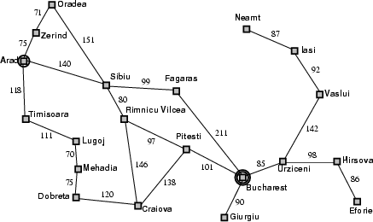

Example: 8-queens problem
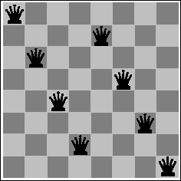

  - Initial State: Any arrangement of 0 to 8 queens on board.
  - Operators: add a queen to any square.
  - Goal Test: 8 queens on board, none attacked.
  - Path cost: not applicable or Zero (because only the final state counts, search cost might be of interest).

State Spaces versus Search Trees:
- State Space
  - Set of valid states for a problem
  - Linked by operators
  - e.g., 20 valid states (cities) in the Romanian travel problem
- Search Tree
- Root node = initial state
- Child nodes = states that can be visited from parent
- Note that the depth of the tree can be infinite
  - E.g., via repeated states
- Partial search tree

  - Portion of tree that has been expanded so far
- Fringe
  - Leaves of partial search tree, candidates for expansion Search trees = data structure to search state-space

Properties of Search Algorithms

Which search algorithm one should use will generally depend on the problem domain. There are four important factors to consider:

- Completeness – Is a solution guaranteed to be found if at least one solution exists?

- Optimality – Is the solution found guaranteed to be the best (or lowest cost) solution if there exists more than one solution?

- Time Complexity – The upper bound on the time required to find a solution, as a function of the complexity of the problem.

- Space Complexity – The upper bound on the storage space (memory) required at any point during the search, as a function of the complexity of the problem.

General problem solving, Water-jug problem, 8-puzzle problem General Problem Solver:
The General Problem Solver (GPS) was the first useful AI program, written by Simon, Shaw, and Newell in 1959. As the name implies, it was intended to solve nearly any problem.
Newell and Simon defined each problem as a space. At one end of the space is the starting point; on the other side is the goal. The problem-solving procedure itself is conceived as a set of operations to cross that space, to get from the starting point to the goal state, one step at a time.
The General Problem Solver, the program tests various actions (which Newell and Simon called operators) to see which will take it closer to the goal state. An operator is any activity that changes the

state of the system. The General Problem Solver always chooses the operation that appears to bring it closer to its goal.

Example: Water Jug Problem

Consider the following problem:

A Water Jug Problem: You are given two jugs, a 4-gallon one and a 3-gallon one, a pump which has unlimited water which you can use to fill the jug, and the ground on which water may be poured. Neither jug has any measuring markings on it. How can you get exactly 2 gallons of water in the 4-gallon jug?

State Representation and Initial State :
We will represent a state of the problem as a tuple (x, y) where x represents the amount of water in the 4-gallon jug and y represents the amount of water in the 3-gallon jug. Note 0 ≤x≤ 4, and 0 ≤y ≤3. Our initial state: (0, 0)

Goal Predicate - state = (2, y) where 0≤ y≤ 3.

Operators -we must defi ne a set of operators that will take us from one state to another:

1. | Fill 4-gal jug | (x,y) | → (4,y)
 |  | x < 4
2. | Fill 3-gal jug | (x,y) | → (x,3)
 |  | y < 3
3. | Empty 4-gal jug on ground | (x,y) | → (0,y)
 |  | x > 0
4. | Empty 3-gal jug on ground | (x,y) | → (x,0)
 |  | y > 0
5. | Pour water from 3-gal jug | (x,y) | →! (4, y - (4 - x))
 | to ll 4-gal jug | 0 < x+y 4 and y > 0
6. | Pour water from 4-gal jug | (x,y) | → (x - (3-y), 3)
 | to ll 3-gal-jug | 0 < x+y 3 and x > 0
7. | Pour all of water from 3-gal jug | (x,y) | → (x+y, 0)

 | into 4-gal jug | 0 < x+y 4 and y 0
8. | Pour all of water from 4-gal jug | (x,y) | → (0, x+y)
 | into 3-gal jug | 0 < x+y 3 and x 0

Through Graph Search, the following solution is found :

Gals in 4-gal jug Gals in 3-gal jug |  | Rule Applied
0 | 0
 |  | 1. | Fill 4
4 | 0
6. Pour 4 into 3 to ll
1 | 3
4. Empty 3
1 | 0
8. Pour all of 4 into 3
0 | 1
 |  | 1. | Fill 4
4 | 1
6. Pour into 3
2 | 3

Second Solution:
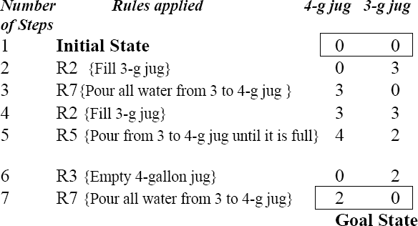

Control strategies
Control Strategies means how to decide which rule to apply next during the process of searching for a solution to a problem.
Requirement for a good Control Strategy

It should cause motion
In water jug problem, if we apply a simple control strategy of starting each time from the top of rule list and choose the first applicable one, then we will never move towards solution.

It should explore the solution space in a systematic manner
If we choose another control strategy, let us say, choose a rule randomly from the applicable rules then definitely it causes motion and eventually will lead to a solution. But one may arrive to same state several times. This is because control strategy is not systematic.

Systematic Control Strategies (Blind searches):

Breadth First Search:

Let us discuss these strategies using water jug problem. These may be applied to any search problem. Construct a tree with the initial state as its root.
Generate all the offspring of the root by applying each of the applicable rules to the initial state.
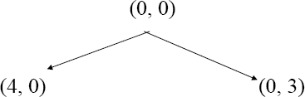

Now for each leaf node, generate all its successors by applying all the rules that are appropriate.

8 Puzzle Problem.

The 8 puzzle consists of eight numbered, movable tiles set in a 3x3 frame. One cell of the frame is always empty thus making it possible to move an adjacent numbered tile into the empty cell. Such a puzzle is illustrated in following diagram.
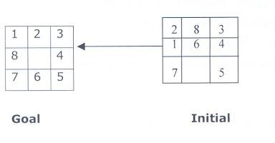

The program is to change the initial configuration into the goal configuration. A solution to the problem is an appropriate sequence of moves, such as “move tiles 5 to the right, move tile 7 to the left, move tile 6 to the down, etc”.

Solution:

To solve a problem using a production system, we must specify the global database the rules, and the control strategy. For the 8 puzzle problem that correspond to these three components. These elements are the problem states, moves and goal. In this problem each tile configuration is a state. The set of all configuration in the space of problem states or the problem space, there are only 3, 62,880 different configurations o the 8 tiles and blank space. Once the problem states have been conceptually identified, we must construct a computer representation, or description of them . this description is then used as the database of a production system. For the 8-puzzle, a straight forward description is a 3X3 array of matrix of numbers. The initial global database is this description of the initial problem state. Virtually any kind of data structure can be used to describe states.

A move transforms one problem state into another state. The 8-puzzle is conveniently interpreted as having the following for moves. Move empty space (blank) to the left, move blank up, move blank to the right and move blank down,. These moves are modeled by production rules that operate on the state descriptions in the appropriate manner.

The rules each have preconditions that must be satisfied by a state description in order for them to be applicable to that state description. Thus the precondition for the rule associated with “move blank up” is derived from the requirement that the blank space must not already be in the top row.

The problem goal condition forms the basis for the termination condition of the production system. The control strategy repeatedly applies rules to state descriptions until a description of a goal state is produced. It also keeps track of rules that have been applied so that it can compose them into sequence representing the problem solution. A solution to the 8-puzzle problem is given in the following figure.

Example:- Depth – First – Search traversal and Breadth - First - Search traversal

for 8 – puzzle problem is shown in following diagrams.

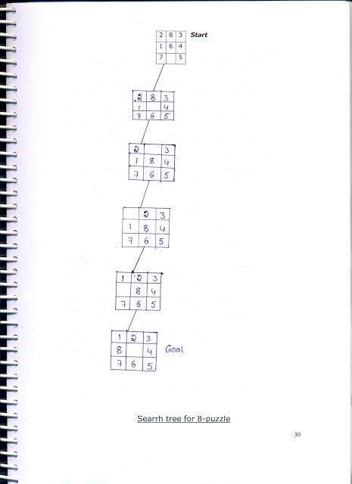
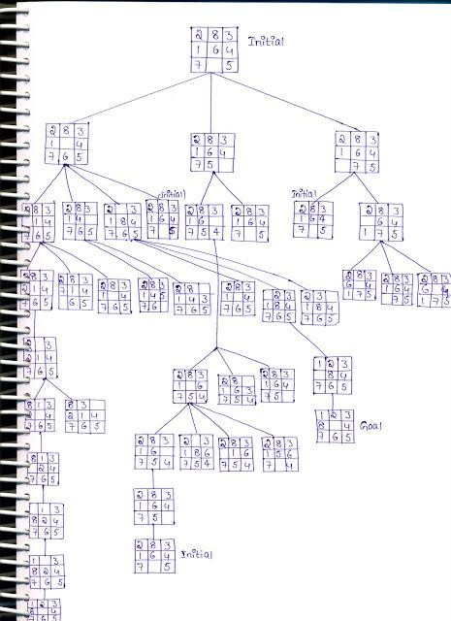

Exhaustive Searches, BFS and DFS

Search is the systematic examination of states to find path from the start/root state to the goal state.

Many traditional search algorithms are used in AI applications. For complex problems, the traditional algorithms are unable to find the solution within some practical time and space limits. Consequently, many special techniques are developed; using heuristic functions. The algorithms that use heuristic

functions are called heuristic algorithms. Heuristic algorithms are not really intelligent; they appear to be intelligent because they achieve better performance.
Heuristic algorithms aremore efficient because they take advantage of feedback from the data to direct the search path.

Uninformed search

Also called blind, exhaustive or brute-force search, uses no information about the problem to guide the search and therefore may not be very efficient.

Informed Search:

Also called heuristic or intelligent search, uses information about the problem to guide the search, usually guesses the distance to a goal state and therefore efficient, but the search may not be always possible.

Uninformed Search Methods:
Breadth- First -Search:
Consider the state space of a problem that takes the form of a tree. Now, if we search the goal along each breadth of the tree, starting from the root and continuing up to the largest depth, we call it breadth first search.

Algorithm:
- Create a variable called NODE-LIST and set it to initial state
- Until a goal state is found or NODE-LIST is empty do
  - Remove the first element from NODE-LIST and call it E. If NODE-LIST was empty, quit
  - For each way that each rule can match the state described in E do:
    - Apply the rule to generate a new state
    - If the new state is a goal state, quit and return this state
    - Otherwise, add the new state to the end of NODE-LIST

BFS illustrated:

Step 1: Initially fringe contains only one node corresponding to the source state A.

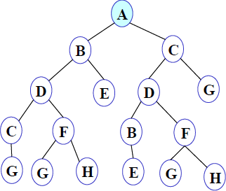

Figure 1
FRINGE: A

Step 2: A is removed from fringe. The node is expanded, and its children B and C are generated. They are placed at the back of fringe.
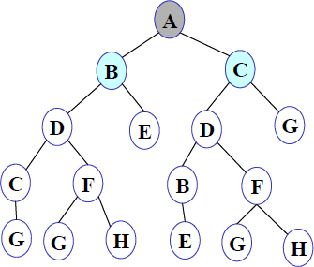

Figure 2
FRINGE: B C

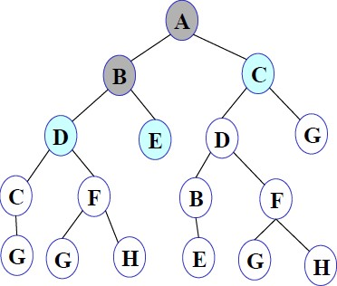
Step 3: Node B is removed from fringe and is expanded. Its children D, E are generated and put at the back of fringe.

Figure 3
FRINGE: C D E

Step 4: Node C is removed from fringe and is expanded. Its children D and G are added to the back of fringe.

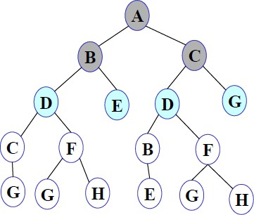

Figure 4
FRINGE: D E D G

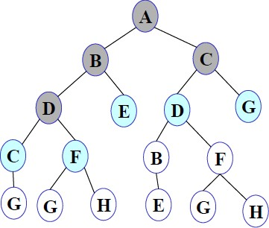
Step 5: Node D is removed from fringe. Its children C and F are generated and added to the back of fringe.

Figure 5
FRINGE: E D G C F

Step 6: Node E is removed from fringe. It has no children.
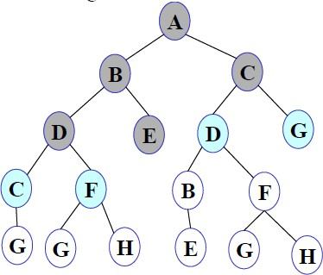

Figure 6
FRINGE: D G C F

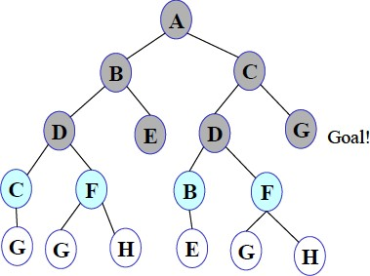
Step 7: D is expanded; B and F are put in OPEN.

Figure 7
FRINGE: G C F B F

Step 8: G is selected for expansion. It is found to be a goal node. So the algorithm returns the path A C G by following the parent pointers of the node corresponding to G. The algorithm terminates.

Breadth first search is:

  - One of the simplest search strategies
  - Complete. If there is a solution, BFS is guaranteed to find it.
  - If there are multiple solutions, then a minimal solution will be found
  - The algorithm is optimal (i.e., admissible) if all operators have the same cost. Otherwise, breadth first search finds a solution with the shortest path length.
  - Time complexity : O(b^{d} )
  - Space complexity : O(b^{d} )
  - Optimality :Yes

b - branching factor(maximum no of successors of any node), d – Depth of the shallowest goal node
Maximum length of any path (m) in search space
Advantages: Finds the path of minimal length to the goal.

Disadvantages:
- Requires the generation and storage of a tree whose size is exponential the depth of the shallowest goal node.
- The breadth first search algorithm cannot be effectively used unless the search space is quite small.

Depth- First- Search.
We may sometimes search the goal along the largest depth of the tree, and move up only when further traversal along the depth is not possible. We then attempt to find alternative offspring of the parent of the node (state) last visited. If we visit the nodes of a tree using the above principles to search the goal, the traversal made is called depth first traversal and consequently the search strategy is called depth first search.

Algorithm:
- Create a variable called NODE-LIST and set it to initial state

- Until a goal state is found or NODE-LIST is empty do
  - Remove the first element from NODE-LIST and call it E. If NODE-LIST was empty, quit
  - For each way that each rule can match the state described in E do:
    - Apply the rule to generate a new state
    - If the new state is a goal state, quit and return this state
    - Otherwise, add the new state in front of NODE-LIST

DFS illustrated:
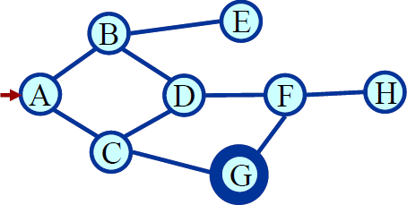
A State Space Graph Step 1: Initially fringe contains only the node for A.
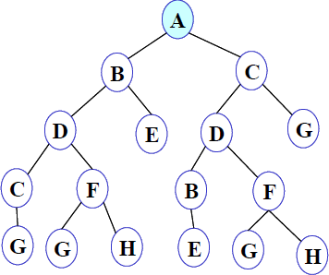

Figure 1
FRINGE: A

Step 2: A is removed from fringe. A is expanded and its children B and C are put in front of fringe.
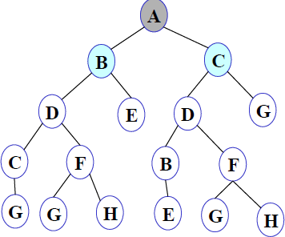

Figure 2
FRINGE: B C

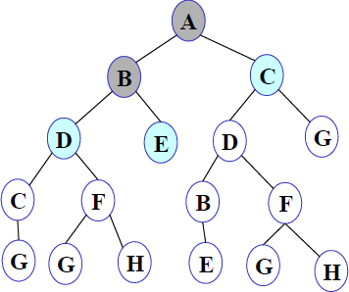
Step 3: Node B is removed from fringe, and its children D and E are pushed in front of fringe.

Figure 3
FRINGE: D E C

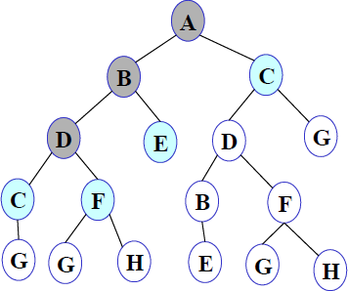
Step 4: Node D is removed from fringe. C and F are pushed in front of fringe.

Figure 4
FRINGE: C F E C

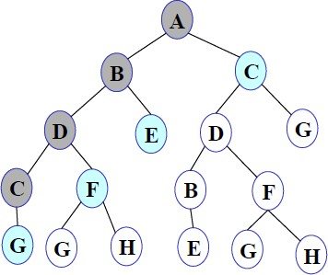
Step 5: Node C is removed from fringe. Its child G is pushed in front of fringe.

Figure 5
FRINGE: G F E C
Step 6: Node G is expanded and found to be a goal node.

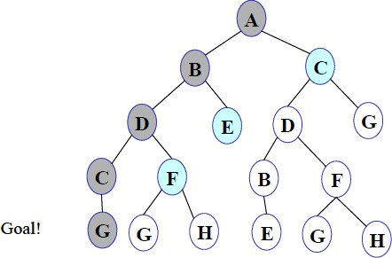

Figure 6
FRINGE: G F E C

The solution path A-B-D-C-G is returned and the algorithm terminates.

Depth first searchis:

- The algorithm takes exponential time.
- If N is the maximum depth of a node in the search space, in the worst case the algorithm will
d
take time O(b ).
- The space taken is linear in the depth of the search tree, O(bN).

Note that the time taken by the algorithm is related to the maximum depth of the search tree. If the search tree has infinite depth, the algorithm may not terminate. This can happen if the search space is infinite. It can also happen if the search space contains cycles. The latter case can be handled by checking for cycles in the algorithm. Thus Depth First Search is not complete.

Exhaustive searches- Iterative Deeping DFS

Description:

- It is a search strategy resulting when you combine BFS and DFS, thus combining the advantages of each strategy, taking the completeness and optimality of BFS and the modest memory requirements of DFS.
- IDS works by looking for the best search depth d, thus starting with depth limit 0 and make a BFS and if the search failed it increase the depth limit by 1 and try a BFS again with depth 1 and so on – first d = 0, then 1 then 2 and so on – until a depth d is reached where a goal is found.

Algorithm:

procedure IDDFS(root)
for depth from 0 to ∞
found ← DLS(root, depth)
if found ≠ null
return found

procedure DLS(node, depth) if depth = 0 and node is a goal return node
else if depth > 0
foreach child of node
found ← DLS(child, depth−1)
if found ≠ null return found return null

Performance Measure:
- Completeness: IDS is like BFS, is complete when the branching factor b is finite.

- Optimality: IDS is also like BFS optimal when the steps are of the same cost.

- Time Complexity:

  - One may find that it is wasteful to generate nodes multiple times, but actually it is not that costly compared to BFS, that is because most of the generated nodes are always in the deepest level reached, consider that we are searching a binary tree and our depth limit reached 4, the nodes generated in last level = 2⁴ = 16, the nodes generated in all nodes before last level = 2⁰ + 2¹ + 2² + 2³= 15
  - Imagine this scenario, we are performing IDS and the depth limit reached depth d, now if you remember the way IDS expands nodes, you can see that nodes at depth d are generated once, nodes at depth d-1 are generated 2 times, nodes at depth d-2 are generated 3 times and so on, until you reach depth 1 which is generated d times, we can view the total number of generated nodes in the worst case as:
    - N(IDS) = (b)d + (d – 1)b²+ (d – 2)b³ + …. + (2)b^{d-1} + (1)b^{d} = O(b^{d})

  - If this search were to be done with BFS, the total number of generated nodes in the worst case will be like:
    - N(BFS) = b + b² + b³ + b⁴ + …. b^{d} + (b^{d+} ¹ – b) = O(b^{d} ⁺ ¹)
  - If we consider a realistic numbers, and use b = 10 and d = 5, then number of generated nodes in BFS and IDS will be like
    - N(IDS) = 50 + 400 + 3000 + 20000 + 100000 = 123450
    - N(BFS) = 10 + 100 + 1000 + 10000 + 100000 + 999990 = 1111100
    - BFS generates like 9 time nodes to those generated with IDS.
- Space Complexity:

  - IDS is like DFS in its space complexity, taking O(bd) of memory.

Weblinks:

  - https://www.youtube.com/watch?v=7QcoJjSVT38

  - https://mhesham.wordpress.com/tag/iterative-deepening-depth-first-search

Conclusion:

- We can conclude that IDS is a hybrid search strategy between BFS and DFS inheriting their advantages.
- IDS is faster than BFS and DFS.
- It is said that “IDS is the preferred uniformed search method when there is a large search space and the depth of the solution is not known”.

Heuristic Searches:

A Heuristic technique helps in solving problems, even though there is no guarantee that it will never lead in the wrong direction. There are heuristics of every general applicability as well as domain specific. The strategies are general purpose heuristics. In order to use them in a specific domain they are coupler with some domain specific heuristics. There are two major ways in which domain - specific, heuristic information can be incorporated into rule-based search procedure.

A heuristic function is a function that maps from problem state description to measures desirability, usually represented as number weights. The value of a heuristic function at a given node in the search process gives a good estimate of that node being on the desired path to solution.

Greedy Best First Search

Greedy best-first search tries to expand the node that is closest to the goal, on the: grounds that this is likely to lead to a solution quickly. Thus, it evaluates nodes by using just the heuristic function:
f (n) = h (n).

Taking the example of Route-finding problems in Romania, the goal is to reach Bucharest starting from the city Arad. We need to know the straight-line distances to Bucharest from various cities as shown in Figure 8.1. For example, the initial state is In (Arad), and the straight line distance heuristic h_{SLD} (In (Arad)) is found to be 366. Using the straight-line distance heuristic h_{SLD}, the goal state can be reached faster.
Arad 366 Mehadia 241 Hirsova 151
Bucharest 0 Neamt 234 Urziceni 80
Craiova 160 Oradea 380 Iasi 226
Drobeta 242 Pitesti 100 Vaslui 199
Eforie 161 Rimnicu Vilcea 193 Lugoj 244
Fagaras 176 Sibiu 253 Zerind 374
Giurgiu 77 Timisoara 329
Figure 8.1: Values of h_{SLD}-straight-line distances to B u c h a r e s t.
The Initial State

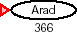

After Expanding Arad

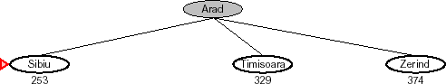

After Expanding Sibiu

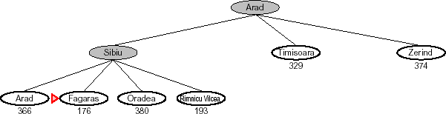
After Expanding Fagaras

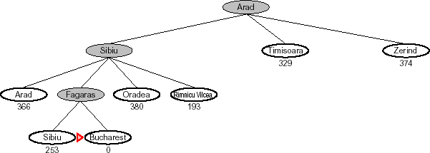

Figure 8.2: Stages in a greedy best-first search for Bucharest using the straight-line distance heuristic
h_{SLD}. Nodes are labeled with their h-values.

Figure 8.2 shows the progress of greedy best-first search using h_{SLD} to find a path from Arad to Bucharest. The first node to be expanded from Arad will be Sibiu, because it is closer to Bucharest than either Zerind or Timisoara. The next node to be expanded will be Fagaras, because it is closest.
Fagaras in turn generates Bucharest, which is the goal.

Evaluation Criterion of Greedy Search

- Complete: NO [can get stuck in loops, e.g., Complete in finite space with repeated- state checking ]

Time Complexity: O (bm) [but a good heuristic can give dramatic improvement]
- Space Complexity: O (bm) [keeps all nodes in memory]

Optimal: NO

Greedy best-first search is not optimal, and it is incomplete. The worst-case time and space complexity is O (b^{m}), where m is the maximum depth of the search space.

HILL CLIMBING PROCEDURE:

Hill Climbing Algorithm

We will assume we are trying to maximize a function. That is, we are trying to find a point in the search space that is better than all the others. And by "better" we mean that the evaluation is higher. We might also say that the solution is of better quality than all the others.
The idea behind hill climbing is as follows.

- Pick a random point in the search space.
- Consider all the neighbors of the current state.
- Choose the neighbor with the best quality and move to that state.
- Repeat 2 thru 4 until all the neighboring states are of lower quality.
- Return the current state as the solution state.
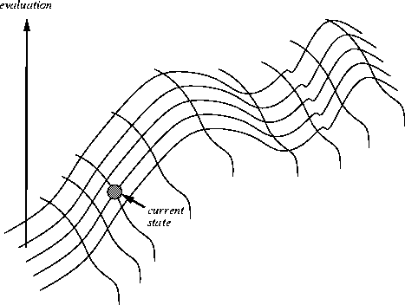We can also present this algorithm as follows (it is taken from the AIMA book (Russell, 1995) and follows the conventions we have been using on this course when looking at blind and heuristic searches).

Algorithm:
Function HILL-CLIMBING(Problem) returns a solution state Inputs: Problem, problem
Local variables: Current, a node
Next, a node
Current = MAKE-NODE(INITIAL-STATE[Problem])

Loop do
Next = a highest-valued successor of Current
If VALUE[Next] < VALUE[Current] then returnCurrent Current = Next

End

Also, if two neighbors have the same evaluation and they are both the best quality, then the algorithm will choose between them at random.

Problems with Hill Climbing

The main problem with hill climbing (which is also sometimes called gradient descent) is that we are not guaranteed to find the best solution. In fact, we are not offered any guarantees about the solution. It could be abysmally bad.
You can see that we will eventually reach a state that has no better neighbours but there are better solutions elsewhere in the search space. The problem we have just described is called a local maxima.

Simulated annealing search
A hill-climbing algorithm that never makes “downhill” moves towards states with lower value (or higher cost) is guaranteed to be incomplete, because it can stuck on a local maximum. In contrast, a purely random walk –that is, moving to a successor chosen uniformly at random from the set of successors – is complete, but extremely inefficient. Simulated annealing is an algorithm that combines hill-climbing with a random walk in some way that yields both efficiency and completeness.
Figure 10.7 shows simulated annealing algorithm. It is quite similar to hill climbing. Instead of picking the best move, however, it picks the random move. If the move improves the situation, it is always accepted. Otherwise, the algorithm accepts the move with some probability less than 1. The probability decreases exponentially with the “badness” of the move – the amount E by which the evaluation is

worsened. The probability also decreases as the "temperature" T goes down: "bad moves are more likely to be allowed at the start when temperature is high, and they become more unlikely as T decreases. One can prove that if the schedule lowers T slowly enough, the algorithm will find a global optimum with probability approaching 1.
Simulated annealing was first used extensively to solve VLSI layout problems. It has been applied widely to factory scheduling and other large-scale optimization tasks.
function S I M U L A T E D - A N NEALING( problem, schedule) returns a solution state inputs: problem, a problem
schedule, a mapping from time to "temperature"
local variables: current, a node
next, a node
T, a "temperature" controlling the probability of downward steps
current ←MAKE-NODE(INITIAL-STATE[problem]) for t←l to ∞ do
T ←schedule[t]
if T = 0 then return current
next ←a randomly selected successor of current
E←VALUE[next] – VALUE[current]
if E> 0 then current ← next
else current ← next only with probability e^{E} ^{/T}

LOCAL SEARCH IN CONTINUOUS SPACES

- We have considered algorithms that work only in discrete environments, but real-world environment are continuous.
- Local search amounts to maximizing a continuous objective function in a multi-dimensional vector space.
- This is hard to do in general.
- Can immediately retreat
  - Discretize the space near each state
  - Apply a discrete local search strategy (e.g., stochastic hill climbing, simulated annealing)

- Often resists a closed-form solution
  - Fake up an empirical gradient
  - Amounts to greedy hill climbing in discretized state space
- Can employ Newton-Raphson Method to find maxima.
- Continuous problems have similar problems: plateaus, ridges, local maxima, etc.

Best First Search:

  - A combination of depth first and breadth first searches.
  - Depth first is good because a solution can be found without computing all nodes and breadth first is good because it does not get trapped in dead ends.
  - The best first search allows us to switch between paths thus gaining the benefit of both approaches. At each step the most promising node is chosen. If one of the nodes chosen generates nodes that are less promising it is possible to choose another at the same level and in effect the search changes from depth to breadth. If on analysis these are no better than this previously unexpanded node and branch is not forgotten and the search method reverts to the

OPEN is a priorityqueue of nodes that have been evaluated by the heuristic function but which have not yet been expanded into successors. The most promising nodes are at the front.

CLOSED are nodes that have already been generated and these nodes must be stored because a graph is being used in preference to a tree.

Algorithm:

- Start with OPEN holding the initial state
- Until a goal is found or there are no nodes left on open do.

  - Pick the best node on OPEN
  - Generate its successors
  - For each successor Do
    - If it has not been generated before ,evaluate it ,add it to OPEN and record its parent

    - If it has been generated before change the parent if this new path is better and in that case update the cost of getting to any successor nodes.

- If a goal is found or no more nodes left in OPEN, quit, else return to 2.

Example:
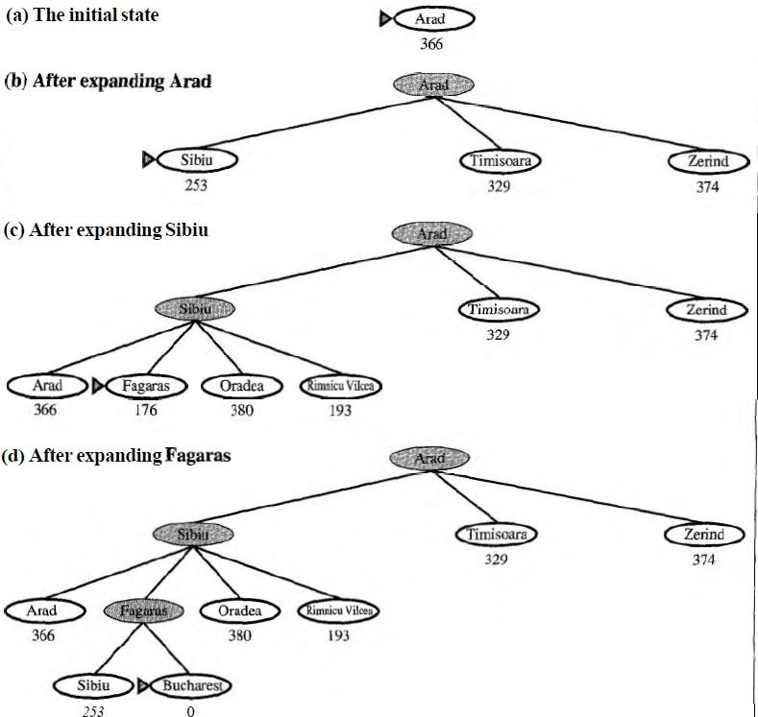

- It is not optimal.
- It is incomplete because it can start down an infinite path and never return to try other possibilities.

- The worst-case time complexity for greedy search is O (b^{m}), where m is the maximum depth of the search space.
- Because greedy search retains all nodes in memory, its space complexity is the same as its time complexity

A* Algorithm

The Best First algorithm is a simplified form of the A* algorithm.

The A* search algorithm (pronounced "Ay-star") is a tree search algorithm that finds a path from a given initial node to a given goal node (or one passing a given goal test). It employs a "heuristic estimate" which ranks each node by an estimate of the best route that goes through that node. It visits the nodes in order of this heuristic estimate.
Similar to greedy best-first search but is more accurate because A* takes into account the nodes that have already been traversed.

From A* we note that f = g + h where

g is a measure of the distance/cost to go from the initial node to the current node

his an estimate of the distance/cost to solution from the current node.

Thus fis an estimate of how long it takes to go from the initial node to the solution

Algorithm:

- Initialize : Set OPEN = (S); CLOSED = ( ) g(s)= 0, f(s)=h(s)

Fail : If OPEN = ( ), Terminate and fail.

- Select : select the minimum cost state, n, from OPEN,

save n in CLOSED

- Terminate : If n €G, Terminate with success and return f(n)

Expand : for each successor, m, of n

  - If m € *OPEN U CLOSED+ Set g(m) = g(n) + c(n , m) Set f(m) = g(m) + h(m)

Insert m in OPEN

  - If m € *OPEN U CLOSED+

Set g(m) = min { g(m) , g(n) + c(n , m)} Set f(m) = g(m) + h(m)
If f(m) has decreased and m € CLOSED Move m to OPEN.

Description:

- A* begins at a selected node. Applied to this node is the "cost" of entering this node (usually zero for the initial node). A* then estimates the distance to the goal node from the current node. This estimate and the cost added together are the heuristic which is assigned to the path leading to this node. The node is then added to a priority queue, often called "open".
- The algorithm then removes the next node from the priority queue (because of the way a priority queue works, the node removed will have the lowest heuristic). If the queue is empty, there is no path from the initial node to the goal node and the algorithm stops. If the node is the goal node, A* constructs and outputs the successful path and stops.
- If the node is not the goal node, new nodes are created for all admissible adjoining nodes; the exact way of doing this depends on the problem at hand. For each successive node, A* calculates the "cost" of entering the node and saves it with the node. This cost is calculated from the cumulative sum of costs stored with its ancestors, plus the cost of the operation which reached this new node.
- The algorithm also maintains a 'closed' list of nodes whose adjoining nodes have been checked. If a newly generated node is already in this list with an equal or lower cost, no further processing is done on that node or with the path associated with it. If a node in the closed list matches the new one, but has been stored with a higher cost, it is removed from the closed list, and processing continues on the new node.

- Next, an estimate of the new node's distance to the goal is added to the cost to form the heuristic for that node. This is then added to the 'open' priority queue, unless an identical node is found there.
- Once the above three steps have been repeated for each new adjoining node, the original node taken from the priority queue is added to the 'closed' list. The next node is then popped from the priority queue and the process is repeatedThe heuristic costs from each city to Bucharest:
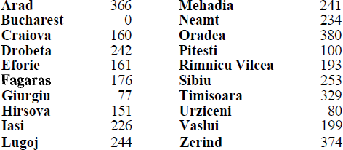

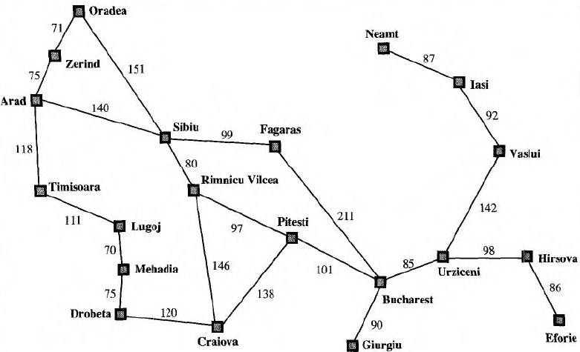

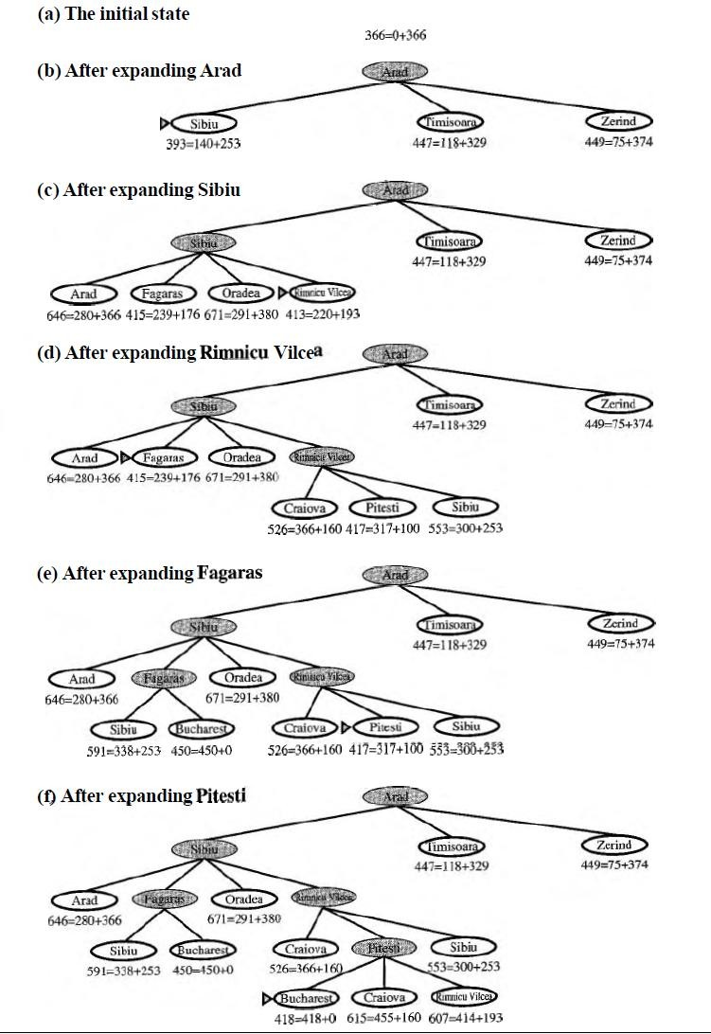

A* search properties:

- The algorithm A* is admissible. This means that provided a solution exists, the first solution found by A* is an optimal solution. A* is admissible under the following conditions:

- Heuristic function: for every node n , h(n) ≤ h*(n) .

  - A* is also complete.

- A* is optimally efficient for a given heuristic.

- A* is much more efficient that uninformed search.

Iterative Deeping A* Algorithm: Algorithm:
Let L be the list of visited but not expanded node, and C the maximum depth
- Let C=0
- Initialize Lto the initial state (only)
- If List empty increase C and goto 2), else
extract a node n from the front of L
- If n is a goal node,
SUCCEED and return the path from the initial state to n
- Remove n from L. If the level is smaller than C, insert at the front of L all the children n' of n with f(n') ≤ C
- Goto 3)
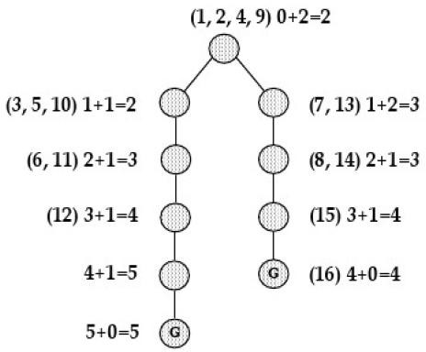

- IDA* is complete & optimal Space usage is linear in the depth of solution. Each iteration is depth first search, and thus it does not require a priority queue.
- Iterative deepening A* (IDA*) eliminates the memory constraints of A* search algorithm without sacrificing solution optimality.

- Each iteration of the algorithm is a depth-first search that keeps track of the cost, f(n) = g(n) + h(n), of each node generated.
- As soon as a node is generated whose cost exceeds a threshold for that iteration, its path is cut off, and the search backtracks before continuing.

- The cost threshold is initialized to the heuristic estimate of the initial state, and in each successive iteration is increased to the total cost of the lowest-cost node that was pruned during the previous iteration.
- The algorithm terminates when a goal state is reached whose total cost dees not exceed the current threshold.

UNIT II
Problem Solving by Search-II and Propositional Logic .Adversarial Search: Games, Optimal Decisions in Games, Alpha–Beta Pruning, Imperfect Real-Time Decisions.
Constraint Satisfaction Problems: Defining Constraint Satisfaction Problems, Constraint Propagation, Backtracking Search for CSPs, Local Search for CSPs, The Structure of Problems.
Propositional Logic: Knowledge-Based Agents, The Wumpus World, Logic, Propositional Logic, Propositional Theorem Proving: Inference and proofs, Proof by resolution, Horn clauses and definite clauses, Forward and backward chaining, Effective Propositional Model Checking, Agents Based on Propositional Logic.

Constraint Satisfaction Problems
https://www.cnblogs.com/RDaneelOlivaw/p/8072603.html

Sometimes a problem is not embedded in a long set of action sequences but requires picking the best option from available choices. A good general-purpose problem solving technique is to list the constraints of a situation (either negative constraints, like limitations, or positive elements that you want in the final solution). Then pick the choice that satisfies most of the constraints.
Formally speaking, a constraint satisfaction problem (or CSP) is defined by a set of variables, X1;X2; : : :
;Xn, and a set of constraints, C1;C2; : : : ;Cm. Each variable Xi has anonempty domain Di of possible values. Each constraint Ci involves some subset of tvariables and specifies the allowable combinations of values for that subset. A state of theproblem is defined by an assignment of values to some or all of the variables, {Xi = vi;Xj =vj ; : : :} An assignment that does not violate any constraints is called a consistent or

legalassignment. A complete assignment is one in which every variable is mentioned, and a solution to a CSP is a complete assignment that satisfies all the constraints. Some CSPs also require a solution that maximizes an objectivefunction.
CSP can be given an incremental formulation as a standard search problem as follows:

- Initial state: the empty assignment fg, in which all variables are unassigned.

- Successor function: a value can be assigned to any unassigned variable, provided that it does not conflict with previously assigned variables.
- Goal test: the current assignment is complete.

- Path cost: a constant cost for every step

Examples:

  - The best-known category of continuous-domain CSPs is that of linear programming problems, where constraints must be linear inequalities forming a convex region.
  - Crypt arithmetic puzzles.

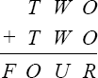

Example: The map coloring problem.

The task of coloring each region red, green or blue in such a way that no neighboring regions have the same color.

We are given the task of coloring each region red, green, or blue in such a way that the neighboring regions must not have the same color.

To formulate this as CSP, we define the variable to be the regions: WA, NT, Q, NSW, V, SA, and
T. The domain of each variable is the set {red, green, blue}. The constraints require

neighboring regions to have distinct colors: for example, the allowable combinations for WA and NT are the pairs {(red,green),(red,blue),(green,red),(green,blue),(blue,red),(blue,green)}. (The constraint can also be represented as the inequality WA ≠ NT). There are many possible solutions, such as {WA = red, NT = green, Q = red, NSW = green, V = red, SA = blue, T = red}.Map of Australia showing each of its states and territories
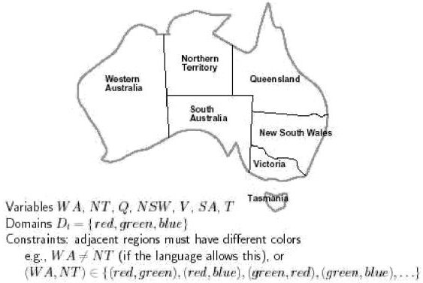

Constraint Graph: A CSP is usually represented as an undirected graph, called constraint graph where the nodes are the variables and the edges are the binaryconstraints.
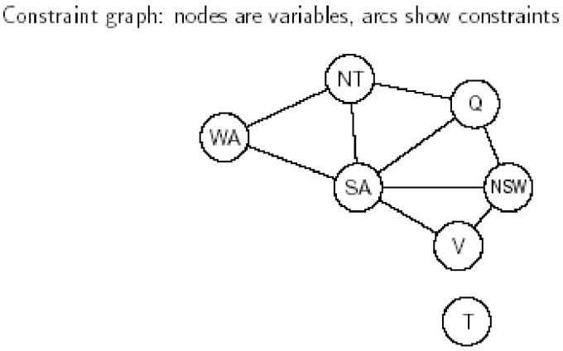

The map-coloring problem represented as a constraint graph. CSP can be viewed as a standard search problem as follows:
- Initial state : the empty assignment {},in which all variables are unassigned.
- Successor function: a value can be assigned to any unassigned variable, provided that it does not conflict with previously assigned variables.
- Goal test: the current assignment is complete.

- Path cost: a constant cost(E.g.,1) for every step.

Game Playing
Adversarial search, or game-tree search, is a technique for analyzing an adversarial game in order to try to determine who can win the game and what moves the players should make in order to win. Adversarial search is one of the oldest topics in Artificial Intelligence. The original ideas for adversarial search were developed by Shannon in 1950 and independently by Turing in 1951, in the context of the game of chess—and their ideas still form the basis for the techniques used today.

Person Games:
  - Players: We call them Max and Min.
  - Initial State: Includes board position and whose turn it is.
  - Operators: These correspond to legal moves.
  - Terminal Test: A test applied to a board position which determines whether the game is over. In chess, for example, this would be a checkmate or stalemate situation.
  - Utility Function: A function which assigns a numeric value to a terminalstate. For example, in chess the outcome is win (+1), lose (-1) or draw (0). Note that by convention, we always measure utility relative to Max.

MiniMax Algorithm:
- Generate the whole game tree.
- Apply the utility function to leaf nodes to get their values.
- Use the utility of nodes at level n to derive the utility of nodes at level n-1.
- Continue backing up values towards the root (one layer at a time).
- Eventually the backed up values reach the top of the tree, at which point Max chooses the move that yields the highest value. This is called the minimax decision because it maximises the utility for Max on the assumption that Min will play perfectly to minimise it.

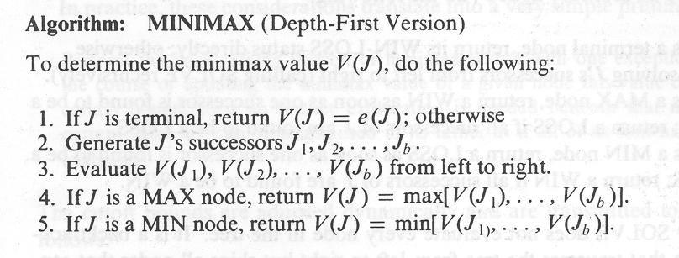
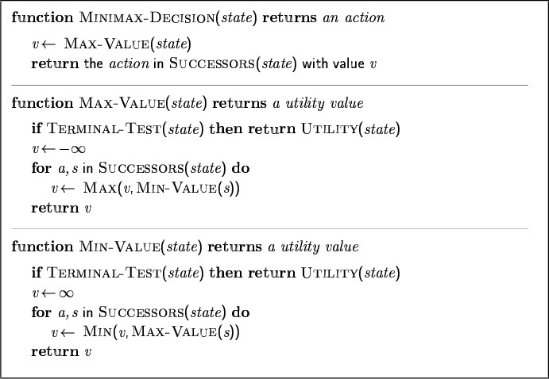

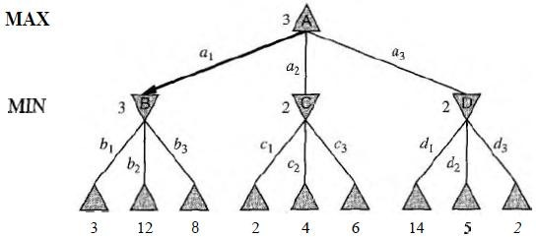
Example:
Properties of minimax:

- Complete : Yes (if tree is finite)
- Optimal : Yes (against an optimal opponent)
- Time complexity : O(b^{m})
- Space complexity : O(bm) (depth-first exploration)
- For chess, b ≈ 35, m ≈100 for "reasonable" games
→ exact solution completely infeasible.

Limitations
  - Not always feasible to traverse entire tree
  - Time limitations

Alpha-beta pruning algorithm:

- Pruning: eliminating a branch of the search tree from consideration without exhaustive examination of each node
- α-β Pruning: the basic idea is to prune portions of the search tree that cannot improve the utility value of the max or min node, by just considering the values of nodes seen so far.
- Alpha-beta pruning is used on top of minimax search to detect paths that do not need to be explored. The intuition is:
- The MAX player is always trying to maximize the score. Call this α.
- The MIN player is always trying to minimize the score. Call this β .
- Alpha cutoff: Given a Max node n, cutoff the search below n (i.e., don't generate or examine any more of n's children) if alpha(n) >= beta(n)
(alpha increases and passes beta from below)
- Beta cutoff.: Given a Min node n, cutoff the search below n (i.e., don't generate or examine any more of n's children) if beta(n) <= alpha(n)
(beta decreases and passes alpha from above)
- Carry alpha and beta values down during search Pruning occurs whenever alpha >= beta

Algorithm:
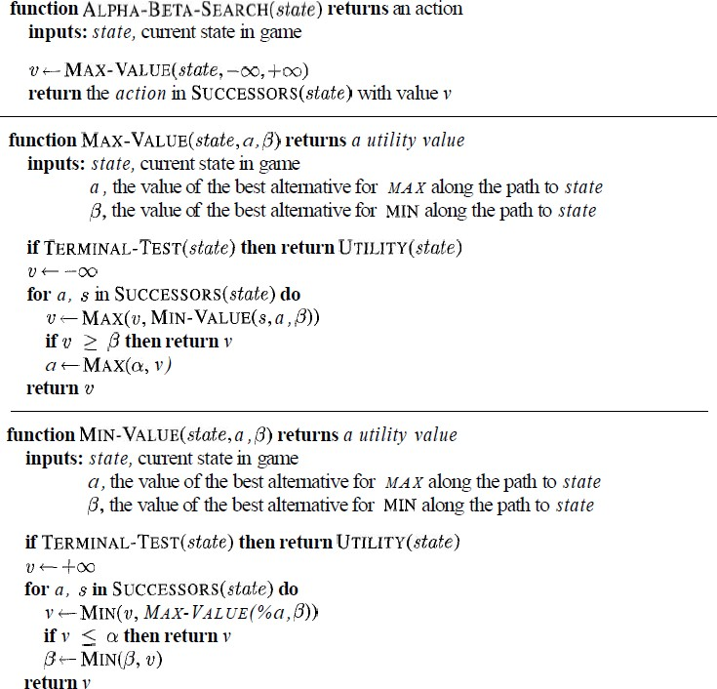

Example:

- Setup phase: Assign to each left-most (or right-most) internal node of the tree, variables: alpha = -infinity, beta = +infinity

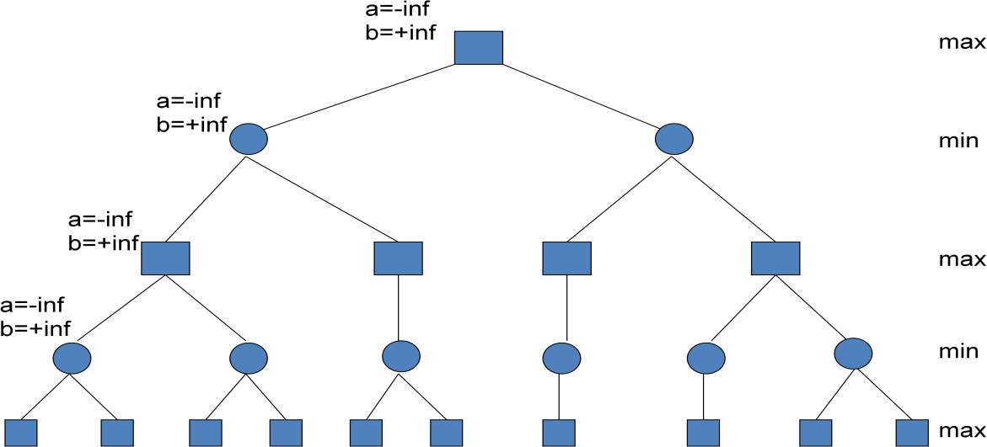

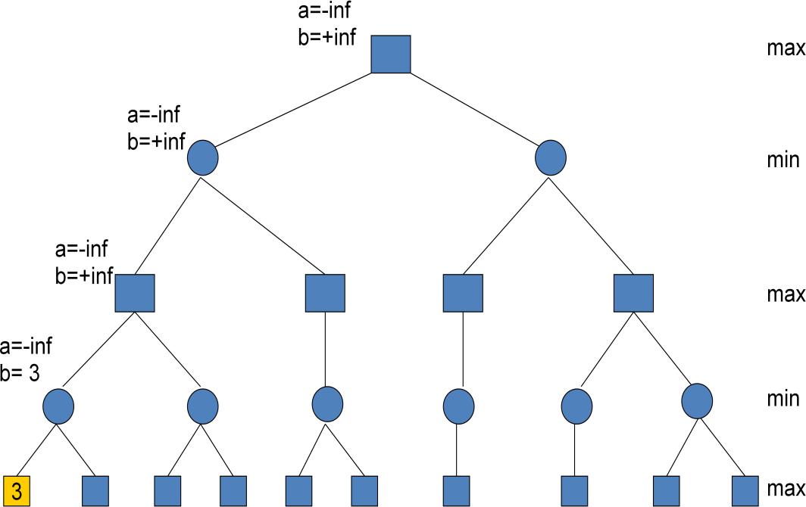
Look at first computed final configuration value. It’s a 3. Parent is a min node, so set the beta (min) value to 3.

- Look at next value, 5. Since parent is a min node, we want the minimum of 3 and 5 which is 3. Parent min node is done – fill alpha (max) value of its parent max node. Always set alpha for max nodes and beta for min nodes. Copy the state of the max parent node into the second unevaluated min child.
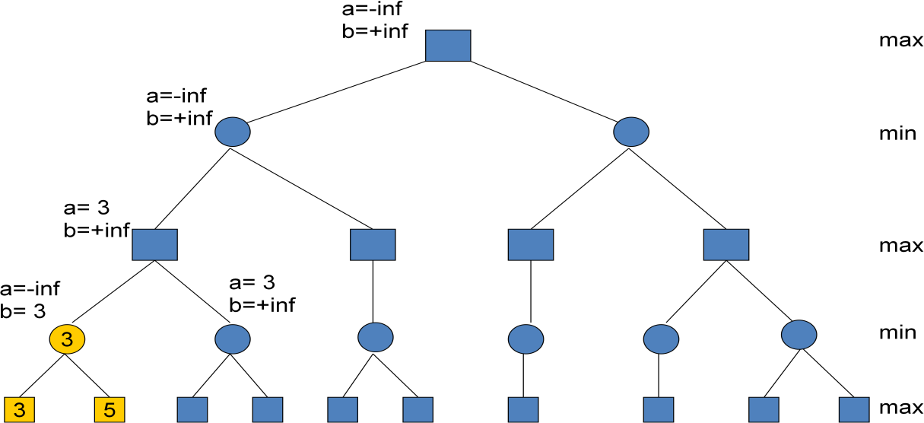

Look at next value, 2. Since parent node is min with b=+inf, 2 is smaller, change b.
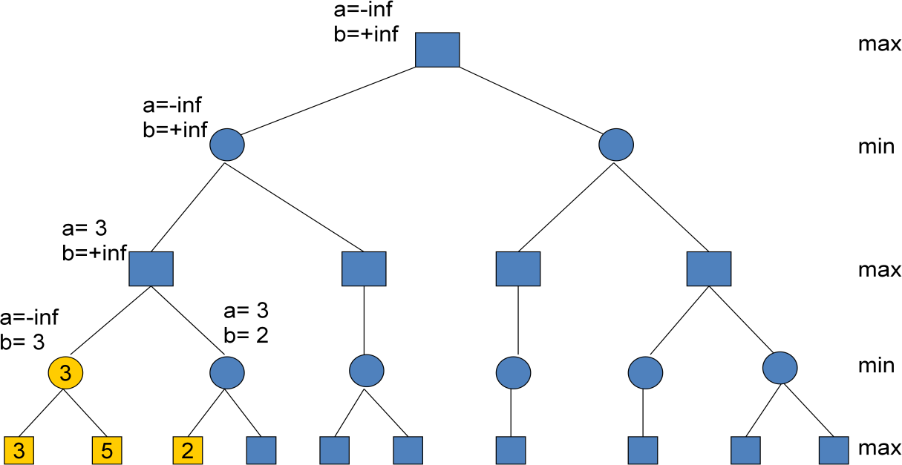

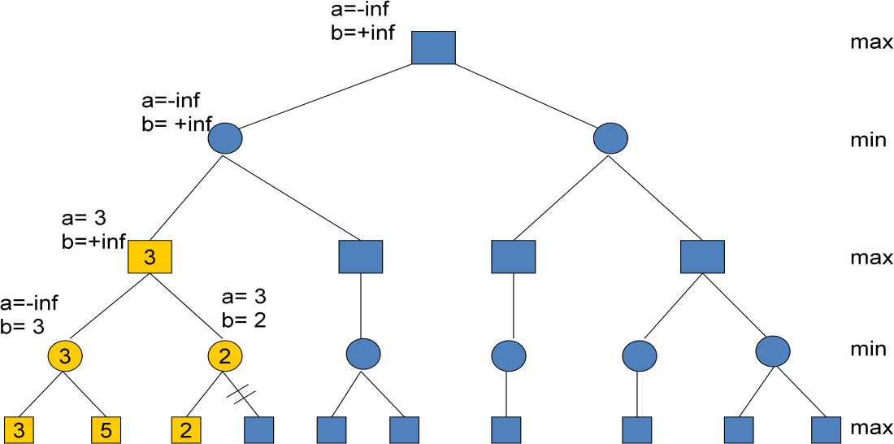
- Now, the min parent node has a max value of 3 and min value of 2. The value of the 2nd child does not matter. If it is >2, 2 will be selected for min node. If it is <2, it will be selected for min node, but since it is <3 it will not get selected for the parent max node. Thus, we prune the right subtree of the min node. Propagate max value up the tree.

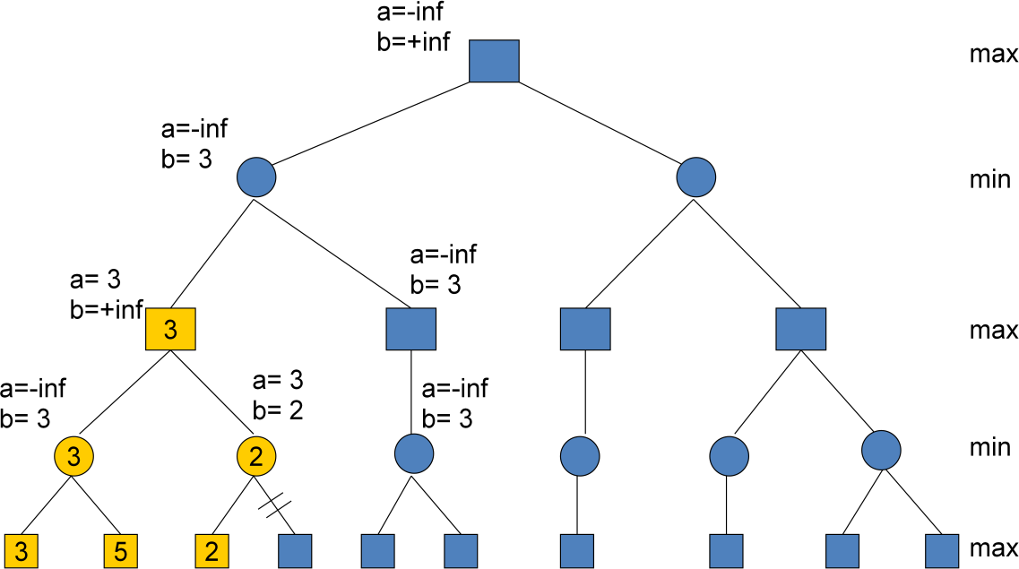
Max node is now done and we can set the beta value of its parent and propagate node state to sibling subtree’s left-most path.

- The next node is 10. 10 is not smaller than 3, so state of parent does not change. We still have to look at the 2nd child since alpha is still –inf.
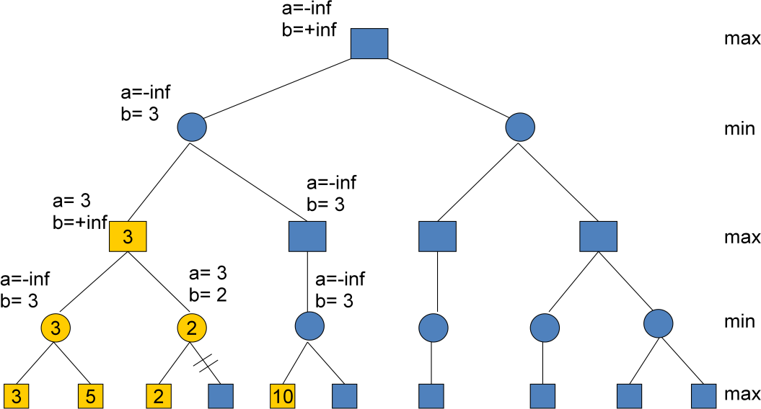

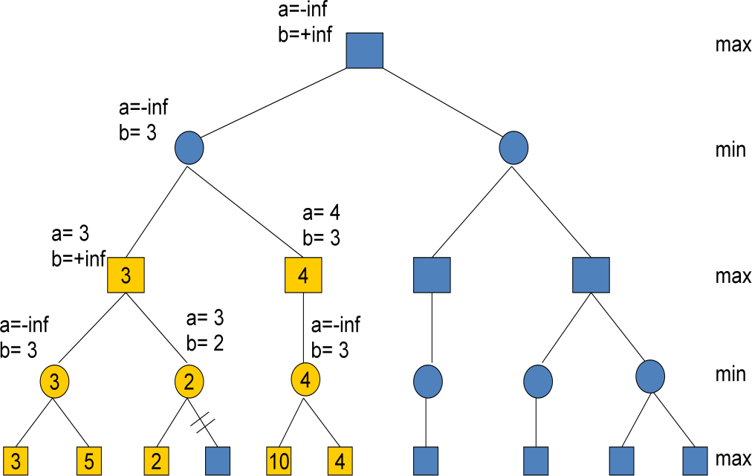
The next node is 4. Smallest value goes to the parent min node. Min subtree is done, so the parent max node gets the alpha (max) value from the child. Note that if the max node had a 2nd subtree, we can prune it since a>b.

- Continue propagating value up the tree, modifying the corresponding alpha/beta values. Also propagate the state of root node down the left-most path of the right subtree.
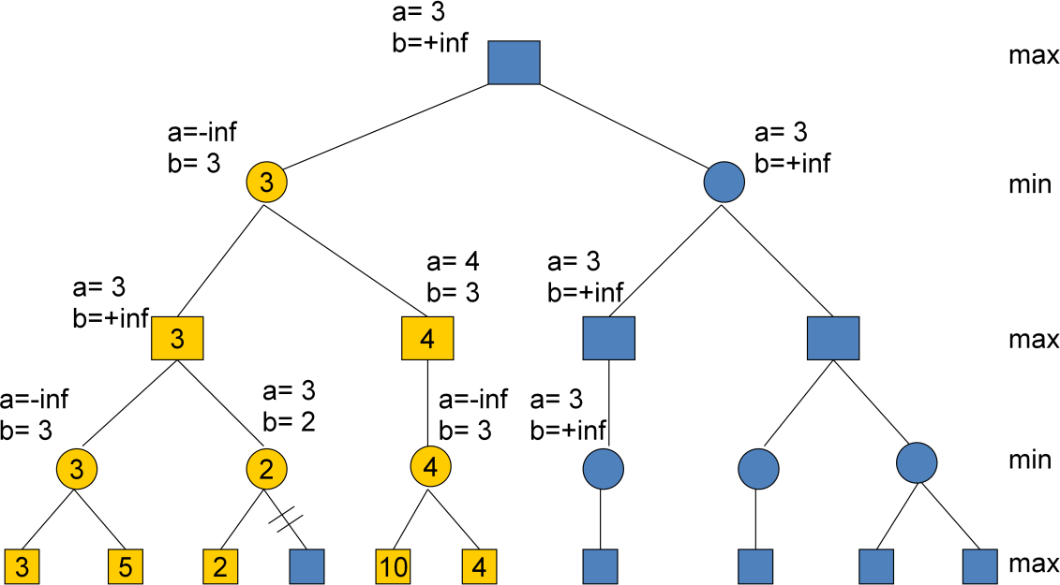

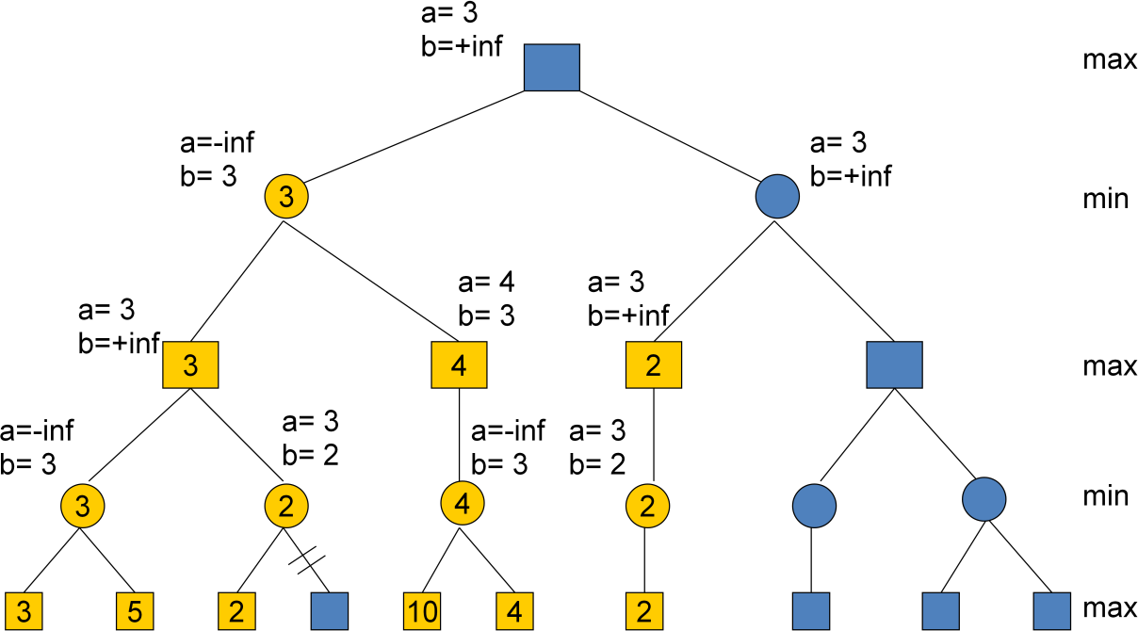
Next value is a 2. We set the beta (min) value of the min parent to 2. Since no other children exist, we propagate the value up the tree.

- We have a value for the 3rd level max node, now we can modify the beta (min) value of the min parent to 2. Now, we have a situation that a>b and thus the value of the rightmost subtree of the min node does not matter, so we prune the whole subtree.
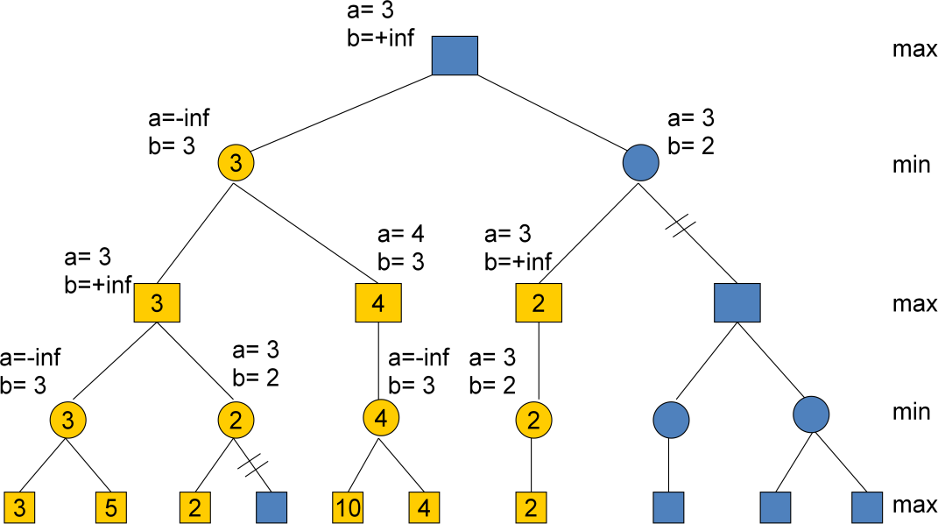

- Finally, no more nodes remain, we propagate values up the tree. The root has a value of 3 that comes from the left-most child. Thus, the player should choose the left-most child’s move in order to maximize his/her winnings. As you can see, the result is the same as with the mini-max example, but we did not visit all nodes of the tree.
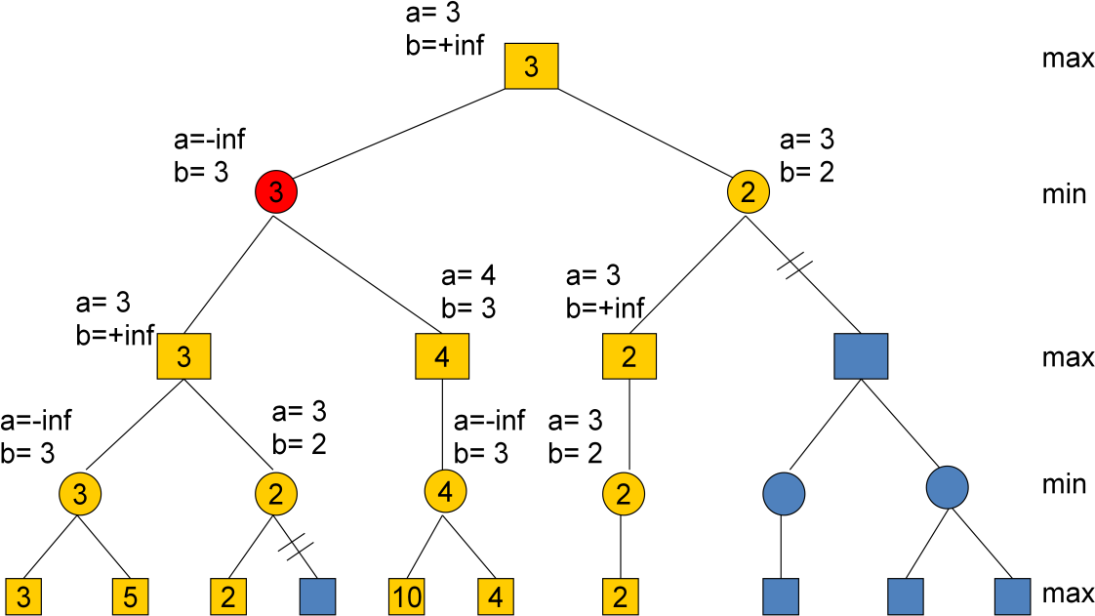

UNIT III

Knowledge Based Agents A knowledge-based agent needs a KB and an inference mechanism. It operates by storing sentences in its knowledge base, inferring new sentences with the inference mechanism, and using them to deduce which actions to take The
interpretation of a sentence is the fact to which it refers.

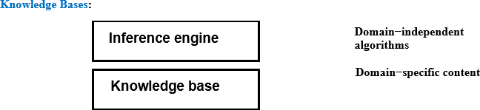

Knowledge base = set of sentences in a formal language Declarative approach to building an agent (or other system): Tell it what it needs toknow - Thenitcan Askitselfwhattodo— answersshouldfollowfromtheKB Agents can be viewed at the knowledge leveli.e., what they know, regardless of howimplemented or at the implementation leveli.e.,data structuresinKBand algorithmsthatmanipulatethem. The Wumpus World:

A variety of "worlds" are being used as examples for Knowledge Representation, Reasoning, and Planning. Among them the Vacuum World, the Block World, and the Wumpus World. The Wumpus World was introduced by Genesereth, and is discussed in Russell-Norvig. The Wumpus World is a simple world (as is the Block World) for which to represent knowledge and to reason. It is a cave with a number of rooms, represented as a 4x4 square

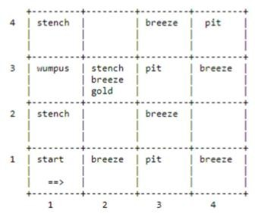

Rules of the Wumpus World The neighborhood of a node consists of the four squares north, south, east, and west of the given square. In a square the agent gets a vector of percepts, with components Stench, Breeze, Glitter, Bump, Scream For example [Stench, None, Glitter, None, None] • Stench is perceived at a square iff the wumpus is at this square or in its neighborhood. • Breeze is perceived at a square iff a pit is in the neighborhood of this square. • Glitter is perceived at a square iff gold is in this square • Bump is perceived at a square iff the agent goes Forward into a wall • Scream is perceived at a square iff the wumpus is killed anywhere in the cave An agent can do the following actions (one at a time): Turn (Right), Turn (Left), Forward, Shoot, Grab, Release, Climb • The agent can go forward in the direction it is currently facing, or Turn Right, or Turn Left. Going forward into a wall will generate a Bump percept. • The agent has a single arrow that it can shoot. It will go straight in the direction faced by the agent until it hits (and kills) the wumpus, or hits (and is absorbed by) a wall. • The agent can grab a portable object at the current square or it can Release an object that it is holding. • The agent can climb out of the cave if at the Start square.The Start square is (1,1) and initially the agent is facing east. The agent dies if it is in the same square asthe wumpus. The objective of the game is to kill the wumpus, to pick up the gold, and to climb out with it. Representing our Knowledge about the Wumpus World Percept(x, y) Where x must be a percept vector and y must be a situation. It means that at situation y theagentperceives x.For convenience we introduce the following definitions: •

Percept([Stench,y,z,w,v],t) = > Stench(t) • Percept([x,Breeze,z,w,v],t) = > Breeze(t) • Percept([x,y,Glitter,w,v],t) = > AtGold(t) Holding(x, y)
Where x is an object and y is a situation. It means that the agent is holding the object x in situation y. Action(x, y) Where x must be an action (i.e. Turn (Right), Turn (Left), Forward,) and y must be a situation. It means that at situation y the agent takes action x. At(x,y,z) Where x is an object, y is a Location, i.e. a pair [u,v] with u and v in {1, 2, 3, 4}, and z is a situation. It means that the agent x in situation z is at location y. Present(x,s) Means that object x is in the current room in the situation s. Result(x, y) It means that the result of applying action x to the situation y is the situation Result(x,y).Notethat Result(x,y) is a term, not a statement. For example we can say • Result(Forward, S0) = S1 • Result(Turn(Right),S1) = S2 These definitions could be made more general. Since in the Wumpus World there is a single agent, there is no reason for us to make predicates and functions relative to a specific agent. In other"worlds" we should change things appropriately.
Validity And Satisfiability A sentence is valid
if it is true in all models, e.g.,True,A∨¬A, A⇒A,(A𝖠(A⇒B)) ⇒B Validity is connected to inference via the Deduction Theorem: KB |= αif and onlyif(KB⇒α) isvalid Asentenceissatisfiableifitistrue insome model e.g., A∨B, C Asentence isunsatisfiableifitistrueinnomodels e.g., A 𝖠¬A Satisfiability is connected to inference via the following: KB|=α iff(KB𝖠¬α)isunsatisfiable i.e., prove α by reductionandabsurdum
Proof Methods

Proof methods divide into (roughly)two kinds:

Application of inference rules – Legitimate(sound)generationofnewsentencesfromold – Proof=asequenceofinferenceruleapplicationscanuseinferencerulesasoperatorsinastand
ardsearch | algorithm | – Typicallyrequiretranslationofsentencesintoanormalform | Model
checking | – | Truthtableenumeration(alwaysexponentialinn) | –

Improvedbacktracking,e.g.,Davis–Putnam–Loge Mann–Loveland – Heuristic searchinmodelspace(soundbutincomplete) e.g.,min-conflicts-likehillclimbingalgorithms
Forward and Backward Chaining

Horn Form (restricted) KB = conjunction of Horn clauses Horn clause = – proposition symbol;or – (conjunctionofsymbols) ⇒ symbol Example KB: C𝖠(B ⇒ A) 𝖠 (C𝖠D ⇒ B)
Modus Ponens (for Horn Form): complete for Horn KBs α1,...,αn,α1𝖠···𝖠α⇒ β β
Canbeusedwithforwardchaining orbackwardchaining. These algorithms areverynaturalandruninlineartime.,
ForwardChaining
Idea: If anyrulewhosepremisesaresatisfiedintheKB, additsconclusiontotheKB,untilqueryisfound
ForwardChaining Algorithm
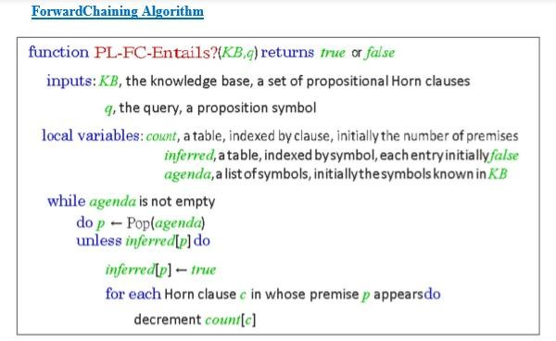

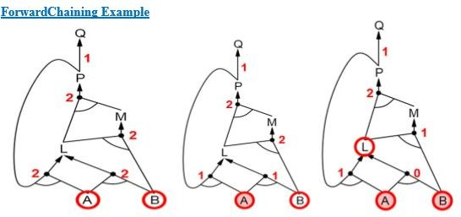

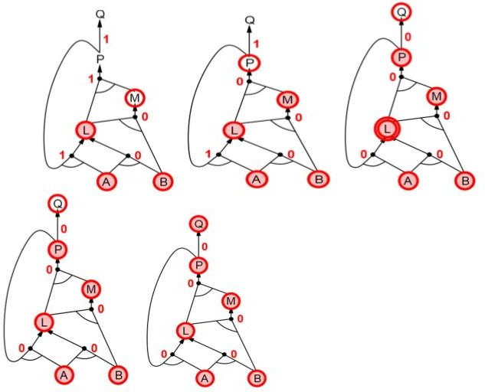

Proof of Completeness

FC derives every atomic sentence that is entailed by KB

  - FCreachesafixedpointwherenonewatomicsentencesarederived

  - Considerthefinalstateasamodelm,assigningtrue/falsetosymbols

  - Every clause in the original KB is true inm i. Proof:Supposeaclausea1𝖠...𝖠ak⇒bisfalsei

nm | Then a1𝖠. | . . 𝖠akis | true | in | m | and | b | is | false in m
Thereforethealgorithmhasnotreachedafixedpoint ! |  |  |  |  | 4. Hence |  | m is a |  | model ofKB 5.
IfKB|=q,thenqistrueineverymodelofKB,includingm |  |  |  |  |  |  | a. |  | Generalidea:
constructanymodelofKBby soundinference,checkα

Backward Chaining

Idea:workbackwardsfromthequeryq: to prove q byBC, check if q is known already, or prove by BC all premises of some rule concluding q Avoidloops: checkifnewsubgoalisalreadyonthegoalstack Avoid repeated work: check if new subgoal 1. has already been proved true, or 2. has alreadyfailed

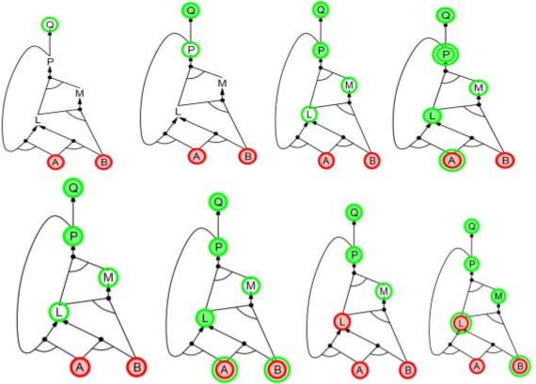
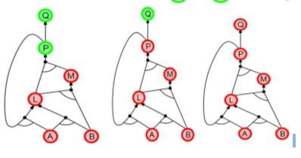

Forward vs Backward Chaining

FC is data-driven, cf. automatic, unconscious processing, e.g.,objectrecognition,routinedecisions Maydolotsofworkthatisirrelevanttothegoal BC is goal- driven, appropriate forproblem-solving, e.g., Where are my keys? How do I get into a PhD program? Complexity of BC can be much less than linear in size of KB
FIRST ORDER LOGIC:

PROCEDURAL LANGUAGES AND PROPOSITIONAL LOGIC:

Drawbacks of Procedural Languages

✓ Programming languages (such as C++ or Java or Lisp) are by far the largest class of formal languages in common use. Programs themselves represent only computational processes. Data structures within programs can represent facts.
For example, a program could use a 4 × 4 array to represent the contents of the wumpus world. Thus, the programming language statement World*2,2+← Pit is a fairly natural way to assert that there is a pit in square [2,2].
What programming languages lack is any general mechanism for deriving facts from other facts; each update to a data structure is done by a domain-specific procedure whose details are derived by the programmer from his or her own knowledge of the domain.

✓ A second drawback of is the lack the expressiveness required to handle partial information . For example data structures in programs lack the easy way to say, “There is a pit in *2,2+ or *3,1+” or “If the wumpus is in *1,1+ then he is not in *2,2+.”

Advantages of Propositional Logic

✓ The declarative nature of propositional logic, specify that knowledge and inference are separate, and inference is entirely domain-independent. ✓ Propositional logic is a declarative language because its semantics is based on a truth relation between sentences and possible worlds. ✓ It also has sufficient expressive power to deal with partial information, using disjunction and negation.

✓ Propositional logic has a third COMPOSITIONALITY property that is desirable in representation languages, namely, compositionality. In a compositional language, the meaning of a sentence is a function of the meaning of its parts. For example, the meaning of “S1,4𝖠 S1,2” is related to the meanings of “S1,4” and “S1,2.
Drawbacks of Propositional Logic ✓ Propositional logic lacks the expressive power to concisely describe an environment with many objects.
For example, we were forced to write a separate rule about breezes and pits for each square, such as B1,1⇔ (P1,2 ∨ P2,1) .

✓ In English, it seems easy enough to say, “Squares adjacent to pits are breezy.” ✓ The syntax and semantics of English somehow make it possible to describe the environment concisely

SYNTAX AND SEMANTICS OF FIRST-ORDER LOGIC

Models for first-order logic :

The models of a logical language are the formal structures that constitute the possible worlds under consideration. Each model links the vocabulary of the logical sentences to elements of the possible world, so that the truth of any sentence can be determined. Thus, models for propositional logic link proposition symbols to predefined truth values. Models for first-order logic have objects. The domain of a model is the set of objects or domain elements it contains. The domain is required to be nonempty—every possible world must contain at least one object.

A relation is just the set of tuples of objects that are related. ✓ Unary Relation: Relations relates to single Object ✓ Binary Relation: Relation Relates to multiple objects Certain kinds of relationships are best considered as functions, in that a given object must be related to exactly one object.

For Example:

Richard the Lionheart, King of England from 1189 to 1199; His younger brother, the evil King John, who ruled from 1199 to 1215; the left legs of Richard and John; crown
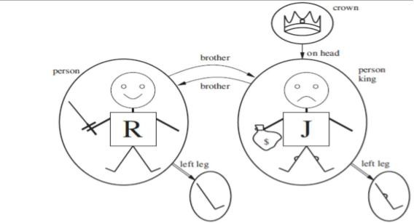

Unary Relation : John is a king Binary Relation :crown is on head of john , Richard is brother ofjohn The unary "left leg" function includes the following mappings: (Richard the Lionheart) ->Richard's left leg (King John) ->Johns left Leg
Symbols and interpretations

Symbols are the basic syntactic elements of first-order logic. Symbols stand for objects, relations, and functions.
The symbols are of three kinds: ✓ Constant symbols which stand for objects; Example: John, Richard ✓ Predicate symbols, which stand for relations; Example: OnHead, Person, King, and Crown
✓ Function symbols, which stand for functions. Example: left leg Symbols will begin with uppercase letters.
Interpretation The semantics must relate sentences to models in order to determine truth. For this to happen, we need an interpretation that specifies exactly which objects, relations and functions are referred to by the constant, predicate, and function symbols.

For Example:

✓ Richard refers to Richard the Lionheart and John refers to the evil king John. ✓ Brother refers to the brotherhood relation ✓ OnHead refers to the "on head relation that holds betweenthe crown and King John; ✓ Person, King, and Crown refer to the sets of objects that are persons, kings, and crowns. ✓ LeftLeg refers to the "left leg" function,

The truth of any sentence is determined by a model and an interpretation for the sentence's symbols. Therefore, entailment, validity, and so on are defined in terms of all possiblemodels and all possible interpretations. The number of domain elements in each model may be unbounded-for example, the domain elements may be integers or real numbers. Hence, the number of possible models is anbounded, as is the number of interpretations.

Term

A term is a logical expression that refers to an object. Constant symbols are therefore terms. Complex Terms A complex term is just a complicated kind of name. A complex term is formed by a function symbol followed by a parenthesized list of terms as arguments to the function symbol For example: "King John's left leg" Instead of using a constant symbol, we use LeftLeg(John). The formal semantics of terms :

Consider a term f (tl,. . . , t,). The function symbol frefers to some function in the model (F); the argument terms refer to objects in the domain (call them d1….dn); and the term as a whole refers to the object that is the value of the function Fapplied to dl, . . . , d,. For example,: the LeftLeg function symbol refers to the function “ (King John) -+ John's left leg” and John refers to King John, then LeftLeg(John) refers to King John's left leg. In this way, the interpretation fixes the referent of every term.

Atomic sentences

An atomic sentence is formed from a predicate symbol followed by a parenthesized list of terms: For Example: Brother(Richard, John).
Atomic sentences can have complex terms as arguments. For Example: Married (Father(Richard), Mother( John)).
An atomic sentence is true in a given model, under a given interpretation, if the relation referred to by the predicate symbol holds among the objects referred to by the arguments
Complex sentences Complex sentences can be constructed using logical Connectives, just as in propositional calculus. For Example:

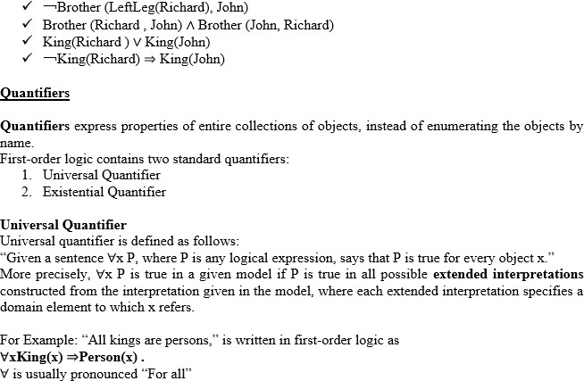

Thus, the sentence says, ―For all x, if x is a king, then x is a person.‖ The symbol x is called a variable. Variables are lowercase letters. A variable is a term all by itself, and can also serve as the argument of a function A term with no variables is called a ground term.
Assume we can extend the interpretation in different ways: x→ Richard the Lionheart, x→ King John, x→ Richard’s left leg, x→ John’s left leg, x→ the crown
The universally quantified sentence ∀x King(x) ⇒Person(x) is true in the original model if the sentence King(x) ⇒Person(x) is true under each of the five extended interpretations. That is, the universally quantified sentence is equivalent to asserting the following five sentences:
Richard the Lionheart is a king ⇒Richard the Lionheart is a person. King John is a king ⇒King John is a person. Richard’s left leg is a king ⇒Richard’s left leg is a person. John’s left leg is a king ⇒John’s left leg is a person. The crown is a king ⇒the crown is a person.

Existential quantification (∃)

Universal quantification makes statements about every object. Similarly, we can make a statement about some object in the universe without naming it, by using an existential quantifier.

“The sentence ∃x P says that P is true for at least one object x. More precisely, ∃x P is true in a given model if P is true in at least one extended interpretationthat assigns x to a domain element.” ∃x is pronounced “There exists an x such that . . .” or “For some x . . .”.
For example, that King John has a crown on his head, we write ∃xCrown(x) 𝖠OnHead(x, John) Given assertions:
Richard the Lionheart is a crown 𝖠Richard the Lionheart is on John’s head; King John is a crown
𝖠King John is on John’s head; Richard’s left leg is a crown 𝖠Richard’s left leg is on John’s head; John’s left leg is a crown 𝖠John’s left leg is on John’s head; The crown is a crown 𝖠the crown is on John’s head. The fifth assertion is true in the model, so the original existentially quantified sentence is true in the model. Just as ⇒appears to be the natural connective to use with ∀, 𝖠is the natural connective to use with ∃.
Nested quantifiers

One can express more complex sentences using multiple quantifiers.

For example, “Brothers are siblings” can be written as ∀x∀y Brother (x, y) ⇒Sibling(x, y). Consecutive quantifiers of the same type can be written as one quantifier with several variables.

For example, to say that siblinghood is a symmetric relationship, we can write∀x, y Sibling(x, y) ⇔Sibling(y, x).
In other cases we will have mixtures.

For example: 1. “Everybody loves somebody” means that for every person, there is someone that person loves: ∀x∃y Loves(x, y) . 2. On the other hand, to say “There is someone who is loved by everyone,” we write ∃y∀x Loves(x, y) .
Connections between ∀and ∃

Universal and Existential quantifiers are actually intimately connected with each other, through negation.

Example assertions: 1. “ Everyone dislikes medicine” is the same as asserting “ there does not exist someone who likes medicine” , and vice versa: “∀x ￢Likes(x, medicine)” is equivalent to “￢∃x Likes(x, medicine)”. 2. “Everyone likes ice cream” means that “ there is no one who does not like ice cream” : ∀xLikes(x, IceCream) is equivalent to ￢∃x ￢Likes(x, IceCream) .
Because ∀is really a conjunction over the universe of objects and ∃is a disjunction that they obey De Morgan’s rules. The De Morgan rules for quantified and unquantified sentences are as follows:
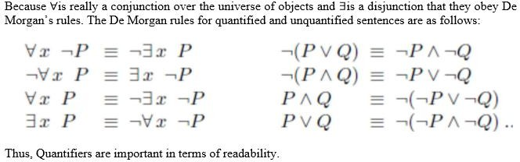

Equality

First-order logic includes one more way to make atomic sentences, other than using a predicateand terms .We can use the equality symbol to signify that two terms refer to the same object.
For example,

“Father(John) =Henry” says that the object referred to by Father (John) and the object referred to by Henry are the same.
Because an interpretation fixes the referent of any term, determining the truth of an equality sentence is simply a matter of seeing that the referents of the two terms are the same object.The equality symbol can be used to state facts about a given function.It can also be used with negation to insist that two terms are not the same object.
For example,

“Richard has at least two brothers” can be written as, ∃x, y Brother (x,Richard ) 𝖠Brother (y,Richard
) 𝖠￢(x=y) .

The sentence

∃x, y Brother (x,Richard ) 𝖠Brother (y,Richard ) does not have the intended meaning. In particular, it is true only in the model where Richard has only one brother considering the extended interpretation in which both x and y are assigned to King John. The addition of ￢(x=y) rules out such models.
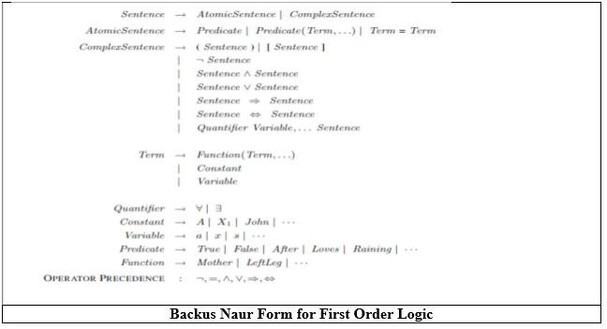

USING FIRST ORDER LOGIC Assertions and queries in first-order logic Assertions:
Sentences are added to a knowledge base using TELL, exactly as in propositional logic. Such sentences are called assertions.
For example,

John is a king, TELL (KB, King (John)). Richard is a person. TELL (KB, Person (Richard)). All kings are persons: TELL (KB, ∀x King(x) ⇒Person(x)).
Asking Queries:

We can ask questions of the knowledge base using ASK. Questions asked with ASK are called queries or goals.

For example,

ASK (KB, King (John)) returns true.

Anyquery that is logically entailed by the knowledge base should be answered affirmatively. Forexample, given the two preceding assertions, the query:
“ASK (KB, Person (John))” should also return true. Substitution or binding list
We can ask quantified queries, such as ASK (KB, ∃x Person(x)) .

The answer is true, but this is perhaps not as helpful as we would like. It is rather like answering “Can you tell me the time?” with “Yes.”
If we want to know what value of x makes the sentence true, we will need a different function, ASKVARS, which we call with ASKVARS (KB, Person(x)) and which yields a stream of answers.
In this case there will be two answers: {x/John} and {x/Richard}. Such an answer is called a substitution or binding list.
ASKVARS is usually reserved for knowledge bases consisting solely of Horn clauses, because in such knowledge bases every way of making the query true will bind the variables to specific values.
The kinship domain

The objects in Kinship domain are people.

We have two unary predicates, Male and Female.

Kinship relations—parenthood, brotherhood, marriage, and so on—are represented by binary predicates: Parent, Sibling, Brother,Sister,Child, Daughter, Son, Spouse, Wife, Husband, Grandparent,Grandchild, Cousin, Aunt, and Uncle.
We use functions for Mother and Father, because every person has exactly one of each of these.

We can represent each function and predicate, writing down what we know in termsof the other symbols.

For example:- 1. one’s mother is one’s female parent: ∀m, c Mother (c)=m ⇔Female(m) 𝖠Parent(m, c) .
- One’s husband is one’s male spouse: ∀w, h Husband(h,w) ⇔Male(h) 𝖠Spouse(h,w) .

- Male and female are disjoint categories: ∀xMale(x) ⇔￢Female(x) .

- Parent and child are inverse relations: ∀p, c Parent(p, c) ⇔Child (c, p) .

- A grandparent is a parent of one’s parent: ∀g, c Grandparent (g, c) ⇔∃p Parent(g, p) 𝖠Parent(p, c)
.

- A sibling is another child of one’s parents: ∀x, y Sibling(x, y) ⇔x _= y 𝖠∃p Parent(p, x) 𝖠Parent(p, y) .
Axioms:

Each of these sentences can be viewed as an axiom of the kinship domain. Axioms are commonly associated with purely mathematical domains. They provide the basic factual information from which useful conclusions can be derived.
Kinship axioms are also definitions; they have the form ∀x, y P(x, y) ⇔. . ..

The axioms define the Mother function, Husband, Male, Parent, Grandparent, and Sibling predicates in terms of other predicates.
Our definitions “bottom out” at a basic set of predicates (Child, Spouse, and Female) in terms of which the others are ultimately defined. This is a natural way in which to build up the representation of a domain, and it is analogous to the way in which software packages are built up by successive definitions of subroutines from primitive library functions.

Theorems:

Not all logical sentences about a domain are axioms. Some are theorems—that is, they are entailed by the axioms.
For example, consider the assertion that siblinghood is symmetric: ∀x, y Sibling(x, y) ⇔Sibling(y, x) .

It is a theorem that follows logically from the axiom that defines siblinghood. If we ASK the knowledge base this sentence, it should return true. From a purely logical point of view, a knowledge base need contain only axioms and no theorems, because the theorems do not increase the set of conclusions that follow from the knowledge base. From a practical point of view, theorems are essential to reduce the computational cost of deriving new sentences. Without them, a reasoning system has to start from first principles every time.

Axioms :Axioms without Definition

Not all axioms are definitions. Some provide more general information about certain predicates without constituting a definition. Indeed, some predicates have no complete definition because we do not know enough to characterize them fully.

For example, there is no obvious definitive way to complete the sentence

∀xPerson(x) ⇔. . .

Fortunately, first-order logic allows us to make use of the Person predicate without completely defining it. Instead, we can write partial specifications of properties that every person has and properties that make something a person:
∀xPerson(x) ⇒. . . ∀x . . . ⇒Person(x) .

Axioms can also be “just plain facts,” such as Male (Jim) and Spouse (Jim, Laura).Such facts form the descriptions of specific problem instances, enabling specific questions to be answered. The answers to these questions will then be theorems that follow from the axioms
Numbers, sets, and lists Number theory
Numbers are perhaps the most vivid example of how a large theory can be built up from NATURAL NUMBERS a tiny kernel of axioms. We describe here the theory of natural numbers or non-negative integers. We need:
✓ predicate NatNum that will be true of natural numbers; ✓ one PEANO AXIOMS constant symbol, 0;
✓ One function symbol, S (successor). ✓ The Peano axioms define natural numbers and addition.

Natural numbers are defined recursively: NatNum(0) . ∀n NatNum(n) ⇒ NatNum(S(n)) .

That is, 0 is a natural number, and for every object n, if n is a natural number, then S(n) is a natural number.
So the natural numbers are 0, S(0), S(S(0)), and so on. We also need axioms to constrain the successor function: ∀n 0 != S(n) . ∀m, n m != n ⇒ S(m) != S(n) .
Now we can define addition in terms of the successor function: ∀m NatNum(m) ⇒ + (0, m) = m .
∀m, n NatNum(m) 𝖠 NatNum(n) ⇒ + (S(m), n) = S(+(m, n))

The first of these axioms says that adding 0 to any natural number m gives m itself. Addition is represented using the binary function symbol “+” in the term + (m, 0);
To make our sentences about numbers easier to read, we allow the use of infix notation. We can also write S(n) as n + 1, so the second axiom becomes :
∀m, n NatNum (m) 𝖠 NatNum(n) ⇒ (m + 1) + n = (m + n)+1 .

This axiom reduces addition to repeated application of the successor function. Once we have addition, it is straightforward to define multiplication as repeated addition, exponentiation as repeated multiplication, integer division and remainders, prime numbers, and so on. Thus, the whole of number theory (including cryptography) can be built up from one constant, one function, one predicate and four axioms.

Sets

The domain of sets is also fundamental to mathematics as well as to commonsense reasoning. Sets can be represented as individualsets, including empty sets.
Sets can be built up by: ✓ adding an element to a set or ✓ Taking the union or intersection of two sets.
Operations that can be performed on sets are: ✓ To know whether an element is a member of a set
✓ Distinguish sets from objects that are not sets. Vocabulary of set theory:

The empty set is a constant written as { }. There is one unary predicate, Set, which is true of sets. The binary predicates are
✓ ∈x s (x is a member of set s) ✓ s1⊆ s2 (set s1 is a subset, not necessarily proper, of set s2).

The binary functions are

✓ s1 ∩ s2 (the intersection of two sets), ✓ s𝖴1 s2 (the union of two sets), and ✓ ,x|s- (the set resulting from adjoining element x to set s).

One possible set of axioms is as follows:

✓ The only sets are the empty set and those made by adjoining something to a set:∀sSet(s) ⇔(s={})
∨(∃x, s2 Set(s2) 𝖠s={x|s2}) . ✓ The empty set has no elements adjoined into it. In other words, there is no way to decompose {} into a smaller set and an element: ￢∃x, s {x|s}={} . ✓ Adjoining an element already in the set has no effect: ∀x, s x∈s ⇔s={x|s} . ✓ The only members of a set are the elements that were adjoined into it. We express this recursively, saying that x is a member of s if and only if s is equal to some set s2 adjoined with some element y, where either y is the same as x or x is a member of s2: ∀x, s x∈s ⇔∃y, s2 (s={y|s2} 𝖠(x=y ∨x∈s2)) ✓ A set is a subset of another set if and only if all of the first set’s members are members of the second set: ∀s1, s2 s1 ⊆s2 ⇔(∀x x∈s1
⇒x∈s2) ✓ Two sets are equal if and only if each is a subset of the other: ∀s1, s2 (s1 =s2) ⇔(s1 ⊆s2
𝖠s2 ⊆s1)

✓ An object is in the intersection of two sets if and only if it is a member of both sets:∀x, s1, s2 x∈(s1 ∩ s2) ⇔(x∈s1 𝖠x∈s2) ✓ An object is in the union of two sets if and only if it is a member of either set: ∀x, s1, s2 x∈(s1 𝖴s2) ⇔(x∈s1 ∨x∈s2)
Lists : are similar to sets. The differences are that lists are ordered and the same element canappear more than once in a list. We can use the vocabulary of Lisp for lists:
✓ Nil is the constant list with no element;s ✓ Cons, Append, First, and Rest are functions; ✓ Find is the predicate that does for lists what Member does for sets. ✓ List? is a predicate that is true only of lists. ✓ The empty list is * +. ✓ The term Cons(x, y), where y is a nonempty list, is wittren [x|y]. ✓ The

term Cons(x, Nil) (i.e., the list containing the element x) is written as [x]. ✓ A list of several elements, such as [A,B,C], corresponds to the nested term ✓ Cons(A, Cons(B, Cons(C, Nil))).
The wumpus world

Agents Percepts and Actions

The wumpus agent receives a percept vector with five elements. The corresponding first-order sentence stored in the knowledge base must include both the percept and the time at which it occurred; otherwise, the agent will get confused about when it saw what.We use integers for time steps. A typical percept sentence would be
Percept ([Stench, Breeze, Glitter,None, None], 5).

Here, Percept is a binary predicate, and Stench and so on are constants placed in a list. The actions in the wumpus world can be represented by logical terms:
Turn (Right), Turn (Left), Forward,Shoot,Grab, Climb.

To determine which is best, the agent program executes the query:

ASKVARS (∃a BestAction (a, 5)), which returns a binding list such as {a/Grab}. The agent program can then return Grab as the action to take.
The raw percept data implies certain facts about the current state.

For example: ∀t, s, g, m, c Percept ([s, Breeze, g,m, c], t) ⇒Breeze(t) , ∀t, s, b, m, c Percept ([s, b, Glitter,m, c], t) ⇒Glitter (t) ,

UNIT III – Knowledge and Reasoning

These rules exhibit a trivial form of the reasoning process called perception.

Simple ―reflex‖ behavior can also be implemented by quantified implication sentences.

For example, we have ∀tGlitter (t) ⇒BestAction(Grab, t) .

Given the percept and rules from the preceding paragraphs, this would yield the desired conclusion Best Action (Grab, 5)—that is, Grab is the right thing to do.
Environment Representation

Objects are squares, pits, and the wumpus. Each square could be named—Square1,2and so on—but then the fact that Square1,2and Square1,3 are adjacent would have to be an ―extra‖ fact, and this needs one suchfact for each pair of squares. It is better to use a complex term in which the row and columnappear as integers;
For example, we can simply use the list term [1, 2]. Adjacency of any two squares can be defined as:
∀x, y, a, b Adjacent ([x, y], [a, b]) ⇔ (x = a 𝖠(y = b − 1 ∨y = b + 1)) ∨(y = b 𝖠(x = a − 1 ∨x
= a + 1)).

Each pit need not be distinguished with each other. The unary predicate Pit is true of squares containing pits.
Since there is exactly one wumpus, a constant Wumpus is just as good as a unary predicate. The agent’s location changes over time, so we write At (Agent, s, t) to mean that theagent is at square s at time t.
To specify the Wumpus location (for example) at [2, 2] we can write ∀t At (Wumpus, [2, 2], t).
Objects can only be at one location at a time: ∀x, s1, s2, t At(x, s1, t) 𝖠At(x, s2, t) ⇒s1 = s2 .

Given its current location, the agent can infer properties of the square from properties of its current percept.
For example, if the agent is at a square and perceives a breeze, then that square is breezy:

∀s, t At(Agent, s, t) 𝖠Breeze(t) ⇒Breezy(s) .

It is useful to know that a square is breezy because we know that the pits cannot move about. Breezy has no time argument.
Having discovered which places are breezy (or smelly) and, very importantly, not breezy (or not smelly), the agent can deduce where the pits =e (and where the wumpus is).
There are two kinds of synchronic rules that could allow such deductions: Diagnostic rules:
Diagnostic rules lead from observed effects to hidden causes. For finding pits, the obvious diagnostic rules say that if a square is breezy, some adjacent square must contain a pit, or
∀s Breezy(s) ⇒∃r Adjacent (r, s)𝖠Pit(r) ,

and that if a square is not breezy, no adjacent square contains a pit: ∀s￢Breezy (s) ⇒￢∃r Adjacent (r, s) 𝖠 Pit (,r) .Combining these two, we obtain the biconditional sentence ∀s Breezy ( s )⇔∃r Adjacent(r, s) 𝖠 Pit (r) .
Causal rules:

Causal rules reflect the assumed direction of causality in the world: some hidden property of the world causes certain percepts to be generated. For example, a pit causes all adjacent squares to be breezy:
and if all squares adjacent to a given square are pitless, the square will not be breezy: ∀s[∀r Adjacent (r, s) ⇒￢Pit (r)] ⇒￢Breezy ( s ) .

It is possible to show that these two sentences together are logically equivalent to the biconditional sentence ― ∀s Breezy ( s )⇔∃r Adjacent(r, s) 𝖠 Pit (r)‖ .
The biconditional itself can also be thought of as causal, because it states how the truth value of Breezy is generated from the world state.

Systems that reason with causal rules are called model-based reasoning systems, because the causal rules form a model of how the environment operates.
Whichever kind of representation the agent uses, ifthe axioms correctly and completely describe the way the world works and the way that percepts are produced, then any complete logical inference procedure will infer the strongest possible description of the world state, given the available percepts. Thus, the agent designer can concentrate on getting the knowledgeright, without worrying too much about the processes of deduction.
Inference in First-Order Logic

Propositional Vs First Order Inference
Earlier inference in first order logic is performed with Propositionalization which is a process of converting the Knowledgebase present in First Order logic into Propositional logic and on that using any inference mechanisms of propositional logic are used to check inference.

Inference rules for quantifiers:
There are some Inference rules that can be applied to sentences with quantifiers to obtain sentences without quantifiers. These rules will lead us to make the conversion.

Universal Instantiation (UI):
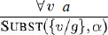
The rule says that we can infer any sentence obtained by substituting a ground term (a term without variables) for the variable. Let SUBST (θ) denote the result of applying the substitution θto the sentence a. Then the rule is written
For any variable v and ground term g.
For example, there is a sentence in knowledge base stating that all greedy kings are Evils
For the variable x, with the substitutions like {x/John},{x/Richard}the following sentences can be inferred.
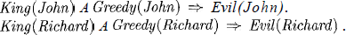

Thus a universally quantified sentence can be replaced by the set of all possible instantiations.

Existential Instantiation (EI):

The existential sentence says there is some object satisfying a condition, and the instantiation process is just giving a name to that object, that name must not already belong to another object. This new name is called a Skolem constant. Existential Instantiation is a special case of a more general process called “skolemization”.
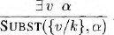
For any sentence a, variable v, and constant symbol k that does not appear elsewhere in the knowledge base,

For example, from the sentence

So, we can infer the sentence

As long as C₁ does not appear elsewhere in the knowledge base. Thus an existentially quantified sentence can be replaced by one instantiation
Elimination of Universal and Existential quantifiers should give new knowledge base which can be shown to be inferentially equivalentto oldin the sense that it is satisfiable exactly when the original knowledge base is satisfiable.

Reduction to propositional inference:
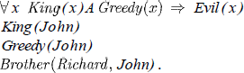
Once we have rules for inferring non quantified sentences from quantified sentences, it becomes possible to reduce first-order inference to propositional inference. For example, suppose our knowledge base contains just the sentences

Then we apply UI to the first sentence using all possible ground term substitutions from the vocabulary of the knowledge base-in this case, {xl John) and {x/Richard). We obtain
We discard the universally quantified sentence. Now, the knowledge base is essentially propositional if we view the ground atomic sentences-King (John), Greedy (John), and Brother (Richard, John) as proposition symbols. Therefore, we can apply any of the complete propositional algorithms to obtain conclusions such as Evil (John).

Disadvantage:
If the knowledge base includes a function symbol, the set of possible ground term substitutions is infinite. Propositional algorithms will have difficulty with an infinitely large set of sentences.
NOTE:
Entailment for first-order logic is semi decidable which means algorithms exist that say yes to every entailed sentence, but no algorithm exists that also says no to every non entailed sentence

  - Unification and Lifting

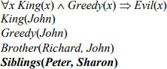
Consider the above discussed example, if we add Siblings (Peter, Sharon) to the knowledge base then it will be
Removing Universal Quantifier will add new sentences to the knowledge base which are not necessary for the query Evil (John)?
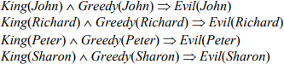
Hence we need to teach the computer to make better inferences. For this purpose Inference rules were used.

First Order Inference Rule:
The key advantage of lifted inference rules over propositionalization is that they make only those substitutions which are required to allow particular inferences to proceed.

Generalized Modus Ponens:
If there is some substitution θ that makes the premise of the implication identical to sentences already in the knowledge base, then we can assert the conclusion of the implication, after applying θ. This inference process can be captured as a single inference rule called Generalized Modus Ponens which is a liftedversion of Modus Ponens-it raises Modus Ponens from propositional to first-order logic
For atomic sentences pi, pi ', and q, where there is a substitution θ such that SUBST( θ , pi ) = SUBST(θ , pi '), for all i,

p1 ', p2 ', …, pn ', (p1 𝖠 p2 𝖠 … 𝖠 pn ⇒ q)
SUBST (θ, q)
There are N + 1 premises to this rule, N atomic sentences + one implication. Applying SUBST (θ, q) yields the conclusion we seek. It is a sound inference rule.
Suppose that instead of knowing Greedy (John) in our example we know that everyone is greedy:

∀y Greedy(y)

We would conclude that Evil(John).

Applying the substitution {x/John, y / John) to the implication premises King ( x ) and Greedy ( x ) and the knowledge base sentences King(John) and Greedy(y)will make them identical. Thus, we can infer the conclusion of the implication.

For our example,

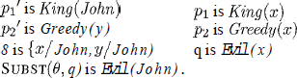

Unification:

It is the process used to find substitutions that make different logical expressions look identical.
Unification is a key component of all first-order Inference algorithms.
UNIFY (p, q) = θ where SUBST (θ, p) = SUBST (θ, q) θ is our unifier value (if one exists). Ex: ―Who does John know?‖
UNIFY (Knows (John, x), Knows (John, Jane)) = {x/ Jane}. UNIFY (Knows (John, x), Knows (y, Bill)) = {x/Bill, y/ John}.
UNIFY (Knows (John, x), Knows (y, Mother(y))) = {x/Bill, y/ John} UNIFY (Knows (John, x), Knows (x, Elizabeth)) = FAIL

- The last unification fails because both use the same variable, X. X can’t equal both John and Elizabeth. To avoid this change the variable X to Y (or any other value) in Knows(X, Elizabeth)

Knows(X, Elizabeth) → Knows(Y, Elizabeth)

Still means the same. This is called standardizing apart.
- sometimes it is possible for more than one unifier returned:

UNIFY (Knows (John, x), Knows(y, z)) =???

This can return two possible unifications: {y/ John, x/ z} which means Knows (John, z) OR {y/ John, x/ John, z/ John}. For each unifiable pair of expressions there is a single most general unifier (MGU), In this case it is {y/ John, x/z).

An algorithm for computing most general unifiers is shown below.

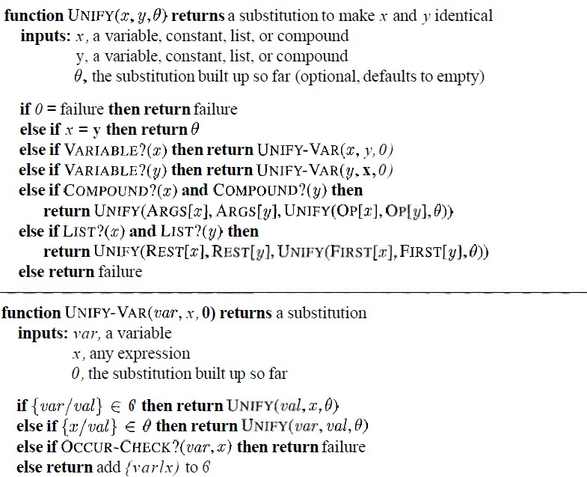

The process is very simple: recursively explore the two expressions simultaneously "side by side," building up a unifier along the way, but failing if two corresponding points in the structures do not match. Occur check step makes sure same variable isn’t used twice.
Figure 2.1 The unification algorithm. The algorithm works by comparing the structures of the inputs, element by element. The substitution 0 that is the argument to UNIFY is built up along the way and is used to make sure that later comparisons are consistent with bindings that were established earlier. In a compound expression, such as F (A, B), the function OP picks out the function symbol F and the function ARCS picks out the argument list (A, B).

Storage and retrieval
- STORE(s) stores a sentence s into the knowledge base

- FETCH(s) returns all unifiers such that the query q unifies with some sentence in the knowledge base.
Easy way to implement these functions is Store all sentences in a long list, browse list one sentence at a time with UNIFY on an ASK query. But this is inefficient.
To make FETCH more efficient by ensuring that unifications are attempted only with sentences that have some chance of unifying. (i.e. Knows(John, x) vs. Brother(Richard, John) are not compatible for unification)
- To avoid this, a simple scheme called predicate indexingputs all the Knows facts in one bucket and all the Brother facts in another.
- The buckets can be stored in a hash table for efficient access. Predicate indexing is useful when there are many predicate symbols but only a few clauses for each symbol.

But if we have many clauses for a given predicate symbol, facts can be stored under multiple index keys.
For the fact Employs (AIMA.org, Richard), the queries are Employs (A IMA. org, Richard) Does AIMA.org employ Richard? Employs (x, Richard) who employs Richard?
Employs (AIMA.org, y) whom does AIMA.org employ?
Employs Y(x), who employs whom?

We can arrange this into a subsumption lattice, as shown below.
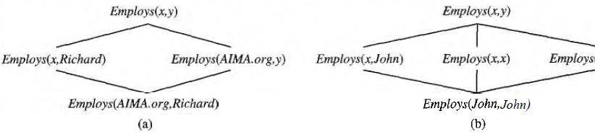

A subsumption lattice has the following properties:
Figure 2.2 (a) The subsumption lattice whose lowest node is the sentence Employs (AIMA.org, Richard). (b) The subsumption lattice for the sentence Employs (John, John).
- child of any node obtained from its parents by one substitution
- the ―highest‖ common descendant of any two nodes is the result of applying their most general unifier

- predicate with n arguments contains O(2n ) nodes (in our example, we have two arguments, so our lattice has four nodes)
- Repeated constants = slightly different lattice.

  - Forward Chaining

First-Order Definite Clauses:
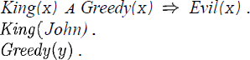
A definite clause either is atomic or is an implication whose antecedent is a conjunction of positive literals and whose consequent is a single positive literal. The following are first-order definite clauses:
Unlike propositional literals, first-order literals can include variables, in which case those variables are assumed to be universally quantified.
Consider the following problem;

“The law says that it is a crime for an American to sell weapons to hostile nations. The country Nono, an enemy of America, has some missiles, and all of its missiles were sold to it by Colonel West, who is American.”
We will represent the facts as first-order definite clauses
". . . It is a crime for an American to sell weapons to hostile nations":

--------- (1)
"Nono . . . has some missiles." The sentence 3 x Owns (Nono, .rc) A Missile (x) is transformed into two definite clauses by Existential Elimination, introducing a new constant M1:

Owns (Nono, M1) (2)
Missile (Ml) (3)
"All of its missiles were sold to it by Colonel West":
Missile (x) A Owns (Nono, x) =>Sells (West, z, Nono) (4)
We will also need to know that missiles are weapons:

Missile (x) =>Weapon (x) (5)

We must know that an enemy of America counts as "hostile":

Enemy (x, America) =>Hostile(x) (6)
"West, who is American":

American (West) (7)
"The country Nono, an enemy of America ":

Enemy (Nono, America) (8)

A simple forward-chaining algorithm:
- Starting from the known facts, it triggers all the rules whose premises are satisfied, adding their conclusions lo the known facts
- The process repeats until the query is answered or no new facts are added. Notice that a fact is not "new" if it is just renamingof a known fact.

We will use our crime problem to illustrate how FOL-FC-ASK works. The implication sentences are (1), (4), (5), and (6). Two iterations are required:
- On the first iteration, rule (1) has unsatisfied premises.
Rule (4) is satisfied with {x/Ml), and Sells (West, M1, Nono) is added. Rule (5) is satisfied with {x/M1) and Weapon (M1) is added.
Rule (6) is satisfied with {x/Nono}, and Hostile (Nono) is added.
- On the second iteration, rule (1) is satisfied with {x/West, Y/MI, z /Nono), and Criminal
(West) is added.
It is sound, because every inference is just an application of Generalized Modus Ponens, it is completefor definite clause knowledge bases; that is, it answers every query whose answers are entailed by any knowledge base of definite clauses

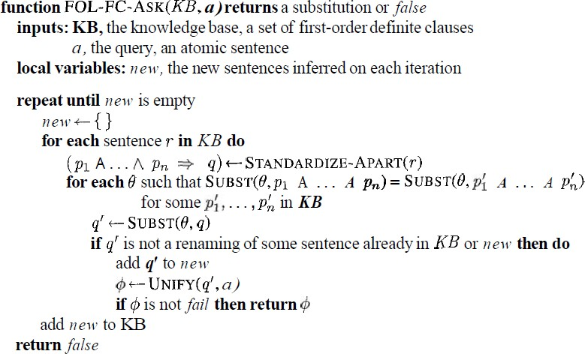
Figure 3.1 A conceptually straightforward, but very inefficient, forward-chaining algorithm. On each iteration, it adds to KB all the atomic sentences that can be inferred in one step from the implication sentences and the atomic sentences already in KB.

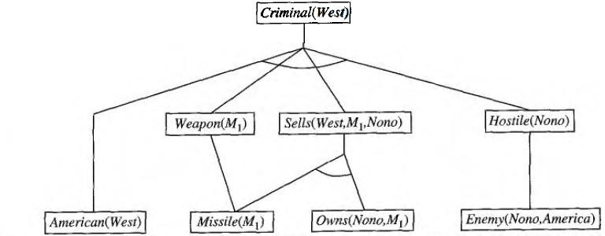

Efficient forward chaining:
Figure 3.2 The proof tree generated by forward chaining on the crime example. The initial facts appear at the bottom level, facts inferred on the first iteration in the middle level, and facts inferred on the second iteration at the top level.
The above given forward chaining algorithm was lack with efficiency due to the the three sources of complexities:
- Pattern Matching

- Rechecking of every rule on every iteration even a few additions are made to rules
- Irrelevant facts

Matching rules against known facts:
For example, consider this rule,

Missile(x) A Owns (Nono, x) =>Sells (West, x, Nono).

The algorithm will check all the objects owned by Nono in and then for each object, it could check whether it is a missile. This is the conjunct ordering problem:
―Find an ordering to solve the conjuncts of the rule premise so that the total cost is minimized‖. The most constrained variable heuristic used for CSPs would suggest ordering the conjuncts to look for missiles first if there are fewer missiles than objects that are owned by Nono.
The connection between pattern matching and constraint satisfaction is actually very close. We can view each conjunct as a constraint on the variables that it contains-for example, Missile(x) is a unary constraint on x. Extending this idea, we can express everyfinite-domain CSP as a single definite clause together with some associated ground facts. Matching a definite clause against a set of facts is NP-hard

- Incremental forward chaining:
On the second iteration, the rule Missile (x) =>Weapon (x)
Matches against Missile (M1) (again), and of course the conclusion Weapon(x/M1) is already known so nothing happens. Such redundant rule matching can be avoided if we make the following observation:
―Every new fact inferred on iteration t must be derived from at leastone new fact inferred on iteration t – 1‖.
This observation leads naturally to an incremental forward chaining algorithm where, at iteration t, we check a rule only if its premise includes a conjunct p, that unifies with a fact p: newly inferred at iteration t - 1. The rule matching step then fixes p, to match with p’, but allows the other conjuncts of the rule to match with facts from any previous iteration.

Irrelevant facts:

- One way to avoid drawing irrelevant conclusions is to use backward chaining.
- Another solution is to restrict forward chaining to a selected subset of rules
- A third approach, is to rewrite the rule set, using information from the goal.so that only relevant variable bindings-those belonging to a so-called magic set-are considered during forward inference.
For example, if the goal is Criminal (West), the rule that concludes Criminal (x) will be rewritten to include an extra conjunct that constrains the value of x:

Magic(x) A American(z) A Weapon(y)A Sells(x, y, z) A Hostile(z) =>Criminal(x )

The fact Magic (West) is also added to the KB. In this way, even if the knowledge base contains facts about millions of Americans, only Colonel West will be considered during the forward inference process.

- Backward Chaining
This algorithm work backward from the goal, chaining through rules to find known facts that support the proof. It is called with a list of goals containing the original query, and returns the set of all substitutions satisfying the query. The algorithm takes the first goal in the list and finds every clause in the knowledge base whose head, unifies with the goal. Each such clause creates a new recursive call in which body, of the clause is added to the goal stack .Remember that facts are clauses with a head but no body, so when a goal unifies with a known fact, no new sub goals are added to the stack and the goal is solved. The algorithm for backward chaining and proof tree for finding criminal (West) using backward chaining are given below.

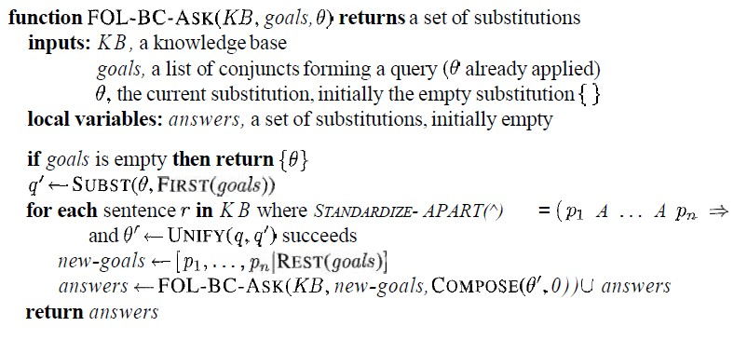
.
Figure 4.1A simple backward-chaining algorithm.

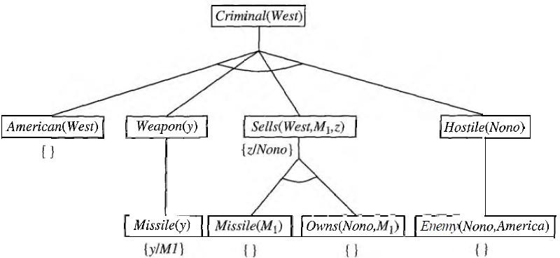

Logic programming:
Figure 4.2 Proof tree constructed by backward chaining to prove that West is a criminal. The tree should be read depth first, left to right. To prove Criminal (West), we have to prove the four conjuncts below it. Some of these are in the knowledge base, and others require further backward chaining. Bindings for each successful unification are shown next to the corresponding sub goal. Note that once one sub goal in a conjunction succeeds, its substitution is applied to subsequent sub goals.
- Prolog is by far the most widely used logic programming language.
- Prolog programs are sets of definite clauses written in a notation different from standard first-order logic.

- Prolog uses uppercase letters for variables and lowercase for constants.
- Clauses are written with the head preceding the body; " : -" is used for left implication, commas separate literals in the body, and a period marks the end of a sentence
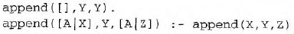
Prolog includes "syntactic sugar" for list notation and arithmetic. Prolog program for append (X, Y, Z), which succeeds if list Z is the result of appending lists x and Y

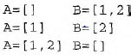
For example, we can ask the query append (A, B, [1, 2]): what two lists can be appended to give [1, 2]? We get back the solutions
- The execution of Prolog programs is done via depth-first backward chaining
- Prolog allows a form of negation called negation as failure. A negated goal not P is considered proved if the system fails to prove p. Thus, the sentence
Alive (X) : - not dead(X) can be read as "Everyone is alive if not provably dead."
- Prolog has an equality operator, =, but it lacks the full power of logical equality. An equality goal succeeds if the two terms are unifiable and fails otherwise. So X+Y=2+3 succeeds with x bound to 2 and Y bound to 3, but Morningstar=evening star fails.
- The occur check is omitted from Prolog's unification algorithm.

Efficient implementation of logic programs:
The execution of a Prolog program can happen in two modes: interpreted and compiled.
- Interpretation essentially amounts to running the FOL-BC-ASK algorithm, with the program as the knowledge base. These are designed to maximize speed.
First, instead of constructing the list of all possible answers for each sub goal before continuing to the next, Prolog interpreters generate one answer and a "promise" to generate the rest when the current answer has been fully explored. This promise is called a choice point.FOL-BC-ASK spends a good deal of time in generating and composing substitutions

when a path in search fails. Prolog will backup to previous choice point and unbind some variables. This is called ―TRAIL‖. So, new variable is bound by UNIFY-VAR and it is pushed on to trail.

- Prolog Compilers compile into an intermediate language i.e., Warren Abstract Machine or WAM named after David. H. D. Warren who is one of the implementers of first prolog compiler. So, WAM is an abstract instruction set that is suitable for prolog and can be either translated or interpreted into machine language.
Continuations are used to implement choice point’scontinuation as packaging up a procedure and a list of arguments that together define what should be done next whenever the current goal succeeds.
- Parallelization can also provide substantial speedup. There are two principal sources of parallelism
- The first, called OR-parallelism, comes from the possibility of a goal unifying with many different clauses in the knowledge base. Each gives rise to an independent branch in the search space that can lead to a potential solution, and all such branches can be solved in parallel.
- The second, called AND-parallelism, comes from the possibility of solving each conjunct in the body of an implication in parallel. AND-parallelism is more difficult to achieve, because solutions for the whole conjunction require consistent bindings for all the variables.

Redundant inference and infinite loops:
Consider the following logic program that decides if a path exists between two points on a directed graph.
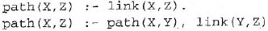
A simple three-node graph, described by the facts link (a, b) and link (b, c)
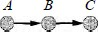
It generates the query path (a, c)
Hence each node is connected to two random successors in the next layer.

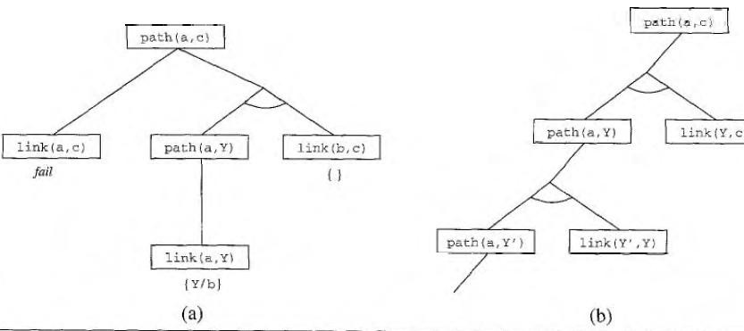

Constraint logic programming:
Figure 4.3 (a) Proof that a path exists from A to C. (b) Infinite proof tree generated when the clauses are in the "wrong" order.
The Constraint Satisfaction problem can be solved in prolog as same like backtracking algorithm.
Because it works only for finite domain CSP’s in prolog terms there must be finite number of solutions for any goal with unbound variables.

- If we have a query, triangle (3, 4, and 5) works fine but the query like, triangle (3, 4, Z) no solution.
- The difficulty is variable in prolog can be in one of two states i.e., Unbound or bound.
- Binding a variable to a particular term can be viewed as an extreme form of constraint namely ―equality‖.CLP allows variables to be constrained rather than bound.
The solution to triangle (3, 4, Z) is Constraint 7>=Z>=1.

5. Resolution

As in the propositional case, first-order resolution requires that sentences be in conjunctive normal form (CNF) that is, a conjunction of clauses, where each clause is a disjunction ofliterals.

Literals can contain variables, which are assumed to be universally quantified. Every sentence of first-order logic can be converted into an inferentially equivalent CNF sentence. We will illustrate the procedure by translating the sentence
"Everyone who loves all animals is loved by someone," or
The steps are as follows:
- Eliminate implications:
- Move Negation inwards: In addition to the usual rules for negated connectives, we need rules for negated quantifiers. Thus, we have
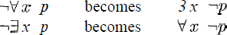

Our sentence goes through the following transformations:

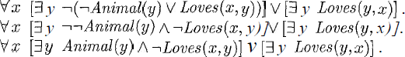
- Standardize variables: For sentences like 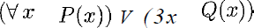 which use the same variable name twice, change the name of one of the variables. This avoids confusion later when we drop the quantifiers. Thus, we have
  - Skolemize: Skolemization is the process of removing existential quantifiers by elimination. Translate 3 x P(x) into P(A), where A is a new constant. If we apply this rule to our sample sentence, however, we obtain

Which has the wrong meaning entirely: it says that everyone either fails to love a particular animal A or is loved by some particular entity B. In fact, our original sentence allows each person to fail to love a different animal or to be loved by a different person.
Thus, we want the Skolem entities to depend on x:

Here F and G are Skolem functions. The general rule is that the arguments of the Skolem function are all the universally quantified variables in whose scope the existential quantifier appears.

  - Drop universal quantifiers: At this point, all remaining variables must be universally quantified. Moreover, the sentence is equivalent to one in which all the universal quantifiers have been moved to the left. We can therefore drop the universal quantifiers
  - Distribute V over A

This is the CNF form of given sentence.

The resolution inference rule:
The resolution rule for first-order clauses is simply a lifted version of the propositional resolution rule. Propositional literals are complementary if one is the negation of the other; first-order literals are complementary if one unifies with the negation of the other. Thus we have

Where UNIFY (l_{i}, m _{j}) == θ.
For example, we can resolve the two clauses

By eliminating the complementary literals Loves (G(x), x) and ¬Loves (u, v), with unifier θ = {u/G(x), v/x), to produce the resolvent clause

Example proofs:
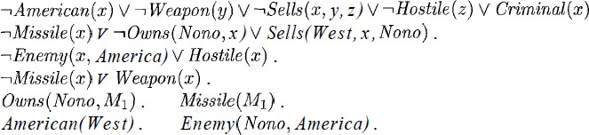
Resolution proves that KB /= a by proving KB A la unsatisfiable, i.e., by deriving the empty clause. The sentences in CNF are

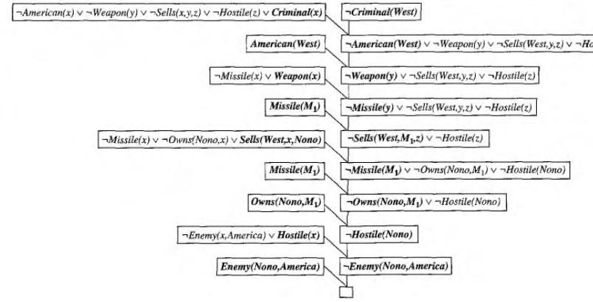
The resolution proof is shown in below figure;

Notice the structure: single "spine" beginning with the goal clause, resolving against clauses from the knowledge base until the empty clause is generated. Backward chaining is really just a
Figure 5.1 A resolution proof that West is a criminal.

special case of resolution with a particular control strategy to decide which resolution to perform next.

UNIT-IV

Planning
Classical Planning: Definition of Classical Planning, Algorithms for Planning with StateSpace Search, Planning Graphs, other Classical Planning Approaches, Analysis of Planning approaches.
Planning and Acting in the Real World: Time, Schedules, and Resources, Hierarchical Planning, Planning and Acting in Nondeterministic Domains, Multi agent Planning
Planning Classical Planning: AI as the study of rational action, which means that planning—devising a plan of action to achieve one’s goals—is a critical part of AI. We have seen two examples of planning agents so far the search-based problem-solving agent.
DEFINITION OF CLASSICAL PLANNING: The problem-solving agent can find sequences of actions that result in a goal state. But it deals with atomic representations of states and thus needs good domain- specific heuristics to perform well. The hybrid propositional logical agent can find plans without domain- specific heuristics because it uses domain-independent heuristics based on the logical structure of the problem but it relies on ground (variable-free) propositional inference,whichmeansthatitmaybeswampedwhentherearemanyactionsandstates.For example,intheworld,thesimpleactionofmovingastepforwardhadtoberepeated for all four agent orientations, T time steps, and n² currentlocations.
In response to this, planning researchers have settled on a factored representation— one in which a state of the world is represented by a collection of variables. We use a language called PDDL, the Planning Domain Definition Language that allows us to express all 4Tn² actions with one action schema. There have been several versions of PDDL.we select a simple version and alter its syntax to be consistent with the rest of the book. We now show how PDDL describes the four things we need to define a search problem: the initial state, the actions that are available in a state, the result of applying an action, and the goal test.
Each state is represented as a conjunction of flaunts that are ground, functionless atoms. For example, Poor 𝖠 Unknown might represent the state of a hapless agent, and a state in a package delivery problem might be At(Truck 1, Melbourne) 𝖠 At(Truck 2, Sydney ). Database semantics is used: the

closed-world assumption means that any flaunts that are not mentioned are false, and the unique names assumption means that Truck 1 and Truck 2 are distinct.
A set of ground (variable-free) actions can be represented by a single action schema. The schema is a lifted representation—it lifts the level of reasoning from propositional logic to a restricted subset of first-order logic. For example, here is an action schema for flying a plane from one location to another: Action(Fly (p, from, to),
PRECOND:At(p, from) 𝖠 Plane(p) 𝖠 Airport (from) 𝖠 Airport (to) EFFECT:¬At(p, from) 𝖠 At(p, to))

The schema consists of the action name, a list of all the variables used in the schema, a precondition and an effect.
A set of action schemas serves as a definition of a planning domain. A specific problem within the domain is defined with the addition of an initial state and a goal.
state is a conjunction of ground atoms. (As with all states, the closed-world assumption is used, which means that any atoms that are not mentioned are false.) The goal is just like a precondition: a conjunction of literals (positive or negative) that may contain variables, such as At(p, SFO ) 𝖠 Plane(p). Any variables are treated as existentially quantified, so this goal is to have any plane at SFO. The problem is solved when we can find a sequence of actions that end in a states that entails the goal.
Example: Air cargo transport
An air cargo transport problem involving loading and unloading cargo and flying it from place to place. The problem can be defined with three actions: Load , Unload , and Fly . The actions affect two predicates: In(c, p) means that cargo c is inside plane p, and At(x, a) means that object x (either plane or cargo) is at airport a. Note that some care must be taken to make sure the At predicates are maintained properly. When a plane flies from one airport to another, all the cargo inside the plane goes with it. In first-order logic it would be easy to quantify over all objects that are inside the plane. But basic PDDL does not have a universal quantifier, so we need a different solution. The approach we use is to say that a piece of cargo ceases to be At anywhere when it is In a plane; the cargo only becomes At the new airport when it is unloaded. So At really means “available for use at a given location.”

The complexity of classical planning :
We consider the theoretical complexity of planning and distinguish two decision problems. PlanSAT is the question of whether there exists any plan that solves a planning problem. Bounded PlanSAT asks whether there is a solution of length k or less; this can be used to find an optimal plan.

The first result is that both decision problems are decidable for classical planning. The proof follows from the fact that the number of states is finite. But if we add function symbols to the language, then the number of states becomes infinite, and PlanSAT becomes only semi decidable: an algorithm exists that will terminate with the correct answer for any solvable problem, but may not terminate on unsolvable problems. The Bounded PlanSAT problem remains decidable even in the presence of function symbols.
Both PlanSAT and Bounded PlanSAT are in the complexity class PSPACE, a class that is larger (and hence more difficult) than NP and refers to problems that can be solved by a deterministic Turing machine with a polynomial amount of space. Even if we make some rather severe restrictions, the problems remain quite difficult.

Algorithms for Planning with State Space Search Forward (progression) state-space search:
Now that we have shown how a planning problem maps into a search problem, we can solve planning problems with any of the heuristic search algorithms from Chapter 3 or a local search algorithm from Chapter 4 (provided we keep track of the actions used to reach the goal). From the earliest days of planning research (around 1961) until around 1998 it was assumed that forward state-space search was too inefficient to be practical. It is not hard to come up with reasons why .
First, forward search is prone to exploring irrelevant actions. Consider the noble task of buying a copy of AI: A Modern Approach from an online bookseller. Suppose there is an action schema Buy(isbn) with effect Own(isbn). ISBNs are 10 digits, so this action schema represents 10 billion ground actions. An uninformed forward-search algorithm would have to start enumerating these 10 billion actions to find one that leads to the goal.
Second, planning problems often have large state spaces. Consider an air cargo problem with 10 airports, where each airport has 5 planes and 20 pieces of cargo. The goal is to move all the cargo at airport A to airport B. There is a simple solution to the problem: load the 20 pieces of cargo into one of the planes at A, fly the plane to B, and unload the cargo. Finding the solution can be difficult because the average branching factor is huge: each of the 50 planes can fly to 9 other airports, and each of the 200 packages can be either unloaded (if it is loaded) or loaded into any plane at its airport (if it is unloaded). So in any state there is a minimum of 450 actions (when all the packages are at airports with no planes) and a maximum of 10,450 (when all packages and planes are at the same airport). On average, let’s say there are about 2000 possible actions per state, so the search graph up to the depth of the obvious solution has about 2000 nodes.

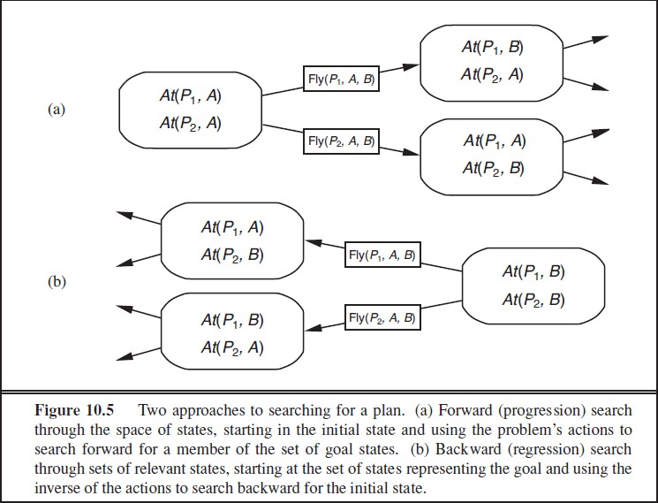

Backward (regression) relevant-states search:
In regression search we start at the goal and apply the actions backward until we find a sequence of steps that reaches the initial state. It is called relevant-states search because we only consider actions that are relevant to the goal (or current state). As in belief-state search (Section 4.4), there is a set of relevant states to consider at each step, not just a single state.
We start with the goal, which is a conjunction of literals forming a description of a set of states—for example, the goal ¬Poor 𝖠 Famous describes those states in which Poor is false, Famous is true, and any other fluent can have any value. If there are n ground flaunts in a domain, then there are 2n ground states (each fluent can be true or false), but 3n descriptions of sets of goal states (each fluent can be positive, negative, or not mentioned).
In general, backward search works only when we know how to regress from a state description to the predecessor state description. For example, it is hard to search backwards for a solution to the n-queens

problem because there is no easy way to describe the states that are one move away from the goal. Happily, the PDDL representation was designed to make it easy to regress actions—if a domain can be expressed in PDDL, then we can do regression search on it.
The final issue is deciding which actions are candidates to regress over. In the forward direction we chose actions that were applicable—those actions that could be the next step in the plan. In backward search we want actions that are relevant—those actions that could be the last step in a plan leading up to the current goal state.
Heuristics for planning:
Neither forward nor backward search is efficient without a good heuristic function. Recall from Chapter 3 that a heuristic function h(s) estimates the distance from a state s to the goal and that if we can derive an admissible heuristic for this distance—one that does not overestimate—then we can use A∗ search to find optimal solutions. An admissible heuristic can be derived by defining a relaxed problem that is easier to solve. The exact cost of a solution to this easier problem then becomes the heuristic for the original problem.
By definition, there is no way to analyze an atomic state, and thus it it requires some ingenuity by a human analyst to define good domain-specific heuristics for search problems with atomic states. Planning uses a factored representation for states and action schemas. That makes it possible to define good domain-independent heuristics and for programs to automatically apply a good domain- independent heuristic for a given problem.
Planning Graphs:
All of the heuristics we have suggested can suffer from inaccuracies. This section shows how a special data structure called a planning graph can be used to give better heuristic estimates. These heuristics can be applied to any of the search techniques we have seen so far. Alternatively, we can search for a solution over the space formed by the planning graph, using an algorithm called GRAPHPLAN.
A planning problem asks if we can reach a goal state from the initial state. Suppose we are given a tree of all possible actions from the initial state to successor states, and their successors, and so on. If we indexed this tree appropriately, we could answer the planning question “can we reach state G from state S0” immediately, just by looking it up. Of course, the tree is of exponential size, so this approach is impractical. A planning graph is polynomial- size approximation to this tree that can be constructed quickly. The planning graph can’t answer definitively whether G is reachable from S0, but it can estimate how many steps it takes to reach G. The estimate is always correct when it reports the goal is not reachable, and it never overestimates the number of steps, so it is an admissible heuristic.

A planning graph is a directed graph organized into levels: first a level S0 for the initial state, consisting of nodes representing each fluent that holds in S0; then a level A0 consisting of nodes for each ground action that might be applicable in S0; then alternating levels Si followed by Ai; until we reach a termination condition (to be discussed later).
Roughly speaking, Si contains all the literals that could hold at time i, depending on the actions executed at preceding time steps. If it is possible that either P or ¬P could hold, then both will be represented in Si. Also roughly speaking, Ai contains all the actions that could have their preconditions satisfied at time
i. We say “roughly speaking” because the planning graph records only a restricted subset of the possible negative interactions among actions; therefore, a literal might show up at level Sj when actually it could not be true until a later level, if at all. (A literal will never show up too late.) Despite the possible error, the level j at which a literal first appears is a good estimate of how difficult it is to achieve the literal from the initial state.
We now define mutex links for both actions and literals. A mutex relation holds between two actions at a given level if any of the following three conditions holds:
- Inconsistent effects: one action negates an effect of the other. For example, Eat(Cake) and the persistence of Have(Cake) have inconsistent effects because they disagree on the effect Have(Cake).
- Interference: one of the effects of one action is the negation of a precondition of the other. For example Eat(Cake) interferes with the persistence of Have(Cake) by its precondition.
- Competing needs: one of the preconditions of one action is mutually exclusive with a precondition of the other. For example, Bake(Cake) and Eat(Cake) are mutex because they compete on the value of the Have(Cake) precondition.
A mutex relation holds between two literals at the same level if one is the negation of the other or if each possible pair of actions that could achieve the two literals is mutually exclusive. This condition is called inconsistent support. For example, Have(Cake) and Eaten(Cake) are mutex in S1 because the only way of achieving Have(Cake), the persistence action, is mutex with the only way of achieving Eaten(Cake), namely Eat(Cake). In S2 the two literals are not mutex, because there are new ways of achieving them, such as Bake(Cake) and the persistence of Eaten(Cake), that are not mutex.
other Classical Planning Approaches:
Currently the most popular and effective approaches to fully automated planning are:
- Translating to a Boolean satisfiability (SAT) problem
- Forward state-space search with carefully crafted heuristics
- Search using a planning graph (Section 10.3)

These three approaches are not the only ones tried in the 40-year history of automated planning. Figure
10.11 shows some of the top systems in the International Planning Competitions, which have been held every even year since 1998. In this section we first describe the translation to a satisfiability problem and then describe three other influential approaches: planning as first-order logical deduction; as constraint satisfaction; and as plan refinement.
Classical planning as Boolean satisfiability :
we saw how SATPLAN solves planning problems that are expressed in propositional logic. Here we show how to translate a PDDL description into a form that can be processed by SATPLAN. The translation is a series of straightforward steps:
- Proposition Alize the actions: replace each action schema with a set of ground actions formed by substituting constants for each of the variables. These ground actions are not part of the translation, but will be used in subsequent steps.
- Define the initial state: assert F 0 for every fluent F in the problem’s initial state, and ¬F for every fluent not mentioned in the initial state.
- Proposition Alize the goal: for every variable in the goal, replace the literals that contain the variable with a disjunction over constants. For example, the goal of having block A on another block,
On(A, x) 𝖠 Block (x) in a world with objects A, B and C, would be replaced by the goal (On(A, A) 𝖠 Block (A)) ∨ (On(A, B) 𝖠 Block (B)) ∨ (On(A, C) 𝖠 Block (C)) .
- Add successor-state axioms: For each fluent F , add an axiom of the form F t+1 ⇔ ActionCausesF t ∨ (F t 𝖠 ¬ActionCausesNotF t) ,
where Action CausesF is a disjunction of all the ground actions that have F in their add list, and Action CausesNotF is a disjunction of all the ground actions that have F in their delete list.
Analysis of Planning approaches:
Planning combines the two major areas of AI we have covered so far: search and logic. A planner can be seen either as a program that searches for a solution or as one that (constructively) proves the existence of a solution. The cross-fertilization of ideas from the two areas has led both to improvements in performance amounting to several orders of magnitude in the last decade and to an increased use of planners in industrial applications. Unfortunately, we do not yet have a clear understanding of which techniques work best on which kinds of problems. Quite possibly, new techniques will emerge that dominate existing methods.
Planning is foremost an exercise in controlling combinatorial explosion. If there are n propositions in a domain, then there are 2n states. As we have seen, planning is PSPACE- hard. Against such pessimism,

the identification of independent sub problems can be a powerful weapon. In the best case—full decomposability of the problem—we get an exponential speedup.
Decomposability is destroyed, however, by negative interactions between actions. GRAPHPLAN records mutexes to point out where the difficult interactions are. SATPLAN rep- resents a similar range of mutex relations, but does so by using the general CNF form rather than a specific data structure. Forward search addresses the problem heuristically by trying to find patterns (subsets of propositions) that cover the independent sub problems. Since this approach is heuristic, it can work even when the sub problems are not completely independent.
Sometimes it is possible to solve a problem efficiently by recognizing that negative interactions can be ruled out. We say that a problem has serializable sub goals if there exists an order of sub goals such that the planner can achieve them in that order without having to undo any of the previously achieved sub goals. For example, in the blocks world, if the goal is to build a tower (e.g., A on B, which in turn is on C, which in turn is on the Table, as in Figure 10.4 on page 371), then the sub goals are serializable bottom to top: if we first achieve C on Table, we will never have to undo it while we are achieving the other sub goals. Planners such as GRAPHPLAN, SATPLAN, and FF have moved the field of planning forward, by raising the level of performance of planning systems.

Planning and Acting in the Real World:
This allows human experts to communicate to the planner what they know about how to solve the problem. Hierarchy also lends itself to efficient plan construction because the planner can solve a problem at an abstract level before delving into details. Presents agent architectures that can handle uncertain environments and interleave deliberation with execution, and gives some examples of real- world systems.
Time, Schedules, and Resources:
The classical planning representation talks about what to do, and in what order, but the representation cannot talk about time: how long an action takes and when it occurs. For example, the planners of Chapter 10 could produce a schedule for an airline that says which planes are assigned to which flights, but we really need to know departure and arrival times as well. This is the subject matter of scheduling. The real world also imposes many resource constraints; for example, an airline has a limited number of staff—and staff who are on one flight cannot be on another at the same time. This section covers methods for representing and solving planning problems that include temporal and resource constraints.

The approach we take in this section is “plan first, schedule later”: that is, we divide the overall problem into a planning phase in which actions are selected, with some ordering constraints, to meet the goals of the problem, and a later scheduling phase, in which temporal information is added to the plan to ensure that it meets resource and deadline constraints.
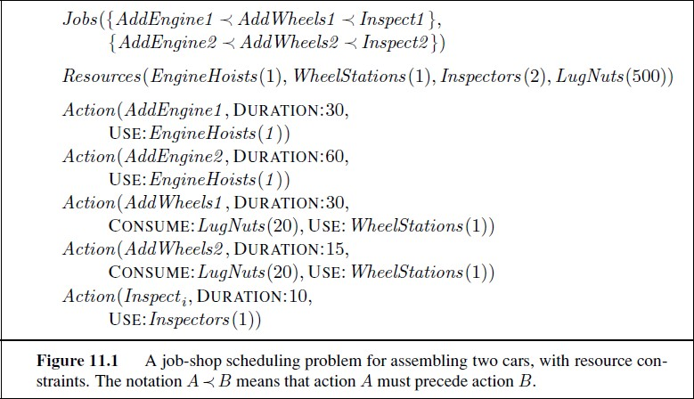

This approach is common in real-world manufacturing and logistical settings, where the planning phase is often performed by human experts. The automated methods of Chapter 10 can also be used for the planning phase, provided that they produce plans with just the minimal ordering constraints required for correctness. G RAPHPLAN (Section 10.3), SATPLAN (Section 10.4.1), and partial-order planners (Section 10.4.4) can do this; search-based methods (Section 10.2) produce totally ordered plans, but these can easily be converted to plans with minimal ordering constraints.

Hierarchical Planning :
The problem-solving and planning methods of the preceding chapters all operate with a fixed set of atomic actions. Actions can be strung together into sequences or branching networks; state-of-the-art algorithms can generate solutions containing thousands of actions.
For plans executed by the human brain, atomic actions are muscle activations. In very round numbers, we have about 103 muscles to activate (639, by some counts, but many of them have multiple subunits); we can modulate their activation perhaps 10 times per second; and we are alive and awake for about 109 seconds in all. Thus, a human life contains about 1013 actions, give or take one or two orders of

magnitude. Even if we restrict ourselves to planning over much shorter time horizons—for example, a two-week vacation in Hawaii—a detailed motor plan would contain around 1010 actions. This is a lot more than 1000.
To bridge this gap, AI systems will probably have to do what humans appear to do: plan at higher levels of abstraction. A reasonable plan for the Hawaii vacation might be “Go to San Francisco airport; take Hawaiian Airlines flight 11 to Honolulu; do vacation stuff for two weeks; take Hawaiian Airlines flight 12 back to San Francisco; go home.” Given such a plan, the action “Go to San Francisco airport” can be viewed as a planning task in itself, with a solution such as “Drive to the long-term parking lot; park; take the shuttle to the terminal.” Each of these actions, in turn, can be decomposed further, until we reach the level of actions that can be executed without deliberation to generate the required motor control sequence.
Planning and Acting in Nondeterministic Domains: While the basic concepts are the same as in Chapter 4, there are also significant differences. These arise because planners deal with factored representations rather than atomic representations. This affects the way we represent the agent’s capability for action and observation and the way we represent belief states—the sets of possible physical states the agent might be in—for unobservable and partially observable environments. We can also take ad- vantage of many of the domain-independent methods given in Chapter 10 for calculating search heuristics.
Consider this problem: given a chair and a table, the goal is to have them match—have the same color. In the initial state we have two cans of paint, but the colors of the paint and the furniture are unknown. Only the table is initially in the agent’s field of view:
Init(Object(Table) 𝖠 Object(Chair ) 𝖠 Can(C1) 𝖠 Can(C2) 𝖠 InView (Table)) Goal (Color (Chair , c) 𝖠 Color (Table, c))
There are two actions: removing the lid from a paint can and painting an object using the paint from an open can. The action schemas are straightforward, with one exception: we now allow preconditions and effects to contain variables that are not part of the action’s variable list. That is, Paint(x, can) does not mention the variable c, representing the color of the paint in the can. In the fully observable case, this is not allowed—we would have to name the action Paint(x, can, c). But in the partially observable case, we might or might not know what color is in the can. (The variable c is universally quantified, just like all the other variables in an action schema.)
Action(RemoveLid (can), PRECOND:Can(can) EFFECT:Open(can))

Action(Paint(x , can),
PRECOND:Object(x) 𝖠 Can(can) 𝖠 Color (can, c) 𝖠 Open(can) EFFECT:Color (x, c))

To solve a partially observable problem, the agent will have to reason about the percepts it will obtain when it is executing the plan. The percept will be supplied by the agent’s sensors when it is actually acting, but when it is planning it will need a model of its sensors. In Chapter 4, this model was given by a function, PERCEPT(s). For planning, we augment PDDL with a new type of schema, the percept schema:

Multi agent Planning:
we have assumed that only one agent is doing the sensing, planning, and acting. When there are multiple agents in the environment, each agent faces a multi agent planning problem in which it tries to achieve its own goals with the help or hindrance of others.
Between the purely single-agent and truly multi agent cases is a wide spectrum of problems that exhibit various degrees of decomposition of the monolithic agent. An agent with multiple effectors that can operate concurrently—for example, a human who can type and speak at the same time—needs to do multi effector planning to manage each effector while handling positive and negative interactions among the effectors. When the effectors are physically decoupled into detached units—as in a fleet of delivery robots in a factory— multi effector planning becomes multibody planning. A multibody problem is still a “standard” single-agent problem as long as the relevant sensor information collected by each body can be pooled—either centrally or within each body—to form a common estimate of the world state that then informs the execution of the overall plan; in this case, the multiple bodies act as a single body.
When a single entity is doing the planning, there is really only one goal, which all the bodies necessarily share. When the bodies are distinct agents that do their own planning, they may still share identical goals; for example, two human tennis players who form a doubles team share the goal of winning the match. Even with shared goals, however, the multibody and multi agent cases are quite different. In a multibody robotic doubles team, a single plan dictates which body will go where on the court and which body will hit the ball. In a multi- agent doubles team, on the other hand, each agent decides what to do; without some method for coordination, both agents may decide to cover the same part of the court and each may leave the ball for the other to hit.

Planning with multiple simultaneous actions

For the time being, we will treat the multi effector, multibody, and multi agent settings in the same way, labeling them generically as multi actor settings, using the generic term actor to cove cover effectors, bodies, and agents. The goal of this section is to work out how to define transition models, correct plans, and efficient planning algorithms for the multi actor setting.
A correct plan is one that, if executed by the actors, achieves the goal. (In the true multi agent setting, of course, the agents may not agree to execute any particular plan, but at least they will know what plans would work if they did agree to execute them.) For simplicity, we assume perfect synchronization: each action takes the same amount of time and actions at each point in the joint plan are simultaneous.

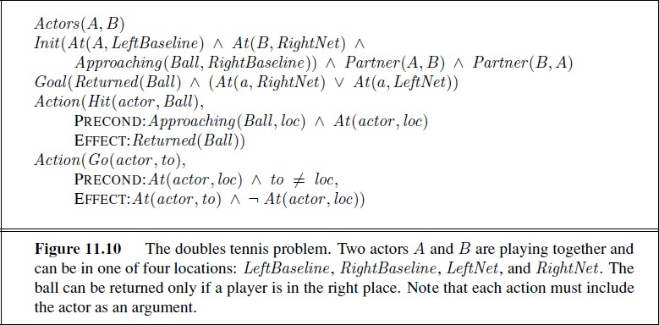

Having put the actors together into a multi actor system with a huge branching factor, the principal focus of research on multi actor planning has been to decouple the actors to the extent possible, so that the complexity of the problem grows linearly with n rather than exponentially. If the actors have no interaction with one another—for example, n actors each playing a game of solitaire—then we can simply solve n separate problems. If the actors are loosely coupled, can we attain something close to this exponential improvement? This is, of course, a central question in many areas of AI.
The standard approach to loosely coupled problems is to pretend the problems are completely decoupled and then fix up the interactions. For the transition model, this means writing action schemas as if the actors acted independently. Let’s see how this works for the doubles tennis problem. Let’s

suppose that at one point in the game, the team has the goal of returning the ball that has been hit to them and ensuring that at least one of them is covering the net.

Planning with multiple agents Cooperation andcoordination:
Now let us consider the true multi agent setting in which each agent makes its own plan. To start with, let us assume that the goals and knowledge base are shared. One might think that this reduces to the multibody case—each agent simply computes the joint solution and executes its own part of that solution. Alas, the “the” in “the joint solution” is misleading. For our doubles team, more than one joint solution exists:
If both agents can agree on either plan 1 or plan 2, the goal will be achieved. But if A chooses plan 2 and B chooses plan 1, then nobody will return the ball. Conversely, if A chooses 1 and B chooses 2, then they will both try to hit the ball.
One option is to adopt a convention before engaging in joint activity. A convention is any constraint on the selection of joint plans. For example, the convention “stick to your side of the court” would rule out plan 1, causing the doubles partners to select plan 2. Drivers on a road face the problem of not colliding with each other; this is (partially) solved by adopting the convention “stay on the right side of the road” in most countries; the alternative, “stay on the left side,” works equally well as long as all agents in an environment agree. Similar considerations apply to the development of human language, where the important thing is not which language each individual should speak, but the fact that a community all speaks the same language. When conventions are widespread, they are called social laws.
Conventions can also arise through evolutionary processes. For example, seed-eating harvester ants are social creatures that evolved from the less social wasps. Colonies of ants execute very elaborate joint plans without any centralized control—the queen’s job is to re- produce, not to do centralized planning—and with very limited computation,
Communication, and memory capabilities in each ant (Gordon, 2000, 2007). The colony has many roles, including interior workers, patrollers, and foragers. Each ant chooses to perform a role ac- cording to the local conditions it observes. One final example of cooperative multi agent behavior appears in the flocking behavior of birds.
We can obtain a reasonable simulation of a flock if each bird agent (sometimes called a boid) observes the positions of its nearest neighbors and then chooses the heading and acceleration that maximizes the weighted sum of these three components.

(a)
(b)
(c)
Figure 11.11 (a) A simulated flock of birds, using Reynold’s boids model. Image courtesy
Giuseppe Randazzo, novastructura.net. (b) An actual flock of starlings. Image by Eduardo (pastaboy sleeps on flickr). (c) Two competitive teams of agents attempting to capture the towers in the NERO game. Image courtesy Risto Miikkulainen.
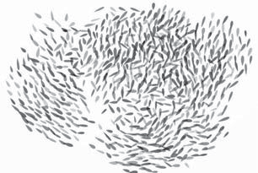
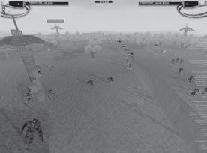
- Cohesion: a positive score for getting closer to the average position of the neighbors
- Separation: a negative score for getting too close to any one neighbor
- Alignment: a positive score for getting closer to the average heading of the neighbors
If all the boids execute this policy, the flock exhibits the emergent behavior of flying as a pseudo rigid body with roughly constant density that does not disperse over time, and that occasionally makes sudden swooping motions. You can see a still images in Figure 11.11(a) and compare it to an actual flock in (b). As with ants, there is no need for each agent to possess a joint plan that models the actions of other agents. The most difficult multi agent problems involve both cooperation with members of one’s own team and competition against members of opposing teams, all without centralized control.

UNIT-V

Uncertainty: Acting under Uncertainty, Basic Probability Notation, Inference Using Full Joint Distributions, Independence, Bayes’ Rule and Its Use, Probabilistic Reasoning: Representing Knowledge in an Uncertain Domain, The Semantics of Bayesian Networks, Efficient Representation of Conditional Distributions, Approximate Inference in Bayesian Networks, Relational and First-Order Probability, Other Approaches to Uncertain Reasoning; Dempster-Shafer theory.
Learning: Forms of Learning, Supervised Learning, Learning Decision Trees.Knowledge in Learning: Logical Formulation of Learning, Knowledge in Learning, Explanation-Based Learning, Learning Using Relevance Information, Inductive Logic Programming

Uncertain knowledge and Learning
Core vs. Probabilistic AI •
  - Knowledge Reasoning : work with facts/assertions; develop rules of logical inference
  - Planning: work with applicability/effects of actions; develop searches for actions which achieve goals/avert disasters.
  - Expert Systems: develop by hand a set of rules for examining inputs, updating internal states and generating outputs
  - Learning approach: use probabilistic models to tune performance based on many data examples.
  - Probabilistic AI: emphasis on noisy measurements, approximation in hard cases, learning, algorithmic issues.
    - logical assertions ⇒ probability distributions
    - logical inference ⇒ conditional probability distributions
    - logical operators ⇒ probabilistic generative models

Probabilistic reasoning
Causes of uncertainty:
Following are some leading causes of uncertainty to occur in the real world.

  - Information occurred from unreliable sources.
  - Experimental Errors
  - Equipment fault
  - Temperature variation
  - Climate change.

Probabilistic reasoning is a way of knowledge representation where we apply the concept of probability to indicate the uncertainty in knowledge. In probabilistic reasoning, we combine probability theory with logic to handle the uncertainty.

We use probability in probabilistic reasoning because it provides a way to handle the uncertainty that is the result of someone's laziness and ignorance.

In the real world, there are lots of scenarios, where the certainty of something is not confirmed, such as "It will rain today," "behavior of someone for some situations," "A match between two teams or two players." These are probable sentences for which we can assume that it will happen but not sure about it, so here we use probabilistic reasoning.

Probability: Probability can be defined as a chance that an uncertain event will occur. It is the numerical measure of the likelihood that an event will occur. The value of probability always remains between 0 and 1 that represent ideal uncertainties.

0 ≤ P(A) ≤ 1, where P(A) is the probability of an event A. P(A) = 0, indicates total uncertainty in an event A.
P(A) =1, indicates total certainty in an event A.

We can find the probability of an uncertain event by using the below formula. P(¬A) = probability of a not happening event.
P(¬A) + P(A) = 1.
Event: Each possible outcome of a variable is called an event.
Sample space: The collection of all possible events is called sample space.
Random variables: Random variables are used to represent the events and objects in the real world. Prior probability: The prior probability of an event is probability computed before observing new information.
Posterior Probability: The probability that is calculated after all evidence or information has taken into account. It is a combination of prior probability and new information.

Conditional probability:
Conditional probability is a probability of occurring an event when another event has already happened.

Let's suppose, we want to calculate the event A when event B has already occurred, "the probability of A under the conditions of B", it can be written as:
Where P(A⋀B)= Joint probability of a and B P(B)= Marginal probability of B.
If the probability of A is given and we need to find the probability of B, then it will be given as:

It can be explained by using the below Venn diagram, where B is occurred event, so sample space will be reduced to set B, and now we can only calculate event A when event B is already occurred by dividing the probability of P(A⋀B) by P( B ).

Example:
In a class, there are 70% of the students who like English and 40% of the students who likes English and mathematics, and then what is the percent of students those who like English also like mathematics?
Solution:
Let, A is an event that a student likes Mathematics B is an event that a student likes English.
Hence, 57% are the students who like English also like Mathematics.

Why Reason Probabilistically?

- In many problem domains it isn't possible to create complete, consistent models of the world. Therefore agents (and people) must act in uncertain worlds (which the real world is).
- Want an agent to make rational decisions even when there is not enough information to prove that an action will work.
- Some of the reasons for reasoning under uncertainty:
  - True uncertainty. E.g., flipping a coin.
  - Theoretical ignorance. There is no complete theory which is known about the problem domain. E.g., medical diagnosis.
  - Laziness. The space of relevant factors is very large, and would require too much work to list the complete set of antecedents and consequents. Furthermore, it would be too hard to use the enormous rules that resulted.
  - Practical ignorance. Uncertain about a particular individual in the domain because all of the information necessary for that individual has not been collected.

- Probability theory will serve as the formal language for representing and reasoning with uncertain knowledge.

Bayes' theorem:
Bayes' theorem is also known as Bayes' rule, Bayes' law, or Bayesian reasoning, which determines the probability of an event with uncertain knowledge.

In probability theory, it relates the conditional probability and marginal probabilities of two random events.
Bayes' theorem was named after the British mathematician Thomas Bayes. The Bayesian inference is an application of Bayes' theorem, which is fundamental to Bayesian statistics
It is a way to calculate the value of P(B|A) with the knowledge of P(A|B).
Bayes' theorem allows updating the probability prediction of an event by observing new information of the real world.

Example: If cancer corresponds to one's age then by using Bayes' theorem, we can determine the probability of cancer more accurately with the help of age.

Bayes' theorem can be derived using product rule and conditional probability of event A with known event B:

As from product rule we can write:

- P(A ⋀ B)= P(A|B) P(B) or

Similarly, the probability of event B with known event A:

1. P(A ⋀ B)= P(B|A) P(A)

Equating right hand side of both the equations, we will get:

The above equation (a) is called as Bayes' rule or Bayes' theorem. This equation is basic of most modern AI systems for probabilistic inference.

It shows the simple relationship between joint and conditional probabilities. Here,
P(A|B) is known as posterior, which we need to calculate, and it will be read as Probability of hypothesis A when we have occurred an evidence B.
P(B|A) is called the likelihood, in which we consider that hypothesis is true, then we calculate the probability of evidence.
P(A) is called the prior probability, probability of hypothesis before considering the evidence P(B) is called marginal probability, pure probability of an evidence.

In the equation (a), in general, we can write P (B) = P(A)*P(B|Ai), hence the Bayes' rule can be written as:
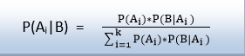

Applying Bayes' rule:

Bayes' rule allows us to compute the single term P(B|A) in terms of P(A|B), P(B), and P(A). This is very useful in cases where we have a good probability of these three terms and want to determine the fourth one.

Suppose we want to perceive the effect of some unknown cause, and want to compute that cause, then the Bayes' rule becomes:
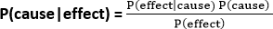

Example-1:

Question: what is the probability that a patient has diseases meningitis with a stiff neck?

Given Data:

A doctor is aware that disease meningitis causes a patient to have a stiff neck, and it occurs 80% of the time. He is also aware of some more facts, which are given as follows:

- The Known probability that a patient has meningitis disease is 1/30,000.
- The Known probability that a patient has a stiff neck is 2%.

Let a be the proposition that patient has stiff neck and b be the proposition that patient has meningitis. , so we can calculate the following as:

P(a|b) = 0.8 P(b) = 1/30000 P(a)= .02
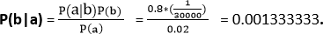

Hence, we can assume that 1 patient out of 750 patients has meningitis disease with a stiff neck.

Bayesian Network can be used for building models from data and experts opinions, and it consists of two parts:

- Directed Acyclic Graph
- Table of conditional probabilities.

The generalized form of Bayesian network that represents and solve decision problems under uncertain knowledge is known as an Influence diagram.

A Bayesian network graph is made up of nodes and Arcs (directed links), where:
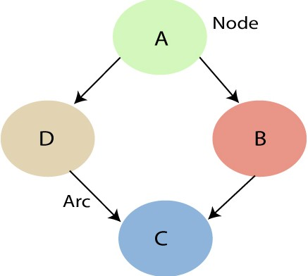

- Each node corresponds to the random variables, and a variable can be continuous or discrete.
- Arc or directed arrows represent the causal relationship or conditional probabilities between random variables. These directed links or arrows connect the pair of nodes in the graph.
These links represent that one node directly influence the other node, and if there is no directed link that means that nodes are independent with each other

In the above diagram, A, B, C, and D are random variables represented by the nodes of the network graph.
  - If we are considering node B, which is connected with node A by a directed arrow, then node A is called the parent of Node B.

Node C is independent of node A.

The Bayesian network has mainly two components:

Causal Component
- Actual numbers

Each node in the Bayesian network has condition probability distribution P(X_{i} |Parent(X_{i}) ), which determines the effect of the parent on that node.

Representing Belief about Propositions

  - Rather than reasoning about the truth or falsity of a proposition, reason about the belief that a proposition or event is true or false
  - For each primitive proposition or event, attach a degree of belief to the sentence
  - Use probability theory as a formal means of manipulating degrees of belief
  - Given a proposition, A, assign a probability, P(A), such that 0 <= P(A) <= 1, where if A is true, P(A)=1, and if A is false, P(A)=0. Proposition A must be either true or false, but P(A) summarizes our degree of belief in A being true/false.
    - Examples
    - P(Weather=Sunny) = 0.7 means that we believe that the weather will be Sunny with 70% certainty. In this case Weather is a random variable that can take on values in a domain such as {Sunny, Rainy, Snowy, Cloudy}.
    - P(Cavity=True) = 0.05 means that we believe there is a 5% chance that a person has a cavity. Cavity is a Boolean random variable since it can take on possible values True and False.
    - Example: P(A=a ^ B=b) = P(A=a, B=b) = 0.2, where A=My_Mood, a=happy, B=Weather, and b=rainy, means that there is a 20% chance that when it's raining my mood is happy.

  - We will assume that in a given problem domain, the programmer and expert identify all of the relevant propositional variables that are needed to reason about the domain.
  - Each of these will be represented as a random variable, i.e., a variable that can take on values from a set of mutually exclusive and exhaustive values called the sample space or partition of the random variable. Usually this will mean a sample space {True, False}.
  - For example, the proposition Cavity has possible values True and False indicating whether a given patient has a cavity or not. A random variable that has True and False as its possible values is called a Boolean random variable.

More generally, propositions can include the equality predicate with random variables and the possible values they can have.
For example, we might have a random variable Color with possible values red, green, blue, and other.
Then P(Color=red) indicates the likelihood that the color of a given object is red.
Similarly, for Boolean random variables we can ask P(A=True), which is abbreviated to P(A), and P(A=False), which is abbreviated to P(~A).

Axioms of Probability Theory

Probability Theory provides us with the formal mechanisms and rules for manipulating propositions represented probabilistically. The following are the three axioms of probability theory:

  - 0 <= P(A=a) <= 1 for all a in sample space of A
  - P(True)=1, P(False)=0
  - P(A v B) = P(A) + P(B) - P(A ^ B)

From these axioms we can show the following properties also hold:

  - P(~A) = 1 - P(A)
  - P(A) = P(A ^ B) + P(A ^ ~B)
  - Sum{P(A=a)} = 1, where the sum is over all possible values a in the sample space of A

Joint Probability Distribution

Given an application domain in which we have determined a sufficient set of random variables to encode all of the relevant information about that domain, we can completely specify all of the possible probabilistic information by constructing the full joint probability distribution,
P(V1=v1, V2=v2, ..., Vn=vn), which assigns probabilities to all possible combinations of values to all random variables.

For example, consider a domain described by three Boolean random variables, Bird, Flier, and Young. Then we can enumerate a table showing all possible interpretations and associated probabilities:

Bird | Flier | Young | Probability
T | T | T | 0.0
T | T | F | 0.2
T | F | T | 0.04
T | F | F | 0.01
F | T | T | 0.01
F | T | F | 0.01
F | F | T | 0.23
F | F | F | 0.5

Notice that there are 8 rows in the above table representing the fact that there are 2³ ways to assign values to the three Boolean variables. More generally, with n Boolean variables the table will be of size 2^{n}. And if n variables each had k possible values, then the table would be size k^{n}.

Also notice that the sum of the probabilities in the right column must equal 1 since we know that the set of all possible values for each variable are known. This means that for n Boolean random variables, the table has 2^{n}-1 values that must be determined to completely fill in the table.

If all of the probabilities are known for a full joint probability distribution table, then we can compute any probabilistic statement about the domain. For example, using the table above, we can compute

  - P(Bird=T) = P(B) = 0.0 + 0.2 + 0.04 + 0.01 = 0.25
  - P(Bird=T, Flier=F) = P(B, ~F) = P(B, ~F, Y) + F(B, ~F, ~Y) = 0.04 + 0.01 = 0.05

Conditional Probabilities

  - Conditional probabilities are key for reasoning because they formalize the process of accumulating evidence and updating probabilities based on new evidence.
  - For example, if we know there is a 4% chance of a person having a cavity, we can represent this as the prior (aka unconditional) probability P(Cavity)=0.04.
  - Say that person now has a symptom of a toothache, we'd like to know what is the posterior probability of a Cavity given this new evidence. That is, compute P(Cavity | Toothache).
  - If P(A|B) = 1, this is equivalent to the sentence in Propositional Logic B => A. Similarly, if P(A|B)
=0.9, then this is like saying B => A with 90% certainty.
  - In other words, we've made implication fuzzy because it's not absolutely certain.
  - Given several measurements and other "evidence", E1, ..., Ek, we will formulate queries as P(Q | E1, E2, ..., Ek) meaning "what is the degree of belief that Q is true given that we know E1, ..., Ek and nothing else."

Conditional probability is defined as: P(A|B) = P(A ^ B)/P(B) = P(A,B)/P(B)
One way of looking at this definition is as a normalized (using P(B)) joint probability (P(A,B)).

  - Example Computing Conditional Probability from the Joint Probability Distribution Say we want to compute P(~Bird | Flier) and we know the full joint probability distribution function given above.
  - We can do this as follows:
  - P(~B|F) = P(~B,F) / P(F)
• = (P(~B,F,Y) + P(~B,F,~Y)) / P(F)
• = (.01 + .01)/P(F)

Next, we could either compute the marginal probability P(F) from the full joint probability distribution, or, as is more commonly done, we could do it by using a process called normalization, which first requires computing

P(B|F) = P(B,F) / P(F)
= (P(B,F,Y) + P(B,F,~Y)) / P(F)
= (0.0 + 0.2)/P(F)

Now we also know that P(~B|F) + P(B|F) = 1, so substituting from above and solving for P(F) we get P(F) = 0.22. Hence, P(~B|F) = 0.02/0.22 = 0.091.

While this is an effective procedure for computing conditional probabilities, it is intractable in general because it means that we must compute and store the full joint probability distribution table, which is exponential in size.

Some important rules related to conditional probability are:
- Rewriting the definition of conditional probability, we get the Product Rule: P(A,B) = P(A|B)P(B)
- Chain Rule: P(A,B,C,D) = P(A|B,C,D)P(B|C,D)P(C|D)P(D), which generalizes the product rule for a joint probability of an arbitrary number of variables. Note that ordering the variables results in a different expression, but all have the same resulting value.
- Conditionalized version of the Chain Rule: P(A,B|C) = P(A|B,C)P(B|C)
- Bayes's Rule: P(A|B) = (P(A)P(B|A))/P(B), which can be written as follows to more clearly emphasize the "updating" aspect of the rule: P(A|B) = P(A) * [P(B|A)/P(B)] Note: The terms P(A) and P(B) are called the prior (or marginal) probabilities. The term P(A|B) is called the posterior probability because it is derived from or depends on the value of B.
- Conditionalized version of Bayes's Rule: P(A|B,C) = P(B|A,C)P(A|C)/P(B|C)
- Conditioning (aka Addition) Rule: P(A) = Sum{P(A|B=b)P(B=b)} where the sum is over all possible values b in the sample space of B.
o P(~B|A) = 1 - P(B|A)

Assuming conditional independence of B and C given A, we can simplify Bayes's Rule for two pieces of evidence B and C:

  - P(A | B,C) = (P(A)P(B,C | A))/P(B,C)
• = (P(A)P(B|A)P(C|A))/(P(B)P(C|B))
• = P(A) * [P(B|A)/P(B)] * [P(C|A)/P(C|B)]
• = (P(A) * P(B|A) * P(C|A))/P(B,C)

Naive Bayes Classifier:

Say we have a random variable, C, which represents the possible ways to classify an input pattern of features that have been measured.

The domain of C is the set of possible classifications, e.g., it might be the possible diagnoses in a medical domain.

Say the possible values for C are {a,b,c}, and the features we have measured are E1=e1, E2=e2, ..., En=en.
Then we can compute P(C=a | E1=e1, ..., En=en),
P(C=b | E1=e1, ..., En=en) and

P(C=c | E1=e1, ..., En=en) assuming E1, ..., En are conditionally independent given C. Since for each value of C the denominators are the same above, they can be ignored. So, for example
P(C=a | E1=e1, ..., En=en) = P(C=a) * P(E1=e1 | C=a) * P(E2=e2 | C=a) * ... * P(En=en | C=a) Choose the value for C that gives the maximum probability.
Finally, since only relative values are needed and probabilities are often very small, it is common to compute the sum of logarithms of the probabilities:

log P(C=a | E1=e1, ..., En=en) = log P(C=a) + log P(E1=e1 | C=a) + ... + log P(En=en | C=a).

If B and C are (unconditionally) independent, then P(C|B) = P(C), so

P(A | B,C) = P(A) * [P(B|A)/P(B)] * [P(C|A)/P(C)]

  - Example

Consider the medical domain consisting of three Boolean variables: PickledLiver, Jaundice, Bloodshot, where the first indicates if a given patient has the "disease" PickledLiver, and the second and third describe symptoms of the patient. We'll assume that Jaundice and Bloodshot are independent.

The doctor wants to determine the likelihood that the patient has a PickledLiver.

Based on no other information, she knows that the prior probability P(PickledLiver) = 10⁻¹⁷. So, this represents the doctor's initial belief in this diagnosis. However, after examination, she determines that the patient has jaundice. She knows that P(Jaundice) = 2⁻¹⁰ and P(Jaundice | PickledLiver) = 2⁻³, so she computes the new updated probability in the patient having PickledLiver as:

P(PickledLiver | Jaundice) = P(P)P(J|P)/P(J)
= (2-17 * 2-3)/2-10
= 2-10

So, based on this new evidence, the doctor increases her belief in this diagnosis from 2⁻¹⁷ to 2⁻¹⁰.

Next, she determines that the patient's eyes are bloodshot, so now we need to add this new piece of evidence and update the probability of PickledLiver given Jaundice and Bloodshot.

Say, P(Bloodshot) = 2⁻⁶ and P(Bloodshot | PickledLiver) = 2⁻¹. Then, she computes the new conditional probability:

P(PickledLiver | Jaundice, Bloodshot) = (P(P)P(J|P)P(B|P))/(P(J)P(B))
= 2⁻¹⁰ * [2⁻¹ / 2⁻⁶]
= 2-5

So, after taking both symptoms into account, the doctor's belief that the patient has a PickledLiver is 2⁻⁵.

Bayesian Networks (aka Belief Networks)

  - Bayesian Networks, also known as Bayes Nets, Belief Nets, Causal Nets, and Probability Nets, are a space-efficient data structure for encoding all of the information in the full joint probability distribution for the set of random variables defining a domain. That is, from the Bayesian Net one can compute any value in the full joint probability distribution of the set of random variables.
  - Represents all of the direct causal relationships between variables
  - Intuitively, to construct a Bayesian net for a given set of variables, draw arcs from cause variables to immediate effects.
  - Space efficient because it exploits the fact that in many real-world problem domains the dependencies between variables are generally local, so there are a lot of conditionally independent variables
  - Captures both qualitative and quantitative relationships between variables
  - Can be used to reason
    - Forward (top-down) from causes to effects -- predictive reasoning (aka causal reasoning)
    - Backward (bottom-up) from effects to causes -- diagnostic reasoning
  - Formally, a Bayesian Net is a directed, acyclic graph (DAG), where there is a node for each random variable, and a directed arc from A to B whenever A is a direct causal influence on B. Thus the arcs represent direct causal relationships and the nodes represent states of affairs. The occurrence of A provides support for B, and vice versa. The backward influence is call "diagnostic" or "evidential" support for A due to the occurrence of B.
  - Each node A in a net is conditionally independent of any subset of nodes that are not descendants of A given the parents of A.

Net Topology Reflects Conditional Independence Assumptions

  - Conditional independence defines local net structure. For example, if B and C are conditionally independent given A, then by definition P(C|A,B) = P(C|A) and, symmetrically, P(B|A,C) = P(B|A). Intuitively, think of A as the direct cause of both B and C. In a Bayesian Net this will be represented by the local structure:

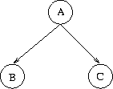

For example, in the dentist example in the textbook, having a Cavity causes both a Toothache and the dental probe to Catch, but these two events are conditionally independent given Cavity. That is, if we know nothing about whether or not someone has a Cavity, then Toothache and Catch are dependent. But as soon as we definitely know the person has a cavity or not, then knowing that the person has a Toothache as well has no effect on whether Catch is true. This conditional independence relationship will be reflected in the Bayesian Net topology as:
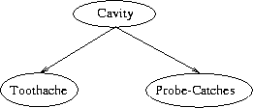

  - In general, we will construct the net so that given its parents, a node is conditionally independent of the rest of the net variables. That is,

P(X1=x1, ..., Xn=xn) = P(xi | Parents(Xi)) * ... * P(xn | Parents(Xn))

Hence, we don't need the full joint probability distribution, only conditionals relative to the parent variables.

  - Example (From (Charniak, 1991))

Consider the problem domain in which when I go home I want to know if someone in my family is home before I go in. Let's say I know the following information:

- Why my wife leaves the house, she often (but not always) turns on the outside light. (She also sometimes turns the light on when she's expecting a guest.)

- When nobody is home, the dog is often left outside.

- If the dog has bowel-troubles, it is also often left outside.

- If the dog is outside, I will probably hear it barking (though it might not bark, or I might hear a different dog barking and think it's my dog).

Given this information, define the following five Boolean random variables:

O: Everyone is Out of the house L: The Light is on
D: The Dog is outside
B: The dog has Bowel troubles H: I can Hear the dog barking

From this information, the following direct causal influences seem appropriate:

- H is only directly influenced by D. Hence H is conditionally independent of L, O and B given D.
- D is only directly influenced by O and B. Hence D is conditionally independent of L given O and B.
- L is only directly influenced by O. Hence L is conditionally independent of D, H and B given O.
- O and B are independent.

Based on the above, the following is a Bayesian Net that represents these direct causal relationships (though it is important to note that these causal connections are not absolute, i.e., they are not implications):

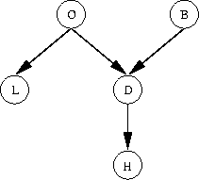

Next, the following quantitative information is added to the net; this information is usually given by an expert or determined empirically from training data.

  - For each root node (i.e., node without any parents), the prior probability of the random variable associated with the node is determined and stored there
  - For each non-root node, the conditional probabilities of the node's variable given all possible combinations of its immediate parent nodes are determined. This results in a conditional probability table (CPT) at each non-root node.

Doing this for the above example, we get the following Bayesian Net:

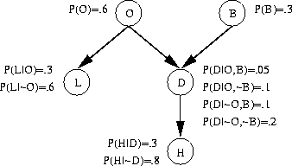

Notice that in this example, a total of 10 probabilities are computed and stored in the net, whereas the full joint probability distribution would require a table containing 2⁵ = 32 probabilities. The reduction is due to the conditional independence of many variables.

Two variables that are not directly connected by an arc can still affect each other. For example, B and H are not (unconditionally) independent, but H does not directly depend on B.

Given a Bayesian Net, we can easily read off the conditional independence relations that are represented. Specifically, each node, V, is conditionally independent of all nodes that are not descendants of V, given V's parents. For example, in the above example H is conditionally independent of B, O, and L given D. So, P(H | B,D,O,L) = P(H | D).

Building a Bayesian Net

Intuitively, "to construct a Bayesian Net for a given set of variables, we draw arcs from cause variables to immediate effects. In almost all cases, doing so results in a Bayesian network [whose conditional independence implications are accurate]." (Heckerman, 1996)

More formally, the following algorithm constructs a Bayesian Net:

- Identify a set of random variables that describe the given problem domain
- Choose an ordering for them: X1, ..., Xn
- for i=1 to n do
  - Add a new node for Xi to the net
  - Set Parents(Xi) to be the minimal set of already added nodes such that we have conditional independence of Xi and all other members of {X1, ..., Xi-1} given Parents(Xi)
  - Add a directed arc from each node in Parents(Xi) to Xi
  - If Xi has at least one parent, then define a conditional probability table at Xi: P(Xi=x | possible assignments to Parents(Xi)). Otherwise, define a prior probability at Xi: P(Xi)

- There is not, in general, a unique Bayesian Net for a given set of random variables. But all represent the same information in that from any net constructed every entry in the joint probability distribution can be computed.
- The "best" net is constructed if in Step 2 the variables are topologically sorted first. That is, each variable comes before all of its children. So, the first nodes should be the roots, then the nodes they directly influence, and so on.
- The algorithm will not construct a net that is illegal in the sense of violating the rules of probability.

Computing Joint Probabilities from a Bayesian Net

To illustrate how a Bayesian Net can be used to compute an arbitrary value in the joint probability distribution, consider the Bayesian Net shown above for the "home domain."

Goal: Compute P(B,~O,D,~L,H)

P(B,~O,D,~L,H) = P(H,~L,D,~O,B)
= P(H | ~L,D,~O,B) * P(~L,D,~O,B) by Product Rule
= P(H|D) * P(~L,D,~O,B) by Conditional Independence of H and L,O, and B given D
= P(H|D) P(~L | D,~O,B) P(D,~O,B) by Product Rule
= P(H|D) P(~L|~O) P(D,~O,B) by Conditional Independence of L and D,
and L and B, given O
= P(H|D) P(~L|~O) P(D | ~O,B) P(~O,B) by Product Rule
= P(H|D) P(~L|~O) P(D|~O,B) P(~O | B) P(B) by Product Rule
= P(H|D) P(~L|~O) P(D|~O,B) P(~O) P(B) by Independence of O and B
= (.3)(1 - .6)(.1)(1 - .6)(.3)
= 0.00144

where all of the numeric values are available directly in the Bayesian Net (since P(~A|B) = 1 - P(A|B)).

APPROXIMATE INFERENCE IN BAYESIAN NETWORKS
- Direct sampling methods

The simplest kind of random sampling process for Bayesian networks generates events from a network that has no evidence associated with it. The idea is to sample each variable in turn, in topological order. The probability distribution from which the value is sampled is conditioned on the values already assigned to the variable’s parents.

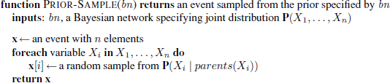

Likelihood weighting
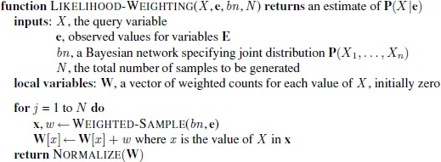
Likelihood weighting avoids the inefficiency of rejection sampling by generating only eventsthat are consistent with the evidence e. It is a particular instance of the general statisticaltechnique of importance sampling, tailored for inference in Bayesian networks.

Inference by Markov chain simulation

Markov chainMonte Carlo (MCMC) MARKOV CHAIN algorithms work quite differently from rejection sampling and likelihood weighting. Instead of generating each sample from scratch, MCMC algorithms generate each sample by making a random change to the preceding sample. It is therefore helpful to think of an MCMC algorithm as being in a particular current state specifying a value for every variable and generating a next state by making random changes to the current state.

FIRST-ORDER PROBABILITY MODELS

Possible worlds
For Bayesian networks, the possible worlds are assignmentsof values to variables; for the Boolean case in particular, the possible worlds areidentical to those of propositional logic. For a first-order probability model, then, it seemswe need the possible worlds to be those of first-order logic—that is, a set of objects withrelations among them and an interpretation that maps constant symbols to objects, predicatesymbols to relations, and function symbols to functions on those objects.

Relational probability models
Like first-order logic, RPMs have constant, function, and predicate symbols.We can refine the model by introducing a context-specific independence.

A context-specific independence allows a variable to be independent of some of its parents given certain values of others.

Open-universe probability models
- A vision system doesn’t know what exists, if anything, around the next corner, and may not know if the object it sees now is the same one it saw a few minutes ago.
- A text-understanding system does not know in advance the entities that will be featured in a text, and must reason about whether phrases such as “Mary,” “Dr. Smith,” “she,”“his cardiologist,” “his mother,” and so on refer to the same object.
- An intelligence analyst hunting for spies never knows how many spies there really are and can only guess whether various pseudonyms, phone numbers, and sightings belong to the same individual.

Representing ignorance: Dempster–Shafer theory

The Dempster–Shafer theory DEMPSTER–SHAFER is designed to deal with the distinction between uncertainty and ignorance. Rather than computing the probability of a proposition, it computes theprobability that the evidence supports the proposition. This measure of belief is called abelief function, written Bel(X).

The mathematical formulation of Dempster–Shafer theory is similar tothose of probability theory; the main difference is that, instead of assigning probabilities to possible worlds, the theory assigns masses to sets of possible world, that is, to events.

The masses still must add to 1 over all possible events. Bel(A) is defined to be the sum ofmasses for all events that are subsets of (i.e., that entail) A, including A itself. With thisdefinition, Bel(A) and Bel(¬A) sum to at most 1, and the gap—the interval between Bel(A)and 1 − Bel(¬A)—is often interpreted as bounding the probability of A.

As with default reasoning, there is a problem in connecting beliefs to actions. Wheneverthere is a gap in the beliefs, then a decision problem can be defined such that a Dempster–Shafer system is unable to make a decision.
Bel(A) should be interpretednot as a degree of belief in A but as the probability assigned to all the possible worlds (nowinterpreted as logical theories) in which A is provable.

For eg:-
let us consider a room where four person are presented A, B, C, D(lets say) And suddenly lights out and when the lights come back B has been died due to stabbing in his back with the help of a knife. No one came into the room and no one has leaved the room and B has not committed suicide. Then we have to find out who is the murdrer?

  - Either {A} or{C} or {D} has killed him.
  - Either {A, C} or {C, D} or {A, C} have killed him.

  - Or the three of them kill him i.e; {A, C, D}
  - None of the kill him {o}(let us say).
These will be the possible evidences by which we can find the murderer by measure of plausiblity. Using the above example we can say :
Set of possible conclusion (P): ,p1, p2….pn-where P is set of possible conclusion and cannot be exhaustive means at least one (p)i must be true.(p)i must be mutually exclusive.Power Set will contain 2n elements where n is number of elements in the possible set.

For eg:-
If P = { a, b, c}, then Power set is given as
{o, {a}, {b}, {c}, {a, b}, {b, c}, {a, c}, {a, b, c}}= 23 elements.

Mass function m(K): It is an interpretation of m({K or B}) i.e; it means there is evidence for {K or B} which cannot be divided among more specific beliefs for K and B.

Belief in K: The belief in element K of Power Set is the sum of masses of element which are subsets of K. This can be explained through an example
Lets say K = {a, b, c}
Bel(K) = m(a) + m(b) + m(c) + m(a, b) + m(a, c) + m(b, c) + m(a, b, c) Plaausiblity in K: It is the sum of masses of set that intersects with K. i.e; Pl(K) = m(a) + m(b) + m(c) + m(a, b) + m(b, c) + m(a, c) + m(a, b, c)

Characteristics of Dempster Shafer Theory:
It will ignorance part such that probability of all events aggregate to 1.Ignorance is reduced in this theory by adding more and more evidences.Combination rule is used to combine various types of possiblities.
Advantages:
  - Ucertainty interval reduces.
  - DST has much lower level of ignorance.
  - Diagnose Hierarchies can be represented using this.
  - Person dealing with such problems is free to think about evidences. Disadvantages:
  - In this computation effort is high, as we have to deal with 2n of sets.

Learning
An agent is learning if it improves its performance on future tasks after making observations about the world.

Forms Of Learning
Any component of an agent can be improved by learning from data.It depends upon 4 factors:

- Which component is to be improved
- direct mapping from conditions on the current state to actions
- infer relevant properties of the world
- results of possible actions
- Action-value information
- Goals that describe classes of states
- What prior knowledge the agent already has.

- What representation is used for the data and the component.
- representations: propositional and first-order logical sentences
- Bayesian networks for the inferential components
- factored representation—a vector of attribute values—and outputs that can be either a continuous numerical value or a discrete value
- What feedback is available to learn from : types of feedback that determine the three main types of learning
- In unsupervised learning the agent learns patterns in the input even though no explicit feedback is supplied
- reinforcement learning the agent learns from a series of reinforcements—rewards or punishments.
- supervised learning the agent observes some example input–output pairs and learns a function that maps from input to output
- semi-supervised learning we are given a few labeled examples and must make what we can of a large collection of unlabelled examples

SUPERVISED LEARNING

Given a training set of N example input–output pairs (x1, y1), (x2, y2), . . . (xN, yN) , where each yj was generated by an unknown function y = f(x), discover a function h that approximates the true function f. The function h is a hypothesis. To measure the accuracy of a hypothesis we give it a test set of examples that are distinct from the training set.
Conditional Probability Distribution : the function f is stochastic—it is not strictly a function of x, and what we have to learn is a , P(Y | x)
Classification :When the output y is one of a finite set of values the learning problem is called

classification
Regression : When y is a number (such as tomorrow’s temperature), the learning problem is called

regression
Hypothesis space, H, can be a set of polynomials. A polynomial is fitting a function of a single variable to some data points.
Ockham’s razor :how do we choose a function or a polynomial from among multiple consistent hypotheses? One answer is to prefer the simplest hypothesis consistent with the data. This principle is called Ockham’s razor
Realizable : a learning problem is realizable if the hypothesis space contains the true function. Unfortunately, we cannot always tell whether a given learning problem is realizable, because the true function is not known.
Supervised learning can be done by choosing the hypothesis ” h”that is most probable one for the given data:

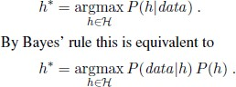

There is a tradeoff between the expressiveness of a hypothesis space and the complexity of finding a good hypothesis within that space.

LEARNING DECISION TREES
Decision tree induction is one of the simplest and yet most successful forms of machine learning.
The decision tree representation :The aim here is to learn a definition for the goal predicate.
A decision tree represents a function that takes as input a vector of attribute values and returns a “decision”—a single output value. The input and output values can be discrete or continuous
- A decision tree reaches its decision by performing a sequence of tests.
- Each internal node in the tree corresponds to a test of the value of one of the input attributes, Ai,
- the branches from the node are labeled with the possible values of the attribute, Ai =vik.
- Each leaf node in the tree specifies a value to be returned by the function.

Decision Tree Algorithm:

The DECISION-TREE-LEARNING algorithm adopts a greedy divide-and-conquer strategy. This test divides the problem up into smaller subproblems that can then be solved recursively.

function DECISION-TREE-LEARNING(examples, attributes, parent examples) returns
a tree
if examples is empty then return PLURALITY-VALUE(parent examples)
else if all examples have the same classification then return the classification
else if attributes is empty then return PLURALITY-VALUE(examples)

else
A←argmaxa ∈ attributes IMPORTANCE(a, examples) tree←a new decision tree with root test A
for each value vk of A do
exs ←,e : e ∈examples and e.A = vk}
subtree←DECISION-TREE-LEARNING(exs, attributes −A, examples) add a branch to tree with label (A = vk) and subtree subtree return tree

Expressiveness of decision trees
A Boolean decision tree is logically equivalent to the assertion that the goal attribute is true if and only if the input attributes satisfy one of the paths leading to a leaf with value true.
Goal ⇔(Path1 ∨Path2 ∨・・・) , where each Path is a conjunction of attribute-value tests required to follow that path. A tree consists of just tests on attributes in the interior nodes, values of

attributes on the branches, and output values on the leaf nodes. For a wide variety of problems, the decision tree format yields a nice, concise result. But some functions cannot be represented concisely. We can evaluate the accuracy of a learning algorithm with a learning curve.

Choosing attribute tests
The greedy search used in decision tree learning is designed to approximately minimize the depth of the final tree. The idea is to pick the attribute that goes as far as possible toward providing an exact classification of the examples. A perfect attribute divides the examples into sets, each of which are all positive or all negative and thus will be leaves of the tree.

Entropy is a measure of the uncertainty of a random variable; acquisition of information corresponds to a reduction in entropy.
We can check that the entropy of a fair coin flip is indeed 1 bit:
H(Fair) = −(0.5 log2 0.5 + 0.5 log2 0.5) = 1 .

The information gain from the attribute INFORMATION GAIN test on A is the expected reduction in entropy:

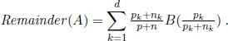

Pruning
In decision trees, a technique called decision tree pruning combats overfitting. Pruning works by eliminating nodes that are not clearly relevant.

Issues in decision trees:
  - Missing data
  - Multivalued attributes
  - Continuous and integer-valued input attributes
  - Continuous-valued output attributes

LEARNING
A LOGICAL FORMULATION OF LEARNING

Current-best-hypothesis search
The idea behind current-best-hypothesis search is to maintain a single hypothesis, and to adjust it as new examples arrive in order to maintain consistency.
The extension of the hypothesis must be increased to include new examples. This is called generalization.
function CURRENT-BEST-LEARNING(examples, h) returns a hypothesis or fail

if examples is empty then return h
e←FIRST(examples)
if e is consistent with h then
return CURRENT-BEST-LEARNING(REST(examples), h) else if e is a false positive for h then
for each hin specializations of h consistent with examples seen so far do h←CURRENT-BEST-LEARNING(REST(examples), h)
if h = fail then return h
else if e is a false negative for h then
for each hin generalizations of h consistent with examples seen so far do h←CURRENT-BEST-LEARNING(REST(examples), h)
if h = fail then return h return fail
The extension of the hypothesis must be decreased to exclude the example. This is called specialization. Least-commitment search
Backtracking arises because the current-best-hypothesis approach has to choose a particular hypothesis as its best guess even though it does not have enough data yet to be sure of the choice. What we can do instead is to keep around all and only those hypotheses that are consistent with all the data so far. Each new example will either have no effect or will get rid of some of the hypotheses.
One important property of this approach is that it is incremental: one never has to go back and reexamine the old examples.

Boundary Set :
We also have an ordering on the hypothesis space, namely, generalization/specialization. This is a partial ordering, which means that each boundary will not be a point but rather a set of hypotheses called a boundary set.
The great thing is that we can represent the entire G-SET version space using just two boundary sets: a most general boundary (the G-set) and a most S-SET specific boundary (the S-set). Everything in between is guaranteed to be consistent with the examples.
The members Si and Gi of the S- and G-sets.
For each one, the new example may be a false positive or a false negative.
- False positive for Si: This means Si is too general, but there are no consistent specializations of Si (by definition), so we throw it out of the S-set.
- False negative for Si: This means Si is too specific, so we replace it by all its immediate generalizations, provided they are more specific than some member of G.
- False positive for Gi: This means Gi is too general, so we replace it by all its immediate specializations, provided they are more general than some member of S.
- False negative for Gi: This means Gi is too specific, but there are no consistent generalizations of Gi (by definition) so we throw it out of the G-set

EXPLANATION-BASED LEARNING
Explanation-based learning is a method for extracting general rules from individual observations.

Memoization
The technique of memoization has long been used in computer science to speed up programs by saving the results of computation. The basic idea of memo functions is to accumulate a database of input– output pairs; when the function is called, it first checks the database to see whether it can avoid solving the problem from scratch.
Explanation-based learning takes this a good deal further, by creating general rules that cover an entire class of cases.
Basic EBL process works as follows:
- Given an example, construct a proof that the goal predicate applies to the example using the available background knowledge
- In parallel, construct a generalized proof tree for the variabilized goal using the same inference steps as in the original proof.
- Construct a new rule whose left-hand side consists of the leaves of the proof tree and whose right- hand side is the variabilized goal (after applying the necessary bindings from the generalized proof).
- Drop any conditions from the left-hand side that are true regardless of the values of the variables in the goal.

Three factors involved in the analysis of efficiency gains from EBL:
- Adding large numbers of rules can slow down the reasoning process, because the inference mechanism must still check those rules even in cases where they do not yield a solution. In other words, it increases the branching factor in the search space.
- To compensate for the slowdown in reasoning, the derived rules must offer significant increases in speed for the cases that they do cover. These increases come about mainly because the derived rules avoid dead ends that would otherwise be taken, but also because they shorten the proof itself.
- Derived rules should be as general as possible, so that they apply to the largest possible set of cases.

LEARNING USING RELEVANCE INFORMATION
The learning algorithm is based on a straightforward attempt to find the simplest determination consistent with the observations.
A determination P ' Q says that if any examples match on P, then they must also match on Q. A determination is therefore consistent with a set of examples if every pair that matches on the predicates on the left-hand side also matches on the goal predicate.

An algorithm for finding a minimal consistent determination

function MINIMAL-CONSISTENT-DET(E,A) returns a set of attributes
inputs: E, a set of examples A, a set of attributes, of size n for i = 0 to n do

for each subset Ai of A of size i do
if CONSISTENT-DET?(Ai,E) then return Ai

function CONSISTENT-DET?(A,E) returns a truth value
inputs: A, a set of attributes E, a set of examples
local variables: H, a hash table
for each example e in E do
if some example in H has the same values as e for the attributes A but a different classification then return false
store the class of e in H, indexed by the values for attributes A of the example e
return true

Given an algorithm for learning determinations, a learning agent has a way to construct a minimal hypothesis within which to learn the target predicate. For example, we can combine MINIMAL- CONSISTENT-DET with the DECISION-TREE-LEARNING algorithm.
This yields a relevance-based decision-tree learning algorithm RBDTL that first identifies a minimal set of relevant attributes and then passes this set to the decision tree algorithm for learning.

INDUCTIVE LOGIC PROGRAMMING
Inductive logic programming (ILP) combines inductive methods with the power of first-order representations, concentrating in particular on the representation of hypotheses as logic programs.
It has gained popularity for three reasons.
  - ILP offers a rigorous approach to the general knowledge-based inductive learning problem.
  - It offers complete algorithms for inducing general, first-order theories from examples, which can therefore learn successfully in domains where attribute-based algorithms are hard to apply.
  - Inductive logic programming produces hypotheses that are (relatively) easy for humans to read The object of an inductive learning program is to come up with a set of sentences for the Hypothesis such that the entailment constraint is satisfied. Suppose, for the moment, that the agent has no background knowledge: Background is empty. Then one possible solution we would need to make pairs of people into objects.

Top-down inductive learning methods
The first approach to ILP works by starting with a very general rule and gradually specializing it so that it fits the data.
This is essentially what happens in decision-tree learning, where a decision tree is gradually grown until it is consistent with the observations.
To do ILP we use first-order literals instead of attributes, and the hypothesis is a set of clauses instead of a decision tree.
Three kinds of literals
    - Literals using predicates
    - Equality and inequality literals
    - Arithmetic comparisons

Inductive learning with inverse deduction
The second major approach to ILP involves inverting the normal deductive proof process. Inverse resolution is based INVERSE on the observation.
Recall that an ordinary resolution step takes two clauses C1 and C2 and resolves them to produce the resolvent C.
An inverse resolution step takes a resolvent C and produces two clauses C1 and C2, such that C is the result of resolving C1 and C2.
Alternatively, it may take a resolvent C and clause C1 and produce a clause C2 such that C is the result of resolving C1 and C2.
A number of approaches to taming the search implemented in ILP systems
      - Redundant choices can be eliminated
      - The proof strategy can be restricted
      - The representation language can be restricted
      - Inference can be done with model checking rather than theorem proving
      - Inference can be done with ground propositional clauses rather than in first-order logic.

